

Fakulteti i Shkencave Kompjuterike dhe Inxhinierisë

**GastNet**

Studentët: Profesori:

Kushtrim Hajrizi - 161738439 Ramiz Hoxha

Agnesa Xhemajli - 161739054 Asistentet:

Besa Cani - 171841228 Medina Shamolli

Armend Osmani - 151635883 Arber Kardiu

Bekim Hasani - 161737960

Mars, 2020

Prishtine

**Project Overview**

GastNet it’s a platform that manages problems relevant to the work market in the sector of gastronomy, with the purpose to set up a network for all workers in this sector. One of responsibilities is offering opportunities of employment to qualified individuals in the most professional settings. At the same time , employers will have a qualified and experienced staff. Owners and managers will have access to right here / right now information about people available and ready to enter in this sector. On the other hand employees will have in hand accurate information related to the workplace they are interested in. Through this platform we aim to facilitate the employment procedures and deducing the time it already takes, provide professionalism from both parties and as a result have a healthy network in this sector.

**Project Scope**

This project includes and aims to assist all individuals active in the sector of gastronomy being these: cooks, bartenders, owners of restaurants, bistros, pubs, and the rest involved. The main problem that this project targets is connecting competent individuals interested to work with the most suitable place.

**Stakeholders**

Main stakeholders involved in the system are:

* + Chefs
  + HeadChefs
  + Waiters
  + Bartendenders
  + Mixologists
  + Managers
  + Field Specialists
  + Field Critics
  + Businesses

This system will offer detailed information about businesses  referring to quality properties, conditions of the workplace, management style and evaluation of salaries in relation to qualifications and expertise. Meanwhile different businesses will be able to connect with individuals that aim to develop themselves professionally. This will include skills, history of employment and performance score from previous workplaces.

Individuals who have been employed earlier in a business will have the chance to give a formal evaluation of it based on his/her experience. Same right is given to former employers also.

The system will be focused specifically in this sector. One of the limitations that this system excludes is that people who haven’t worked before won’t have the possibility to give opinions or recommendations about the business. The same situation is for businesses which won’t be able to evaluate individuals who haven’t been part of their staff.

Another important feature added to the system will be the recruiting module/service, where the main stakeholders involved will be businesses that are looking for a particular employee, and on the other hand people that are looking to get into the market for the first time or just change their job according to their qualifications. The whole process between the job posting to the  application procedures and responding to individuals has been made easy with this feature and the idea is to narrow it down to one simple process and direct communication available between the two parties, a business and individuals respectively.

All in all, as we have pointed out the issues and problems we have targeted, which we want to offer a solution to, this system focuses mainly on the whole process of employment possibilities in the most efficient way possible, and building a healthy network between parties involved on the gastronomy job market.

**Technologies**

**Java SE 8, Spring Boot**

To reduce hard work and increase productivity this application will be developed using Spring Boot. The framework takes care of dependency management across our project. It provides a good platform for Java developers to develop a stand-alone and production-grade spring application that you can just run.

**Spring Cloud Stream**

Spring Cloud Stream is one of the multiple libraries that we will use that are part of the Spring Cloud group (Some of the other technologies of this group will

be mentioned below on the 'Netflix' topic). The internal communication of our services is very important, and in order to provide the best possible response time for our customers we decided to use asynchronous communication and RabbitMQ as a broker (Please check RabbitMQ part). The communication will be asynchronous and event-driven so we will use Spring Cloud Stream which has support for different binder implementations, including a binder

for RabbitMQ, which is the broker that will be used by our system. This library will be used from event-driven internal communications to distributed transactions.

**Spring Data JPA**

Spring Data JPA is a framework which will be used for database communication. It makes use of Hibernate as an ORM tool and will provide a very fast, flexible and easier implementation of data related functions of our system, while removing the boiler plate code.

**Cloud Config Server**

Spring Cloud Config is a library provided by Spring that makes the configuration of distributed systems easier and more flexible.

We needed an external place to have the configurations available for all services and all their running instances.

This will make it easier to make changes to those configuration properties, without the need to reload the instances that relied on those configurations, and also made it possible for those instances to fetch the new configurations on runtime and update their state.

All this is provided by using Spring Cloud Config Server library, and the Spring Cloud Config Client library.

**MySQL**

For the application database, we need an open-source relational database management system based on SQL, MySQL is one of the technologies that fulfills these needs.

**Reddis**

To increase application database performance local caching is one of the most useful tactics. Redis is an open source, in-memory data structure store, used as a database, cache and message broker that we will integrate into this system. By using Redis the data will be stored closer in a local cache, by which it can dramatically speed up response times and reduce network traffic

**Spring Cloud Netflix**

Spring Cloud Netflix provides Netflix OSS integrations for Spring Boot apps through autoconfiguration and binding to the Spring Environment.

It’s an open-source project that includes multiple cloud  infrastructure, libraries concerning issues related to microservices like service registry , load balancing, gateway proxy, Circuit Breaker Pattern etc.

**Eureka Server/Client:**

Service Registry is one of the requirements of a microservices based system, and this is where Netflix Eureka integrated in Spring comes into picture. By providing us the Eureka server and the Eureka Client respectively, we can easily achieve this solution and the implementation is pretty simple and easy to understand. Specifically the Eureka Server plays the role of the Service Registry, by providing a server where all microservices that have the Eureka Client can register once they are up and running. Eureka provides a client-side service registry.

**Hystrix**

To address the problems that come with multiple microservices and possible slowness across them, we will be using patterns such as Circuit Breaker, Bulkhead pattern etc. Netflix provides Hystrix as a fault tolerance library designed to isolate points of access to remote systems, services and 3rd party APIs, and also to enable resilience in complex distributed systems where failure is inevitable.

**Ribbon**

Load balancing is another known issue across the community of developing microservices based software systems. Like the service registry solution mentioned above, the Netflix project provides a library with an efficient and easy to implement solution for load balancing.

It is a cloud library providing client-side load balancing,fault tolerance and caching .

Ribbon, as a part of the Netflix family can interact directly with Eureka server and as such is a part of the libraries we are going to use in our microservices system.

**Zuul**

Zuul is a API gateway which serves as a unified access point. It will be used as a structure that the other part of the application will be hidden from external parties that shouldn’t be able to access it directly. Zuul also helps solve common challenges like request routing, managing cross-origin resource sharing or request throttling.

**Rabbit MQ**

GasNet services will communicate asynchronously and in an event-driven fashion for most of the time. In order to achieve this, our system will use the RabbitMQ message broker which is a popular open-source message broker. RabbitMQ will be used by our Spring Cloud Stream library, which makes the configuration with RabbitMQ easy and flexible to modify.

**Apache Tiles**

Apache Tiles is a template composition framework, it allows authors to define page fragments which can be assembled into a complete page at runtime. These fragments, or tiles, can be used as simple includes in order to reduce the duplication of common page elements or embedded within other tiles to develop a series of reusable templates.

**Apache Tomcat Server**

Apache Tomcat Server is a long-lived, open source Java servlet container that implements several core Java enterprise specs, namely the Java Servlet, JSP and WebSockets APIs. A Java Servlet  encapsulates code and business logic and defines how requests and responses should be handled in a Java server.

**JSP , JSTL**

JSP is a Java standard technology that enables you to write dynamic, data-driven pages for your Java web applications. JSP is an advanced version of Servlets. JSP is a server-side view rendering technology. In our project we will use it to get HTTP requests from the server side and send a response.

JSTL  is a collection of useful JSP tags which encapsulates the core functionality common to many JSP applications

**Bootstrap**

The applications user interface will be implemented with bootstrap as a design template that fulfills system needs.

**Scrum framework**

Concerning our scrum framework planning, and since we know Scrum is an iterative way of working, first we defined our product backlog containing all the desired features the system should offer. Of course there has been changes, and there is room for modifications along the way. After that we have made estimations of these features into user stories and defined tasks with according points and priorities. The story points and priorities where set based on the complexity, as we have already a little bit of experience working with the technologies and microservice architecture. Besides the documentation, we have also had daily scrum meetings as a team and discussed daily tasks, what we have done the day before, any issues we might have had and so on. Before each sprint we have held the sprint planning, where we defined the tasks that needed to be done based on the priority on each sprint, analysed them in detail and assigned them to all the team members. Sprints are 1 week long and at the end of each sprint we have reviewed and tested the deliverables. Any undelivered task planned for the Sprint, was moved to the Product backlog for re-estimation We used JIra to manage the whole workflow and task distribution among the team members.

**Backlog Definition**

**Sprint 1**

User Microservice Setup

Business Microservice Setup

Individual Microservice Setup

Job Microservice Setup

Review Microservice Setup

Discovery Service Setup

Gateway Service Setup

Config Server Setup

**Sprint 2**

Client Application Setup

User Registration

User Login

User Registration with Google OAuth2

User Login with Google OAuth2

User Log Out

System Dashboard

**Sprint 3**

Individual and Business Profile

Individual and Business Profile Edit

Search functionality on dashboard

Individual experience add/edit/remove

Individual activity add/edit/remove

Business Image add/edit/remove

Delete/Disable account

Forgot password

**Sprint 4**

Reviews for individuals

Reviews for businesses

Reviews for skills

Critic type feature

Field specialist type feature

Admin panel with admins list, and admin searching

Admin report handling

Admin privileges feature

Admin email notification feature

**Sprint 5**

Job opening add/edit/remove

Job opening searching and listing

Job application submission feature

Job application review and management from business

About us and contact us page

Individual suggestion feature

**Sprint 6**

Job opening response email feature

Search activity

System defects report page feature

UI testing and polishing for different browsers

General system bug fixes

**Conceptual Model**

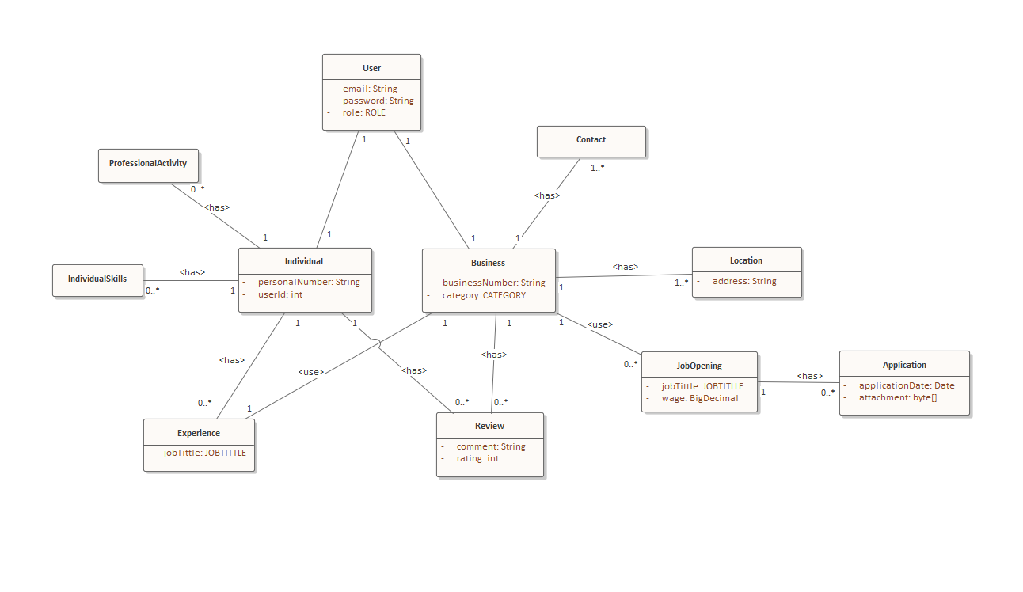

The conceptual model of the system provides an abstracted overview of the system’s main entities. This diagram shows the relationship between the entities and their intercommunication in a big picture. We have the following entities : User, Business, Contact, Location, Review, Individual, ProfessionalActivity, IndividualSkills, Experience, JobOpening, and Application.

**External party API**

Google Maps API  
States And Cities API

Google OAuth2 Login

**Software and tools**

Eclipse IDE

Spring Tool Suite (Eclipse based)

MySQL Server

MySQL Workbench

JIRA

Confluence

Enterprise architecture

Discord

Zoom

**Risk analysis**

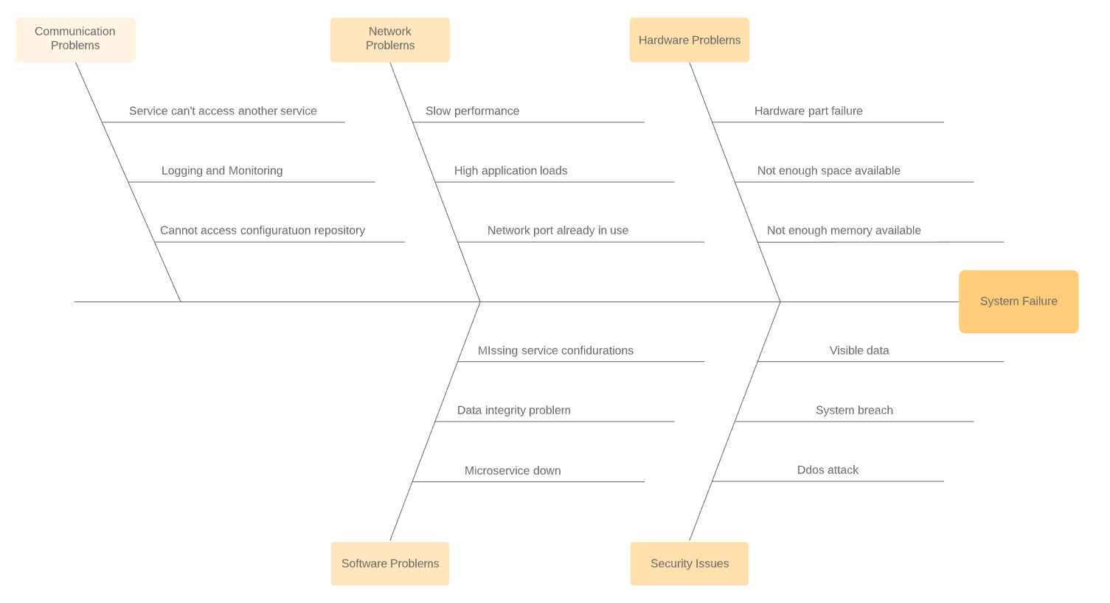

**Hardware Problems**

* *Hardware part failure*

Any hardware component failed leaving the system unable to continue it’s flow as intended or crash the system completely. Hardware changes or replacement should be done as fast as possible.

* *Not enough space available*

Temporary or not needed data should be deleted to create space for the needed operations, or more space should be added, if it cannot be done, a new microservice should be created on another system.

* *Not enough memory available*

More memory should be added or a new microservice instance will be started on a system with more available memory.

**Network Problems**

* *Slow performance |* *High application load*

There is a high load on the network. More microservice instances should be started to share the load.

* *Network port already in use*

New instances will be created on another port or on another server with available ports.

**Communication Problems**

* *Service cannot access another service*

Fault tolerance will be used so the system will continue its work as intended,

In this case requests will be cached for later processing.

* *Logging and monitoring*

Logging and monitoring will log as much data as possible so other system faults are detected early. Trace id will be used across microservices for detecting problem root.

* *Cannot access configuration repository*

There will be multiple instances of configuration services running at the same time. If none are available backup configuration data on the microservice package will be used instead.

**Security Issues**

* *Visible data*

All data will be hashed and encrypted .

* *System breach*

Every three months all users are required to change their credentials.

* *DDoS attack*

To mitigate a DDoS attack is to implement rate-limiting. The number of requests a server can accept within a certain timeframe will be limited.

**Software Problems**

* *Microservice down*

In this approach, the client process tracks the number of failed requests. If the error rate exceeds a configured limit, a “circuit breaker” trips so that further attempts fail immediately till the service self refreshes.

* *Data integrity problem*

Data integrity problems are going to be handled by implementing error detecting mechanisms, maintaining backup and recovery procedures and protecting physical and logical security of systems.

* *Missing service configuration*

Missing configuration will be handled by empty or default values, based on the configuration property and the missing configuration will be updated on repository.

**Hardware Specification**

All the system infrastructure will be deployed on AWS, so there is no need for servers to be bought or paid specifically for the system. Except the domain name, all the other needed parts of the infrastructure, including the servers, databases and the connection between them will be provided by AWS. This takes away the responsibility about the hardware part of the system, and gives opportunity for scaling the system depending on the load. The pricing for can be viewed on this website:

Amazon Web Services, Inc. Pricing

<https://aws.amazon.com/pricing/>.

**User Stories**

3C Analysis

|  |  |
| --- | --- |
| **Card#1** | As a general user,  I want to be able to create a personal account in the application,  So that I can use the system. |
| **Conversion** | 1.What is a general user ?  1.A general user is a person or business that wants to use the system for professional  reasons.  2.What does a general user need to register?  2.A general user needs to have an existing email to be able to register.  3.Can a person have multiple accounts?  3.No a person can only have 1 account.  4.Is there any requirement for creating an account?  4.The person should be at least 16 years old. |
| **Confirmation** | 1.After a general user has successfully created an account a confirmation email will be sent to them.  2.If a general user tries to login without email confirmation the system will show the message “Please finish the email confirmation before trying to log in”  3.If the person doesn’t confirm the email in 24 hours the link will expire and the person needs to create a new account from the beginning. |

|  |  |
| --- | --- |
| **Card#2** | As a general user,  I want to be able to create a personal account in the application using an existing google account,  So that I can use the system. |
| **Conversion** | 1. What does a general user need to register?  1. A general user needs to have an existing google account to be able to register.  2. What data from google account will be shared with GastNet?  2. First name ,last name and email.  3. Can the same google account be used to create multiple GastNet accounts?  3. Only one user can be created from any email account meaning that one email can have    only one account.  4. After opening an account using google can the user login without using google sign in?  4. If the user has created the account using google account the only way to log in will be using the google sign in. |
| **Confirmation** | 1. Before the user can create an account first he needs to confirm the email after redirecting them to the gmail page.  2. If a user does not have a google account they can create an account using other sign up methods. |

|  |  |
| --- | --- |
| **Card#3** | As a general user,  I want to be able to delete my account,  So that all the information about me will be deleted. |
| **Conversion** | 1. How does a user delete its account?  1. The user has to fulfill a form as feedback that tells the reason why it took that decision then it proceeds with confirmation of the decision and logs out of the system.  2. Will the account be permanently deleted?  2. No, it will not be permanently deleted, it just changes account status from active to inactive.  3. Can the user use the same email to open a new account after it deletes the existing one?  3. Yes, the user will be able to open a new account using the previously used email;   4. After the user deletes its account, does its name appear at businesses that registered it as an employee?  4. No after the user deletes the account all the information regarding the business will be deleted from the system |
| **Confirmation** | 1.The user can delete its account just after it fulfills the form that describes the reason why it is deleting it. |

|  |  |
| --- | --- |
| **Card#4** | As a general user,  I want to be able to disable  my account,  So that I won't be part of the system as an active user. |
| **Conversion** | 1. How does a user disable its account?  1. There will be an option where the user can disable the account for a period of time or permanently.  2. If a user disables the account permanently what does he need to do to reopen it ?  2. In order to reopen the account the user has to login in and then there will be an option which will allow him to enable the account  3. Can the user use the same email to open a new account after it disables the existing one?  3. No, the user cannot use the same email to open a new account because the email is still saved to the system.   4. After the user disables its account, does its name appear at businesses that registered it as an employee?  4. No after the user disables the account all the information regarding the business will be hidden from the system |
| **Confirmation** | 1.The user can disable its account for a period of time or permanently till the next login. |

|  |  |
| --- | --- |
| **Card#5** | As a general user,  I want to be able to send feedback to the system,  So that they can correct its mistakes and add new features. |
| **Conversion** | 1. What type of data can an individual send with feedback?  1. Feedback can be screenshots and description about a new bug or feature.  2. Who is going to review these feedbacks?  2. Admin users will have the permission to review these feedbacks  3. How much time will it take to review these feedbacks?  3. It depends on the situation for example if it's a bug it will be reviewed as soon as possible and for new feature implementation it will take more time.  4.Will the feedback be anonymous ?  4.All the feedback will be associated with the user that submitted it. |
| **Confirmation** | 1.Users will be able to send feedback to the system regarding new implementation ideas or bug reporting.  2.Inapproriate feedback will result with the user getting blocked. |

|  |  |
| --- | --- |
| **Card#6** | As a general user,  I want to be able to search individual users through skills/abilities,  So that i can find users that have the specified skill/ability that my business needs. |
| **Conversion** | 1. Will users be able to search with multiple skills/abilities?  1. No, searching will be implemented only for one parameter search.  2. Can all types of users search skills/abilities?  2. Yes all users have the privilege to search through skills and abilities.  3. Will a user be able to contact these individuals?  3. Yes, users can contact others by using email.  4. Will an user be able to know who searched for it?  4. No, users will not be able to know if someone searched for them. |
| **Confirmation** | 1. Every user can search others regarding skills and abilities. |

|  |  |
| --- | --- |
| **Card#7** | As a general user,  I want to be able to see all ratings and comments that other users have made,  So that I can access them easily. |
| **Conversion** | 1.Where will all the ratings and comments of a user show?  1.After u go to a users profile there will be a section where you can see the ratings and comments that they have done.  2.Will all the ratings and comments be shown on the profile of the user?  2.There will be only a certain amount of them if u want to see all the ratings and comments there will be a button “see all” which will redirect you to a page where u will see all their ratings and comments of a user.  3.Will users be able to see the reviews of businesses for other users?  3.Yes the businesses ratings and comments will be public too for all the users.  4.Is there any feature that allows us to hide our ratings and comments from our profile?  4.No, there won't be a feature for hiding them. |
| **Confirmation** | 1.All users of the system will be able to see all the reviews and comments that any other user has made just by going to their profile. |

|  |  |
| --- | --- |
| **Card#8** | As a general user,  I want to be able to login with a GastNet account,  So that I don’t have to repeat all the steps to sign up. |
| **Conversion** | 1.What is a user ?  1.A user is a person or business that wants to use the system for professional  reasons.  2.Why does a user need to register?  2.A user needs to have an existing email to be able to register.  3.Can a person have multiple accounts?  3.No a person can only have 1 account.  4.Is there any requirement for creating an account?  4.The person should be at least 16 years old. |
| **Confirmation** | 1.After the user logs in with his/her account ,the system will check if the email was saved as an account user.  2.If the email is shown on the list of users, then it will proceed to give the password.  3.If the password is correct then he/she will be logged in. |

|  |  |
| --- | --- |
| **Card#9** | As a general user,  I must be able to logout,  So that nobody can access my account. |
| **Conversion** | 1.How will the user be logged out?  1.The system will have a button to log out..  2.Who can logout?  2.Every user can logout.  3.Will the system save my data after logging out?  3.Yes,it will.  4.What will be shown after logging out?  4.We be shown the main page of the web. |
| **Confirmation** | 1.After the user clicks the button ,a popup  window will ask if he is sure.  2.If he clicks OKAY , the system will save if he changes some data.  3.Than the account will be logged out. |

|  |  |
| --- | --- |
| **Card#10** | As a general user,  I must be able to report users if I see inappropriate content,  So that the admin can find easier and  delete these posts. |
| **Conversion** | 1.Who will be able to report inappropriate content?  1.Every user of the GastNet platform.  2.How will the system know that this is inappropriate content?  2.It will check for specific words.  3.How much time will it get to be reviewed by system?  3.About 2-3 working days.  4.Will it notify the user that reported that the post was deleted?  4.Yes, it will by email. |
| **Confirmation** | 1.After the user reports, the system will ask why a content is being reported.  2.Users tells the reasons, then the system sees it and verifies if it should be deleted.  3.If system verifies that it is inappropriate , it will be deleted. |

|  |  |
| --- | --- |
| **Card#11** | As a general user,  I must be able to report a defect in system,  So that UX can be more pleasant. |
| **Conversion** | 1.Who will be able to report a defect in the system?  1.Every user of the GastNet platform.  2.How will the system know that is a defect?  2.It will be checked by our developers.  3.How much time will it get to be reviewed by developers?  3.It depends on the complexity of it.  4.Will it notify the user that it was fixed?  4.Yes, it will by email. |
| **Confirmation** | 1.After the user reports, the system will ask why a content is being reported.  2.Users tells the reasons, then the system sees it and verifies if it should be deleted.  3.If the system verifies that it is inappropriate , it will be deleted. |

|  |  |
| --- | --- |
| **Card#12** | As a general user,  I must be able to change password,  So that I can update it to a better one. |
| **Conversion** | 1.Why should a user be able to change password?  1.For different reasons, but most importantly, it can be forgotten.  2.How many times he can change it?  2.As many times as he/she wants.  3.Will it be safe?  3.Yes, because the user will be asked the current password and then a confirmation will be sent to his/her email.  4.Will be needed to restart the application?  4.No, it will be changed immediately after he/she confirms the email sent by us. |
| **Confirmation** | 1.After the user chooses to change password,the system will ask to write the actual password.  2.If the user writes it correctly, then the system will ask to write a new password.  3.After the user submits it, the system updates it. |

|  |  |
| --- | --- |
| **Card#13** | As a general user,  I must be able to requests ‘forgot password’,  So that I can login again and not lose my account. |
| **Conversion** | 1.What happens after user requests ‘forgot password’?  1.System will ask to choose a way of recovering it.  2.How many kinds of recovery will be?  2.It can be made only  by email.  3.What happens after the user chooses to proceed?  3.If the option by email was chosen then a confirmation email will be sent to his email account.  4.Will it be safe through this option?  4.Yes, because it will use authentication. |
| **Confirmation** | 1.After the user clicks the ‘forgot password’, the system will ask the user to choose to select the way of receiving the confirmation.  2.If based on email was chosen, then a confirmation will be sent to the email.  3.Than users will write new passwords and be logged in. |

|  |  |
| --- | --- |
| **Card#14** | As a general user,  I must be able change email account,  So that if I don’t have that email anymore, I can still have the GastNet account functional. |
| **Conversion** | 1.Which users can change their email account?  1.Every user that has a gmail account.  2.After the user changes their email will that be their main email?  2.Yes, it will.  3.How will this be done?  3.After they decide to change it, will the system send a confirmation to their email?  4.If they have lost it, what can they do?  4.They can contact the administrator, and their requests will be reviewed. |
| **Confirmation** | 1.After the user chooses to change the email then he/she writes a new email address.  2.System requires confirmation.  3.After the user confirms it, the system updates the data. |

|  |  |
| --- | --- |
| **Card#15** | As a general user,  I want to be able to have the option to filter the job positions based on city,  so that i have more easy to find it. |
| **Conversion** | 1.Who can search this feature?  1.Everyone that is a member of our platform.  2.What happens if the city is not an option?  2.A popup window will be shown with tha dialog ‘The search is not found’.  3.What happens if there are no applications in that city?  3.A popup window will be shown with tha dialog ‘Non found’.  4.How many times can the user filter with this option?  4.There is no limitation. |
| **Confirmation** | 1.User searches the city.  2.The system will show the job positions based on the city searched.  3.Then the user will only see these job applications, with the filter wanted. |

|  |  |
| --- | --- |
| **Card#16** | As a general user,  I want to be able to have the option to filter the job positions based on wage,  So that i have more easy to find it. |
| **Conversion** | 1.What other parameters will be added to job filtering?  1.Users will be able to filter jobs through monthly wage , weekly and yearly.  2.Is there any way I can distinct expired job openings  with current job openings?  2.When the users searches next to the jobs if the job is expired it will be shown next to the job opening  3.Is there any filter for expired job openings and current job openings?  3.Yes users will also be able to filter for expired and non expired jobs.  4.Who will be able to search job openings.  4.All the users in the system will be able to search job openings. |
| **Confirmation** | 1.Users of the system will be able to search job openings based on wage and filter them for expired and non expired jobs by using the filters next to the search bar. |

|  |  |
| --- | --- |
| **Card#17** | As a system visitor user,  I want to the system to be responsive,  So that it can be used from mobile browsers also. |
| **Conversion** | 1. Will the system website be shown the same on all browsers?  1. Yes, but specific browser related features will be shown differently depending on the browser.  2. Will the system website be shown different on all resolutions?  2. Yes, the screen will be shown differently based on the screen resolution.  3. Is there a limit for a screen resolution?  3. No the screen will be shown on all screen resolutions.  4. Can the user decide to view the website on mobile, in the same fashion as it is viewed on a computer screen.  4. No, the website display is all changed based on the resolution of the screen, and can not be changed manually. |
| **Confirmation** | 1.The system visitor will open the website on a mobile browser and will see the website differently based on the screen. |

|  |  |
| --- | --- |
| **Card#18** | As a system visitor,  I want to be able to see an ‘About Us’ page,  So that more information about the company is displayed. |
| **Conversion** | 1. What information will the ‘About Us’ page contain.  1. This page will contain relevant information about the company, and the system.  2. Is this page public to all people?  2. Yes, this page is public to all people.  3. Does a user need to have an account to view this page?  3. No, the user does not need to have an account or to be logged in to visit this page.  4. Will this page show information about the technical implementation of the system?  4. No, technical information about the system or its implementation is not displayed on this page. |
| **Confirmation** | The user will go into the system website, and at the bottom of the page will click on the ‘About Us’ page, which will redirect the user to this page. |

|  |  |
| --- | --- |
| **Card#19** | As a system visitor,  I want to be able to see a ‘Contact Us’ page,  So that information about contacting the system is displayed. |
| **Conversion** | 1. What information will contain ‘Contact Us’?  1. ‘Contact Us’ will contain information like phone numbers, email address, location.  2. Is this page public to all people?  2. Yes, this page will be public for all users.  3. Does a user need to have an account to view this page?  3. No, the user does not need to to have an account or to be logged in to visit this page.  4. Will the system visitors be able to contact the team directly from the Contact Us page?  4. No, the users will not be able to contact the team directly. |
| **Confirmation** | 1.System visitors will be able to view the contact page of GastNet where they can contact the system administrators from the page. |

|  |  |
| --- | --- |
| **Card#20** | As an Individual user,  I want to be able to add a personal picture in my profile,  So that other users can recognize me more easily |
| **Conversion** | 1. What is an individual?  1. It’s a person who uses the system for professional activity like finding jobs , criticising businesses , job application.  2. Is an individual allowed to add more than one photo?  2.No an individual can only add one identifying image.  3. Is there any filter that doesn't allow an individual to add photos with inappropriate or violent content?  3.No it is done manually users will have the ability to report the image and admins will be able to remove those images and block those users.  4. Can an individual add a description in their photos?  4. The answer is no , profile pictures are only added for identifying that particular individual.. |
| **Confirmation** | 1.Individuals can upload images as profile picture for identification  2.Inappropriate pictures will be removed and also the users will be blocked |

|  |  |
| --- | --- |
| **Card#21** | As an Individual user,  I want to be able to update my profile picture,  So that I can keep it up to date for recognition. |
| **Conversion** | 1. Can an individual update its photo from an existing one?  1. Yes individuals will be able to update existing photos  2. Can an individual delete a photo?  2. Users will be able to delete and add a new profile picture  3. Can an individual tag other users or add a location in photos?  3. No because the profile picture will be used only for identification  4. Can others leave a comment or like in an individual on these photos?  4. There will be no option for commenting and liking profile pictures |
| **Confirmation** | 1.Individuals will be able to add and remove the profile picture they have. |

|  |  |
| --- | --- |
| **Card#22** | As an Individual user,  I want to be able to change my type,  So that I have access to other actions. |
| **Conversion** | 1. Can the type be changed multiple times?  1. Yes, the individual type will be allowed to be changed multiple times.  2. Who can change the type of an individual?  2. The type of an individual can be changed only by the owning individual or any other admin.  3. Can new types be created when changing the individual type?  3. No, the number of types is set by the system, and will be updated only by the system.  4. Can an individual have no type?  4. No, when updating the individual type, one of the types is mandatory to be selected. |
| **Confirmation** | 1. The individual selects an individual type, and will click the ‘Update’ button, where it will be notified that the type was updated. |

|  |  |
| --- | --- |
| **Card#23** | As an Individual user,  I want to be able to add personal data to my profile,  So that other users will know something more about my professional life and personality. |
| **Conversion** | 1. What type of datas ?  1 Individuals can add work experience , professional training ,professional skills they possess, they will also have a place in their profile where they can add extra description about themself or anything they want to share.  2. Are these data required or optional?  2. Data like name , surname, date of birth and some others are required and there are other data that are optional.  3. Are these data going to be public to other users?  3. All the data that the person will add in the profile will be public for other users.  4. How will the system secure these data?  4. We will not keep sensitive data. All the data that we will keep about an individual profile will be those that will help in professional acknowledgment. For optional and extra data only individual users themself can decide if they want to show it or not. |
| **Confirmation** | 1.The person will be able to add extra data that they want to share for professional circumstances.  2.Inappriopriate data will be deleted and the users will be warned or blocked from the system |

|  |  |
| --- | --- |
| **Card#24** | As an Individual user,  I want to be able to update personal data from my profile,  So that i can show my recent professional activity. |
| **Conversion** | 1. Can an individual delete their data from its profile?  1. Yes they will be able to remove data that they don’t want to make public except from the data that is required.  2. Can an individual add new personal data to an existing one?  2. Individual users will be able to change the content of the data that they added and also add new content to it.  3. Can an individual decide if these data should be private or public?  3. The data that an individual adds to the profile will always be public, they will decide if they want to show it or not, but there is some personal required data that will not be shown.  4. Can an individual deny a specific user to see these data even though they may be public?  4. No , there won't be an option for blocking users to see the data that is shared on a users profile. |
| **Confirmation** | 1.The data that the individual users add to their profiles can be changed and removed how often they want. |

|  |  |
| --- | --- |
| **Card#25** | As an Individual user,  I want to be able to add my skills/abilities to my profile,  So that I can share them with other users. |
| **Conversion** | 1. What type of data will these skills and abilities contain ?  1.The users will be able to add skills and abilities represented by words  obtained during their professional journey.  2. Can other users like or comment on this information?  2. Other users including businesses that they worked on, will be able to rate and add a small description about their performance during their work in the skills/abilities that are represented as words.  3. Will an individual be able to delete a specific comment?  3.They won’t be able to delete negative comments about their professional performance, unless it has inappropriate content in it which can be reported by the users and then admins can delete them.  4.After the individual users delete their skills will the ratings and comments regarding that skill be deleted too?  4.No, the comments and ratings that are given to a specific skill won't be deleted even if u remove the skill. |
| **Confirmation** | 1.An Individual user can add new skills/abilities to their profile represented by words which can be rated and commented by other professional users or businesses they worked in. |

|  |  |
| --- | --- |
| **Card#26** | As an Individual user,  I want to be able to update my skills/abilities in my profile,  So that i can share my recent skills/abilities that i obtained and remove those that i don't want to show. |
| **Conversion** | 1. Can individual users delete these data?  1.Yes individual users will be able remove skills/abilities that they don’t want to show or that they added accidentally.  2. Will individuals users be able to stop others from commenting on this information?  2. No they won't be able to block other users to comment or rate their skills/abilities.  3. Can the individual users delete inappropriate comments ?  3. Individual users will be able to report these comments and the admins have the right to delete these comments.  4.Users that don’t have an account will they be able to see this information?  4.To be able to see profiles of users that use this system it is required to be a user of the system. |
| **Confirmation** | 1.Individual users will be able to change the information they added about their skills/abilities any time they want. |

|  |  |
| --- | --- |
| **Card#27** | As an Individual user,  I want to be able to add to my profile my working experience,  So that others can see where I worked. |
| **Conversion** | 1.Can individual users add experience that is not a gastronomic field?  1.There will be a field in the profile of the users where they will be able to add other working experiences that are not related to gastronomy..  2.Will other users be able to comment and rate the experience that is not related to gastronomy?  2.In the system the working experience rates and comments can be done only from users who worked in the same business and the business itself, therefore rates and comments to these other working experiences will not be allowed..  3.Will the working experience be linked to an existing business in the system ?  3.Yes if the business that they added in the working experience is part of the system then it will be linked to the business itself.  4.How will the system handle if the working experience that they added is fake?  4.Businesses will be able to report the fake information then the admins will investigate the case. |
| **Confirmation** | 1.Users can add in their profile any working experience even if they're not from from gastronomy field exactly.  2..There will be only a specific group of users that can rate and comment on this working experience, these users should be related to the business where they worked |

|  |  |
| --- | --- |
| **Card#28** | As an Individual user,  I want to be able update my working experience,  So that I can keep my resume up to date. |
| **Conversion** | 1. Can an individual delete a specific work experience?  1. An individual will be able to replace it with a new one or even  delete it at all.  2. Will an individual be able to edit this information?  2. The individual will be able to edit this information without changing the content.  3. Will there be any required data to post a new job experience?  3. Job experience is not required, and there is no required data to post it.  4. Can an individual add references released by the employee of the businesses that he worked in the working experience?  4. No , the references can only be added at working activity. |
| **Confirmation** | 1.Individuals will be able to update their working experience by adding and removing information they want. |

|  |  |
| --- | --- |
| **Card#29** | As an Individual user,  I want to be able to add my working activity,  So that others can know about my other working activity. |
| **Conversion** | 1. In what format will this information be presented to other users?  1.This information will be realized as text also it will include certificates or other documents that prove this information.  2. Will others be able to rate or comment on this information?  2. Other individuals or businesses won't be able rate and comment  3. Will others be able to report this information if they consider them as fake?  3. Yes they will be able to report if they consider it as a fake information, then the admin will investigate the case.  4.Can there be multiple documents for one working activity?  4.No they wont be able to add more than one document. |
| **Confirmation** | 1.Individuals will have a page where they can present their other working activities with professional documents and certificates. |

|  |  |
| --- | --- |
| **Card#30** | As an Individual user,  I want to be able to update my working activity,  So that I can keep my other working activity information up to date. |
| **Conversion** | 1. Will an individual be able to delete working activity information?  1. An individual will be able to replace it with a new learning experience information or even delete it at all.  2.Is there any review process when an activity is updated?  2.No the update regarding working activity will be done without a review process.  3.What fields will be editable for an activity we already added?  3. Description and the document will be the only fields which will be allowed to be updated.  4. Is there any validation for documents so that they don’t contain inappropriate content?  4. No, not a validation process but they will be removed without notice. |
| **Confirmation** | 1.Individual users will be able to update description and document for a specific activity for other fields they need to create a new activity.  2.Inappropriate content will be removed as soon as they are reported or noticed. |

|  |  |
| --- | --- |
| **Card#31** | As an Individual user,  I want to be able to rate and comment businesses that I worked on,  So that other individuals that want to work there have feedback for the working environment. |
| **Conversion** | 1.How will the process of rating and commenting proced?  1.The users firstly will need to add a rate for the business which will be on the scale of 1 to 5 and then they will be asked to add a comment for reasons for the rating they gave.  2. Can an individual rate and comment on businesses that it hasn't worked?  2. Only critics can rate all businesses other individual types need to have work experience to be able to rate and comment on that business.  3. Will businesses be able to delete these comments?  3. No they won't be able to delete the ratings and comments.  4. Who will be able to see these comments ?  4. All users that use the system can see these ratings and comments. |
| **Confirmation** | 1.Individuals will be able to add ratings and comments to businesses where they have worked previously only one month after they add that working experience.  2.Inappropriate content will be deleted after they are reported from the business. |

|  |  |
| --- | --- |
| **Card#32** | As an Individual user,  I want to be able to update rate and comments that I wrote on businesses profiles,  So if I make a mistake during the rating and comment to fix it. |
| **Conversion** | 1. Can an individual rate a business more than one time?  1. No Individual users won't be able to rate or comment on a business more than one time.  2. Will an individual be able to edit rates for a specific business?  2. Yes after rating the individual will be able to change the rating or remove as long as 10 minutes after they added it .  3. Will an individual be able to delete its own comment?  3.  Yes, ratings and comments will be able to be deleted as long as 10 minutes after they added it .  4. What if someone writes an inappropriate comment ?  4.After being reported it will be deleted by the admin user and the user that wrote it will be warned. |
| **Confirmation** | 1.Individuals will be able to change the rating and comments that they add to a specific business but only till 10 minutes after they added it. |

|  |  |
| --- | --- |
| **Card#33** | As an individual user,  I want to be able to report posts with inappropriate/not professional content on it,  So that the system does not contain non professional content. |
| **Conversion** | 1. Are these reports going to be private?  1. Yes the reports will be only seen by admin users.  2. Will this report require any information?  2. There will be different types of reports depending on the situation.  3. What process will be taken after the report?  3. If they have inappropriate content it will be deleted and the user will be either blocked or warned.  4. Are the reports anonymous?  4. No, all reports will be associated with the user that submitted it. |
| **Confirmation** | 1.Users will be able to report different types of content and all the content will be investigated by admin users and appropriate measures will be taken. |

|  |  |
| --- | --- |
| **Card#34** | As an Individual user,  I want to be able to notify other individuals for any specific job opening that I think they may be interested in,  So they can apply. |
| **Conversion** | 1. In what form this "notify" is going to be delivered to individuals?  1. The notifications will be sent via email.  2. How many individuals can be notified for job application?  2. There is no limit.  3. Do these individuals need to have any connection to realize this notifying?  3. The system doesn’t have a feature for connections.  4. Will an individual be able to add a description on notification?  4. Yes, it will be an email form where you can send extra descriptions with the notification together. |
| **Confirmation** | 1.Individuals will be able to send job openings using email from the system to other users as suggestions for jobs. |

|  |  |
| --- | --- |
| **Card#35** | As a Individual user,  I want that businesses have the list of employees that currently work on it,  So that i can have more information with whom I'm gonna work. |
| **Conversion** | 1.Will the businesses be obligated to show the employees that work on that business?  1.No the businesses can show or not show the employees based on their decision.  2.What if an employee that works on a business doesn’t have a profile?  2.The system will only show the employees that have profiles in the system  3.Do businesses need to add manually every employee that has an account to the employee list ?  3.No all the employees that have an account and are currently working on that business will be generated automatically.  4.Can the businesses add even the employees which worked before on the business?  4.No because all the employees will be generated automatically. |
| **Confirmation** | 1. Every individual will be able to know employees that work in a business that applied for a job. In this way the individual will know who is going to work with. |

|  |  |
| --- | --- |
| **Card#36** | As a Individual user,  I want to be able to add documents to my job applications,  So that the businesses are more informed about my applications. |
| **Conversion** | 1.What documents format are acceptable to be added on a job application?  1.File types like JPG, JPEG, PNG, PDF, DOC, DOCX, XML are allowed to be added to a job application.  2. Can a job application have multiple attachments associated with it?  2. Yes, a job application can contain multiple attachments.  3. Is there any limit to how many attachments can be added for a job application?  3. The individual will be able to add at least 10 documents related with their application.  4. Is there any validation or review done for documents that are added in an application?  4. Documents that contain inappropriate/hateful content will result in the removal of the job application without notice. |
| **Confirmation** | 1. The individual will choose a document, or multiple documents from their computer and |

|  |  |
| --- | --- |
| **Card#37** | As an individual user,  I want to be able to view the job opening details,  So I can have more information about this job opening. |
| **Conversion** | 1. Will the job openings details be public to all individuals?  1. Yes, the job details will be public to all the system members.  2. What information will be displayed on the job opening details.  2. Information like the job title, description, status will be displayed on the job opening details.  3. Can the job opening details be viewed without the individual being logged in the system?  3. No, the individual needs to be logged in the system in order to see the business details.  4. Can the job openings that are finished be seen also?  4. Yes, job openings that are no longer available will be able to be seen also. |
| **Confirmation** | 1. The individual will click on the job opening and will be redirected to their page. |

|  |  |
| --- | --- |
| **Card#38** | As a business user,  I want to be able to evaluate job applications for job openings,  So that I can inform individual users about the application results. |
| **Conversion** | 1. In what way can a business evaluate job applications?  1. Businesses will be able to approve and deny job applications that are sent from applicants.  2.What kind of response will the users get from the businesses?  2.There are two things a business can do in the process of evaluation. Firstly they evaluate if their application is denied or approved which result will be sent to the job applicant and then the business users will have the option to send an email using the system as a response email with the reasons for approval and denial.  3.Does the system offer features for handling post approved job applications?  3.No the system will handle only the job application part, as for the process after the application approval that will be handled by the business itself.  4.Is there any way that the system can automatically handle the emails sent after evaluation?  4.Yes, the businesses can build default templates for emails which can be used by them for email sending. |
| **Confirmation** | 1.Businesses can evaluate job applications and send emails for result information to the applicants. |

|  |  |
| --- | --- |
| **Card#39** | As a business user,  I want to be able to search for other businesses,  So that i can be more informed about their activities. |
| **Conversion** | 1.Under which parameters can you search other businesses?  1.The search will be based on business name or type.  2.Can businesses see if they appeared on a search result?  2.No they wont be able to see if they appeared on a search result.  3.Will the last searches be saved on the search bar ?  3.Yes the last searches will be saved on the search bar?  4.Can search for disabled business?  4.All the data regarding a business after it disables the account will be hidden. |
| **Confirmation** | 1.Businesses will be able to search businesses using name and type.  2.An appropriate message will be shown if no businesses are found during the search result. |

|  |  |
| --- | --- |
| **Card#40** | As a business user,  I want to be able to search for individual users,  So that I can find people that have qualified skills to be part of my business. |
| **Conversion** | 1. Under which parameters can you search individual users?  1. U can search users by name , surname, profession and type.  2. What are all the individual user types that u can search?  2. Critics, Field Specialist and Workers.  3. Will a business be able to contact individual users that it searches?  3. Yes there will be an option to send an email to users that businesses want to contact.  4. Will Individual users be able to know who searched for them?  4. No, they won't be able to see who searched them. |
| **Confirmation** | 1.Individuals will be able to search businesses using name and type.  2.An appropriate message will be shown if no individuals are found during the search result. |

|  |  |
| --- | --- |
| **Card#41** | As a admin user,  I want to be able to delete inappropriate/not professional content,  So that the system does not contain non professional content. |
| **Conversion** | 1.How will the admin user find the inappropriate/not professional content?  1.Other users will be able to report this content by searching manually.  2.What content is classified as inappropriate/not professional?  2.Everything that is not in compliance with the terms of agreement  3.After deleting this content will that content be saved somewhere if it was deleted accidentally ?  3.No there won't be able to be reverted but before deleting the it will be warned  4.Will the reported data be reviewed only by one admin?  4.It depends on the case if it is a difficult situation the admin should discuss it with others till they arrive at a decision. |
| **Confirmation** | 1.Admins will have the ability to delete inappropriate content that is not in  compliance with the terms of agreement. |

|  |  |
| --- | --- |
| **Card#42** | As a admin user,  I want to be able to block other users,  So that users who use the system for non professional reasons won't be able to use it. |
| **Conversion** | 1.When will a user get blocked?  1.Users will be blocked if they add into the system inappropriate content.  2.Will the users get blocked the first time after adding something inappropriate?  2.Not every time sometimes users will get a warning to not show inappropriate content before getting blocked.  3.Will the users be able to get back on the system after they get blocked?  3.Sometimes users are blocked just for a certain amount of time which will be decided by admin users and they get back after that time.  4.How will you inform the users that their account has been unblocked?  4.After the account gets unblocked the system will send an email to the user informing them that their account has been unblocked. |
| **Confirmation** | 1.Admin users can block users which post inappropriate content, they can block users for a certain amount of time and even permanently. |

|  |  |
| --- | --- |
| **Card#43** | As an admin user,  I want to be able to see the report that users do for inappropriate content,  So that I can investigate and delete them. |
| **Conversion** | 1.What information will the reports contain ?  1.The users will be able to add a description to the report and a screenshot for the specific content they want to report.  2.Will the reports that users do be saved somewhere?  2.Yes they will be saved on the database.  3.After reviewing the reports will they get deleted?  3.No they will be saved for future access if needed.  4.Will the information for the admin  that reviewed the report be saved on the report?  4.Yes the information for the admin that reviewed a specific report will be saved on the report. |
| **Confirmation** | 1.Admins will be able to see all the reports that users do for inappropriate content. |

|  |  |
| --- | --- |
| **Card#44** | As an admin user,  I want to be able to search a specific feedback,  So that I can review when needed. |
| **Conversion** | 1. Using what types of parameters will the search work?  1. The search will be based on the user that did the feedback.  2. Will all feedback be sorted by any sort of value?  2. Yes they will be sorted depending on their relevance.  3. Will feedback be classified in different categories?  3. Yes they will be classified depending on their content.  4. What is going to respond if there is no feedback that corresponds with parameters that admin adds?  4. The system will show an appropriate message. |
| **Confirmation** | 1. The admin will be able to search any feedback that is registered in the system by giving additional parameters. |

|  |  |
| --- | --- |
| **Card#45** | As a business user,  I want to be able to search all the job applications that have been made from individual users,  So that I can review them for future openings. |
| **Conversion** | 1. Who will be able to search for a job application?  1. Only the business who received those job applications will be able to search them.  2. What will be the parameters that will be used for searching job applications?  2. For job application search as parameters will be used application date, application status , individual name and surname.  3. Will the removed job application be searchable?  3. No, the removed job applications are permanently deleted and cannot be searched, thus will not be shown.  4. Will the last searches be saved on the search bar ?  4. Yes the last searches will be saved on the search bar? |
| **Confirmation** | 1. Businesses will be able to search all jobs applications that have been done by other users. |

|  |  |
| --- | --- |
| **Card#46** | As a business user,  I want to be able to pick an address/location using Google Maps,  so that people can find my business more easily. |
| **Conversion** | 1. Who can view my business location?  1. The business location will be accessible to all the users of GastNet.  2. Who will be able to add the business location?  2. The location will be able to be added only by the business to whose profile it belongs.  3. Is the location data shared anywhere else?  3. The location data is used only by GastNet and will not be shared with any other third party company directly.  4. Will my business be shown on Google Maps also outside of GastNet?  4. Google Maps API is only used to retrieve the location data, and is not sent or saved in Google Maps. |
| **Confirmation** | 1. While editing their personal business information, the business can select their location using a Google Maps map.  2. If the Google Maps is not up to date with the latest location that the business is searching for, the most approximate location should be selected for the time being. |

|  |  |
| --- | --- |
| **Card#47** | As a business user,  I want to be able to change my address/location using Google Maps,  so that people are updated about my location changes. |
| **Conversion** | 1. Who will be able to edit the business location?  1. The location will be editable only by the business to whose profile it belongs.  2. Will my previous locations be saved?  2. Only the latest up to date location is saved.  3. How many times will I be able to edit my location?  3. There is no limit about the edits of business location.  4. Can I use a location that was previously used by my business?  4. Yes, since previous locations are not saved, they’re also usable on new updates. |
| **Confirmation** | 1. The business will select the button to Edit the location, and will select it using a Google Maps map.  2. If the Google Maps is not up to date with the latest location that the business is searching for, the most approximate location should be selected for the time being.  3. If the business wants to cancel the editing, they can click the ‘Cancel’ button. |

|  |  |
| --- | --- |
| **Card#48** | As a business user,  I want to be add images related with my location,  So people know more about my business. |
| **Conversion** | 1. Who will be able to add images?  1. Businesses will be able to add images only for their profiles.  2. What type of images can be added?  2. PNG, JPG, JPEG are the supported types for images that can be added.  3. Is there a size limit to the images that can be added?  3. There is no size limit for the images.  4. Can images unrelated with the business be added?  4. Images displaying hateful/inappropriate content or images that are unrelated with the business will be removed. |
| **Confirmation** | 1. Businesses will go into their Home and will click the ‘Add Image’ button, they will be guided to select one image from their computer and the image will be uploaded.  2. If the image type is not supported the business will be notified to try again with a different type. |

|  |  |
| --- | --- |
| **Card#49** | As a business user,  I want to be able to remove images related with my location,  So I can stop showing outdated images of my business. |
| **Conversion** | 1. Who will be able to remove images?  1. Businesses will be able to remove only the images they uploaded.  2. Will the removed images be archived anywhere in the system?  2. Not all the removed images are permanently deleted.  3. What happens if an image is deleted by mistakes?  3. The business will be asked to confirm their action before deleting an image, but if they do so by mistake, they will need to re-upload the same image again.  4. Is there any time limit to remove an image, after it was uploaded?  4. No, the images can be removed at any time. |
| **Confirmation** | 1. The business will click on the ‘Remove’ button at an image, and will be asked to confirm the image removal. If business clicks ‘Yes’ the image will be removed and the business will be notified.  2. If the image could not be removed the business will be notified to try again in a short amount of time. |

|  |  |
| --- | --- |
| **Card#50** | As a business user,  I want to be able to add additional information about my business,  So people can know more about us and contact us more easily. |
| **Conversion** | 1. What additional information will a business be able to add?  1. Businesses will be able to add additional information such as a description about the business, contact information and location information.  2. Will all of this additional information be visible to all other members of the system?  2. All contact/location related additional information will be public.  3. Is the additional information required?  3. No, the additional information is optional.  4. Can only parts of the additional information be added?  4. The business is able to add either all, some, or none of the additional information. |
| **Confirmation** | 1. While registering the business will be asked to add additional information about. Once the fields are filled, the ‘Continue’ button will be clicked and a notification will be shown that the registration was completed successfully.  2. The ‘Skip’ button can be used so no additional information is added at the time. |

|  |  |
| --- | --- |
| **Card#51** | As a business user,  I want to be able to edit additional information about my business,  So people are up to date with the latest business and contact information changes. |
| **Conversion** | 1. What additional information will a business be able to edit?  1. Businesses will be able to edit additional information such as a description about the business, contact information and location information.  2. Will this information be editable at any time?  2. Yes, the business can edit their additional information at any time of their choosing.  3. Is the additional information checked for its validity?  3. Additional information such as contacts, will be validated so no invalid contact information is provided (emails, phone numbers).  4. Will my employees be notified when the additional information about the business their working on is updated?  4. No, there is no mechanism to notify other individuals or businesses about information changes. |
| **Confirmation** | 1. The business will click the ‘Edit Profile’ button, and will be shown a list editable fields containing the additional information. Once updated the business will be notified that the additional data has been updated.  2. If the provided data is invalid, the business will be asked to check the provided data, and change it. |

|  |  |
| --- | --- |
| **Card#52** | As a business user,  I want to be able to view my additional information,  So I review and make sure the data is correct. |
| **Conversion** | 1. Who will be able to view the additional information of a business?  1. All individuals and businesses using the system can view the additional information of a business.  2. Will the viewers be able to download the additional information of a business?  2. No, the additional information of a business is only shown as part of their profile, and cannot be downloaded directly.  3. Is the business profile shown in the same way for all the members of the system?  3. Yes, all members of the system will be shown the same additional information when they view a certain businesses additional information.  4. Can additional information be viewed when an individual/business is not logged into the system?  4. No, in order to view the additional information and its additional information, an account is needed. |
| **Confirmation** | 1. An individual/business can click on a business and they will be sent to their profile where they can view their information.  2. If the business profile is blocked or it cannot be shown, a notification will be shown according to the reason. |

|  |  |
| --- | --- |
| **Card#53** | As a business user,  I want to be able to see all job openings related with my business,  So I can manage them more easily. |
| **Conversion** | 1. Who will be able to see job openings of a business?  1. Job openings can be viewed by all other businesses and individuals.  2. Is there a filtered list of only the job openings that belong to a certain business?  2. Yes, the business will be able to see a list containing only the job openings related to them.  3. What information will be shown on the job opening listings?  3. Only important information like the business of the job opening, job opening status and the title of the job will be shown. Other information is shown in the job opening details.  4. Can businesses/individuals also see job openings that are no longer available?  4. Yes, job openings that are not available right now, but were open in the past are also shown. |
| **Confirmation** | 1. The business will click on the ‘Job Openings’ button, and will be shown a list of job openings related to them.  2. If there are no job openings for the logged in business, an appropriate message will be shown, guiding where a job opening can be created. |

|  |  |
| --- | --- |
| **Card#54** | As a business user,  I want to be able to search for a job opening,  So that I can find them more easily. |
| **Conversion** | 1. Who will be able to search for job openings?  1. All businesses and individuals will be able to search for job openings.  2. What keywords should be used when searching for a job opening?  2. Job opening searching will be based on the job opening title, their business, and additional information.  3. Can job openings of a certain status be searched?  3. Yes, the searching will also be filtered by a status box.  4. Will the removed job openings be searchable?  4. No, the removed job openings are permanently deleted and cannot be searched, thus will not be shown. |
| **Confirmation** | 1. The business or individual can click the search box which says ‘Search for job opening’, and will type the keywords they want and click ‘Enter’, once the search is done a list of job openings with the related keywords will be shown.  2. If there are no businesses with the related keywords, an appropriate message will be shown. |

|  |  |
| --- | --- |
| **Card#55** | As a business user,  I want to be able to create a new job opening,  So individuals are notified that our business is in search of employees. |
| **Conversion** | 1. Who will be able to create a job opening?  1. Only businesses will be able to create job openings.  2. What information is required to create a job opening?  2. Information like the job title, and the description of the job, and the expiry date are required to create a job opening.  3. Is there additional information when creating a new job opening?  3. Yes, information like the wage and shift type can also be provided when creating a job opening.  4. Can a job opening be created with invalid/false data?  4. Job openings that contain invalid or false data will be removed from the system without notice. |
| **Confirmation** | 1. The business will click on the ‘Job Openings’ button, and the click on the ‘Create’ button once it is redirected to the job openings page. When the data is provided the business will click on the ‘Submit’ button and the job opening will be added to the system.  2. If the job opening does not contain the required data the business will be required to add it. |

|  |  |
| --- | --- |
| **Card#56** | As a business user,  I want to be able to edit a job opening,  So the individuals are up to date with the latest job opening changes. |
| **Conversion** | 1. Who will be able to edit a job opening?  1. Only the business that created the job opening will be able to edit it.  2. What kind of information can be edited on a job opening?  2. Only the description of the job opening will be editable.  3. Will the individuals that applied for the job opening be notified for the update?  3. No, the individuals that applied will not be notified for such updates.  4. Is there a limit as to how many times can a job opening be edited?  4. No there is no limit, a job opening can be edited as many times as the business needs. |
| **Confirmation** | 1. The business ‘Edit’ button on from the Job Opening Details page, will change the description and click the ‘Submit’ button.  2. If the description is invalid the business will be asked to change the description and try to update the job opening again. |

|  |  |
| --- | --- |
| **Card#57** | As a business user,  I want to be able to remove a job opening,  so that incorrect or outdated job openings are not shown in the system. |
| **Conversion** | 1. Who will be able to remove a job opening??  1. Only the business that created the job opening will be able to remove it.  2. Can job openings be removed after their status has changed?  2. Yes, job openings can be removed no matter the status of it.  3. Can a job opening be removed if the expiry date has passed?  3. Yes, job openings can be removed even if the expiry date has passed.  4. Can job openings be archived and not removed completely?  4. No, job openings can be changed to ‘Canceled’ or removed from the system, but they cannot be archived for the purpose of creating business only. |
| **Confirmation** | 1. The business will click on a job opening and will click the ‘Remove’ button, after confirming the removal the job opening will be removed from the system and the business will be notified.  2. If the job opening could not be removed the business will be asked to try again later in a short amount of time. |

|  |  |
| --- | --- |
| **Card#58** | As a business user,  I want to be able to change the status of a job opening as ‘Finished’,  So that people are aware that this job opening is no longer available. |
| **Conversion** | 1. Can the status of a job opening be changed to ‘Finished’ at any time?  1. Yes, the business will be able to change the status to finished at any time of their choosing.  2. Who will be able to change the status of a job opening to ‘Finished’?  2. Only the business that created the job opening will be able to set the status to ‘Finished’ for a job opening that belongs to them.  3. Can the job opening status be changed from ‘Finished’ to ‘Active’ again?  3. No, once the status is set to finished it cannot be changed anymore.  4. Will the ‘Finished’ status be set to a job opening if its expiry date has passed?  4. Yes, a job opening will be automatically set to ‘Finished’ status if its expiry date has passed. |
| **Confirmation** | 1. The business will click on the job opening, and click the ‘Set as finished’ button. Once clicked the job opening will be shown as no longer available and the business will be notified that the action was completed successfully.  2. If the job opening status is already as ‘Finished’ the business will not be shown the ‘Set as finished’ button. |

|  |  |
| --- | --- |
| **Card#59** | As a business user,  I want to be able view the details of a job openings,  So I can have more information about it. |
| **Conversion** | 1. Who will be able to view the details of job openings?  1. Job opening details are public to all the system members.  2. What information will be shown on the job opening details page?  2. Information like the job title, description, job opening status, the related business, wage, shift type and other additional information will be shown.  3. Can a job opening details page be viewed without being logged in as a business?  3. No, the job opening details are only shown if the business is logged in the system.  4. Is the job opening details page shown the same for the owning business and other businesses?  4. No, the owning business will see more actions and more information from the job opening details page. |
| **Confirmation** | 1. When clicking on a job opening the business will be redirected to its page.  2. If the job opening cannot be displayed, an appropriate message will be shown. |

|  |  |
| --- | --- |
| **Card#60** | As a business user,  I want to be able to write reviews about an individual that worked or is currently working with us,  so that they will have feedback from their employer. |
| **Conversion** | 1. Who will be able to write a review for an employee?  1. Only the businesses that were related with that individual will be able to write a review.  2. Will all the reviews be public after being written?  2. Yes all the reviews are public after they’re written.  3. Can the reviews contain inappropriate language?  3. Inappropriate/hateful/harmful language will result in the removal of the review without notice.  4. How many reviews can be added for an individual by a business?  4. There is no limit to the numbers of the reviews that can be added by a business for an individual. |
| **Confirmation** | 1. The business will click on the profile of one of its employees and will scroll to the ‘Reviews’ part of the profile, where a review can be written and the submit button can be clicked to add the review to the system.  2. If the review is empty or does not contain valid characters the business will be able to change the content of the review and re-submit it. |

|  |  |
| --- | --- |
| **Card#61** | As a business user,  I want to be able to remove a review about an individual that worked or is currently working with us,  So that incorrect or non valid reviews are not shown. |
| **Conversion** | 1. Who will be able to remove a review from an individual?  1. Only the business that submitted the review can remove it from the individual, or the system admins if the review contains inappropriate language.  2. Can all previously added reviews be removed?  2. All the reviews no matter the time or content can be removed.  3. Is the business asked for confirmation before removing a review?  3. Yes, the business will be asked to confirm the review removal before doing so.  4. Can reviews be removed from employees that no longer work on the related business?  4. Yes, reviews can be removed at any time, if the individual was associated with the business in the past, or it is now. |
| **Confirmation** | 1. The business will click on the ‘X’ button at the right of a review, and will be asked for confirmation, once the action is confirmed, the review will be deleted and the business will be notified.  2. If the review could not be removed the business will be asked to try again later in a short amount of time. |

|  |  |
| --- | --- |
| **Card#62** | As a business user,  I want to be able to view my own profile,  so that I can check if my profile contains the right information. |
| **Conversion** | 1. Will the ‘View Profile’ button show the same page for the logged in business and other businesses?  1. No, when a business is viewing it’s own profile, additional buttons are shown, to make the navigation of the site easier.  2. What actions can a business use from their profile?  2. A business can continue to ‘Edit’ the data on their profile, or go to job openings, images, or locations related to them, from their profile view as a base point.  3. Is a business profile public to all other businesses and individuals?  3. Yes, the business profile is public for all the businesses and individuals.  4. Should a business be logged in to view their own profile?  4. Yes, a business should be logged in so they can view their own profile. |
| **Confirmation** | 1. The business will click on the ‘View Profile’ button, and they will be sent to their profile.  2. If the profile cannot be shown at the moment, an appropriate message will be shown and the business will be notified to try again in a short amount of time. |

|  |  |
| --- | --- |
| **Card#63** | As a business user,  I want to be able to view other businesses profiles,  So that I can have access to more information about them. |
| **Conversion** | 1. What data be shown to see in other business profiles?  1. Only public information like contact information, images, location and additional information will be shown in a business profile.  2. Will the data on other business profiles be editable?  2. No, the data on other business profiles is not editable.  3. Will the other business be notified that their profile was viewed?  3. No, businesses are not notified when their profile is viewed.  4. Should a business be logged in the system, to view the profile of another business?  4. Yes, an account is required to view the profile of other businesses. |
| **Confirmation** | 1. The business name will be clicked and the page will redirect to the business profile, where all its public information is shown.  2. If the profile cannot be displayed, an appropriate message will be shown. |

|  |  |
| --- | --- |
| **Card#64** | As a business user,  I want to be able to view other individuals profile,  So that I can have access to more information about them. |
| **Conversion** | 1. What data will be shown on other individuals profiles?  1. Public information like their name, contact information, and places they’ve worked at, reviews and other additional information will be shown on an individual's profile.  2. Will the individual be notified when their profile is viewed by a business?  2. No, the individual will not be notified when their profile is viewed by a business.  3. Should a business be logged in the system to view other individuals profiles?  3. Yes, an account is needed to view the profile of other individuals.  4. Is there any limit to how many times can an individual profile be viewed by a business?  4. No, there is no limit. |
| **Confirmation** | 1. The business will click on an individual name and will be redirected to their profile.  2. If the profile of the individual cannot be displayed, an appropriate message will be shown. |

|  |  |
| --- | --- |
| **Card#65** | As a business user,  I want to be able to send a job request to an individual,  So that they can review our company and possibly become an employee. |
| **Conversion** | 1. Who can send job requests to an individual?  1. Any business will be able to send job reviews to an individual.  2. Is there any limit as to how many job requests can be sent to an individual.  2. No, there is no limit for the job requests that can be sent to an individual.  3. Can job requests be sent to current employees?  3. No, job requests will not be able to be sent to current business employees.  4. Can job requests contain inappropriate or invalid data?  4. Job requests that contain inappropriate or invalid data can result in the blocking of the business account without notice. |
| **Confirmation** | 1. The business will click on the ‘Sent Job Request’ button from the profile of the individual and will be redirected to a page, so the job request can be filled and sent as an email.  2. If the job request could not be sent the business will be asked to try again in a short amount of time. |

|  |  |
| --- | --- |
| **Card#66** | As a business user,  I want to be able to add new job openings,  So that people can. |
| **Conversion** | 1.What information will the job openings contain?  1.Job wage ,position, shift, expired date and a description about the job responsibilities.  2.In what format will the job opening wage be ?  2.The businesses can specify different types of wage format , monthly weekly and yearly payment.  3.Is there any limit on how many job openings i can announce?  3.No there is no limit on job opening announcements.  4.Who will be able to see the job openings?  4.All the users of the system will be able to see them |
| **Confirmation** | 1.Businesses will be able to add new job openings on the system which will be available for individual users to apply. |

|  |  |
| --- | --- |
| **Card#67** | As a business user,  I want to be able to update my contact,  So that users don't get wrong contacts. |
| **Conversion** | 1.Can a business change their contact?  1.Yes.  2.How many contacts can a business have?  2.As many as it needs.  3.What happens after the business chooses to change contact?  3.The system will get a popup window and be asked if they are sure, after they click ‘Yes’ then they will write their new contact.  4.What type of contacts can a business have?  4.They only can have email and mobile contact. |
| **Confirmation** | 1.After the user chooses to change their contact, then they write their new contact.  2.System requires confirmation by their current email.  3.After the user confirms it, the system updates the data |

|  |  |
| --- | --- |
| **Card#68** | As a field specialist user,  I want to be able suggest an individual to a business,  So that they are informed about individuals that might interest them. |
| **Conversion** | 1. Can businesses also suggest individuals to other businesses?  1. No, other businesses will not be able to suggest individuals to a business.  2. Can critics or other individuals suggest an individual to a business?  2. No, individuals with types other than field specialists will not be  able to suggest other individuals.  3. Is there any limit to the number of individuals that can be suggested?  3. No, there is no limit to the number of individuals that can be suggested?  4. Can the same individual be suggested twice to a business?  4. Yes, an individual can be suggested multiple times to a system, but spam suggesting can result in the account blocking of the field specialist if this behavior is reported. |
| **Confirmation** | 1. The field specialist will click the ‘Suggest Individual’ button and will give the name of the individual so that the suggestion is sent to the business. |

|  |  |
| --- | --- |
| **Card#69** | As a field specialist user,  I want a badge to be shown in my profile showing my individual type,  so that other system users are informed and aware of my position. |
| **Conversion** | 1. Will the badge be public to all system users?  1. Yes, this badge will be shown to all the users that view the profile of a field specialist.  2. Is this badge shown the same for all field specialists?  2. Yes, this badge will be shown the same for all field specialists.  3. Can the badge be hidden from the profile?  3. No, the badge is mandatory to be shown to all the profiles of field specialists.  4. Is the badge removed after an individual changes its type?  4. Yes, the field specialist badge will be removed if the individual type was changed to something other than a field specialist. |
| **Confirmation** | 1. When visiting the profile of a field specialist, near the name of the field specialist a badge will be shown to show that this individual is a food specialist. |

|  |  |
| --- | --- |
| **Card#70** | As a field specialist user,  I want to be able to see other individuals profiles,  So I have more information about individuals related to my field. |
| **Conversion** | 1.What is a field specialist?  1. A field specialist is a type of Individual in the system, which is considered a specialist in one or more industry fields  2. Which profiles can a field specialist see?  2. Based on their specializations, this user will be able to see all individuals/employees of the correlating working field.  3.Who can see field specialists profiles?  3. Other users of the same type, businesses, and higher levels of hierarchies in the system  4.What can other users see relating to Field Specialists information?  4.They can see basic info on profiles, in a list format, including name, last name, city, specialization/s. |
| **Confirmation** | 1.While navigating in the system, the  user can see lists of Individuals profiles based on their field.  2. If individuals are  Field Specialty type of user, they can navigate to the Field Specialists tab, and see a list of all other Field Specialists regardless of their specialization  3. Business profiles can also navigate to this tab and see through a collection of profiles, listed as Field Specialists. |

|  |  |
| --- | --- |
| **Card#** | As a field specialist user,  I should be able to see the individuals skills list on a individual profile,  So I can have more info on the skillset. |
| **Conversion** | 1. What can a field specialist see in the skills list?  1. Basic information on skills, like description and attachments if available  2. Can the field specialist edit skills details on employees profiles?  2.No, only an individual itself can update data related to skills.  3. Can field specialists delete anything on this list?  3. No system does not allow modifications at this level. |
| **Confirmation** | 1.When the user click on the list of employees, inside the business profile details, employees information will be shown in a list format to the user  2.There will be a preview on the basic information for each employee in the list  3. If there is no employee registered in the businesses profile records, an empty list will be shown together with a message related to the issue. |

|  |  |
| --- | --- |
| **Card#72** | As a field specialist user,  I should be able to see a list of all individuals profiles in the main Individuals view,  To be able to interact with those profiles. |
| **Conversion** | 1.What is included in the list shown to the user?  1. The list of profiles, will include all profiles of individuals, and will highlight some basic information on every individual.  2. What does the individual basic information hold ?  2. Main personal information including name, last name, city, working status,working place,  3.Can a field specialist make updates on  any of this information?  3. No, this type of user cannot make updates on personal individual information  4.Can a field specialist delete personal information of other individuals profiles.?  4.No, system doesn't allow for any deletion on personal information by other users |
| **Confirmation** | 1.While navigating in the system, the  user can see lists of Individuals profiles based on their field.  2. If there is no individual profile that corresponds to the users field specialty, there will be an empty list in the systems view and the user will not be able to interact with other profiles related to other fields.  3.System will notify the user with a message concerning the shown empty list. |

|  |  |
| --- | --- |
| **Card#73** | As a field specialist user,  I should be able to see an individual's profile details,  So I can have in-depth information about a specific employee. |
| **Conversion** | 1. What can a field specialist see in the profile details?  1. On top of the basic info that is shown in the preview list, there is additional info on the individuals working experience, individuals skills and activities.  2. Who else can see the same information as a field specialist?  2. Other users like Business profiles, and higher level of the user hierarchies that take place in the system  3.Can the business profiles hide the information on employees list?  3.No, if there's data related to employees, they will be public.  4.What happens if a field specialist user clicks on an employee  profile?  4.When the user clicks on a certain profile, system will redirect user to the main profile view that holds the profile details data |
| **Confirmation** | 1.While navigating in the system, the  user can see lists of Individuals profiles based on their field, and their profile details  2. When the user clicks on a certain profile, system will redirect user to the main profile view that holds the profile details data  3.If there is any problem while fetching data from the Individuals records, the system will show the last valid response cached in the memory. |

|  |  |
| --- | --- |
| **Card#74** | As a field specialist user,  I should be able to see a businesses areas of expertise/products,  So I have more efficient and faster results. |
| **Conversion** | 1. What can a field specialist see in the products details?  1. Pre-set information on specific areas that businesses have marked as their expertise, products they're promoting.  2. Who else can see the same information as a field specialist?  2. Other Business profiles, and higher level of the user hierarchies that take place in the system  3.Can individuals see these details?  3.Only individuals that may have been former employees of the businesses, or individuals that are currently registered as employees in these businesses profiles.  4.Can a field specialist make updates/deletions on this data?  4.No, these privileges are restricted at this system level |
| **Confirmation** | 1.When Field Specialist navigates to the area of expertise details, the system will redirect them to the main view containing detailed info.  2. If there are no products or other marked up areas of expertises data for this particular business, the system will show an empty view with an additional message concerning why there is no data displayed. |

|  |  |
| --- | --- |
| **Card#75** | As a field specialist user,  I should be able to see a business profile rating details,  So I can see the quality of their services based on the ratings. |
| **Conversion** | 1.Which profile rating details are visible to  F.S?  1.Every  accessible business profile from the F.S perspective  2. Can a Field Specialist edit rating data?  2.No, F.S can't make any changes on the data that is being displayed from the system  3.Is the author of these ratings visible to the F.S  3. Yes, the system will also show who gave the ratings and what were the rating values.  4.Will the field specialist be able to delete any ratings data?  4.No, the system doesn't allow this sort of modification, unless it is made by them, and no more than 10 minutes after. |
| **Confirmation** | 1. When F.S clicks on businesses rating details, the system will redirect users to the main Ratings view and will display the records. |

|  |  |
| --- | --- |
| **Card#76** | As a field specialist user,  I should be able to rate a businesses area of expertises and products,  So that I can help develop rating data. |
| **Conversion** | 1.Can the field specialist rate every business?  1. Not everyone, it depends if the user(field specialist) and the businesses share common working fields, or if the products he wants to rate are related to their specialization  2. What kind of rating can the F.S add?  2. The Field Specialist can rate the ‘area of expertises’, and also promote products using a rating value range.  3. Is there any additional interaction that the F.S can make with the Business profiles details?  3.Yes, if a Field Specialist can make a rating , they can also add comments.  4.Can the Business profiles see their ratings?  4.Yes, any business taking rating/comments will be able to go and check more information on this matter |
| **Confirmation** | 1.When F.S adds a rating or comment on a specific business profile, system will notify F.S if the update was successful or not  2. The updates will also be shown in the Business profiles perspective, where the system will make notifications for any updates. |

|  |  |
| --- | --- |
| **Card#77** | As a field specialist user,  I should be able to see all business  profiles,  So that I can have more information on  running businesses . |
| **Conversion** | 1. How will the system show the business profiles to the user?  1. Business profiles will be shown in a list format, holding a preview on the information on each profile  2. What information is shown in the previewed list?  2. Basic information like the business name, location and category.  3. How can the user navigate to the business profiles ?  3. Field Specialist can navigate to the Business profiles tab and view profiles  4. How will the system offer business profile information to the user?  4. When a user clicks in the tab “Businesses” the list of all available profiles will be rendered and displayed in the view? |
| **Confirmation** | 1.If there is no available profile , an empty list will be shown to the user.  2. Additionally, a message will be shown to indicate a problem, unavailable data, or any type of issue concerning the requested information from the user. |

|  |  |
| --- | --- |
| **Card#78** | As a field specialist user,  I should be able to see a business profiles details,  So I can have in-depth information about a specific business. |
| **Conversion** | 1. What can a field specialist see in the profile details?  1. In addition to basic information on a certain profile, the system will also show details like areas of expertise, attachments(images),and contact details.  2. Can a field specialist update/delete any of the info?  2. No, system doesn't allow any modification on the profiles details from external parties like field specialists or other business or individuals profiles  3. Can the admin make changes to the information in the profile details?  3. Except from being able to update the users login information, admin can't make changes into the profiles detailed info.  4.Can the business profile hide the profile details?  4.No, there's no option of hiding, unless they don't share it or just delete the information they don't want to share with other users. |
| **Confirmation** | 1.While navigating in the system, the  user can see a list of Business profiles and their profile details  2. Field Specialist can click on any of the profiles and expand to the profiles detailed info |

|  |  |
| --- | --- |
| **Card#79** | As a field specialist user,  I should be able to see the employee list on a business profile,  So i can have access to their employees' basic information. |
| **Conversion** | 1. What can a field specialist see in the employees list?  1. Basic information on employees like name,last name, and skills.  2. Can the field specialist view additional details on employees profiles?  2. If the users field specialty corresponds to the Employee working field, system will allow user to click on their profile and will redirect them there  3. Can field specialists make any changes on this list?  3. No system does not allow modifications at this level.  4. What if there's no employee records in the business profile employee list?  4. If there is no employee registered in the businesses profile records, an empty list will be shown together with a message related to the issue. |
| **Confirmation** | 1.When the user click on the list of employees, inside the business profile details, employees information will be shown in a list format to the user  2.There will be a preview on the basic information for each employee in the list |

|  |  |
| --- | --- |
| **Card#80** | As a field specialist user,  I should be able to see individuals experience details,  So I can know more about work experience, former workplace. |
| **Conversion** | 1. What data does the experience details hold?  1. On top of the main information, like work experience years, there is  additional information on former workplaces, duration of each of them.  2.Which profiles have this information accessible from the FS standpoint?  2.Every profile that is generally available to the field specialist.  3.Can an individual choose to hide specific information on the experience details?  3. Yes, the system will allow temporary hide parts of data taking place in this level.  4.Can the F.S update/delete data from the experience details?  4. No, any modification in this area is restricted from the F.S perspective |
| **Confirmation** | 1.System will display a view on experience details when F.S clicks on the experience tab.  2. If there's no data coming from the Experience records, the system will display an empty view and an additional message concerning this issue. |

|  |  |
| --- | --- |
| **Card#81** | As a field specialist user,  I should be able to see individuals skills details,  So i can know more about individuals skillset. |
| **Conversion** | 1.What is an individual's skillset?  1. A list of every skill record in the Individuals profile details, visible to the field specialist  2.What additional information is integrated into the skills details.  2. Information over what skills are related to the current working place, additional attachment related to skills, activities and training.  3.How will the system show details on the skills set of employees  3.When F.S clicks on additional skill details, the system will display a view with all  the data related to the particular individual profile in the skills and activities level.  4.Can a Field Specialist user edit/delete data on this level?  4.No, this functionality is limited to only personal skill set of users, they can only edit/delete their own skill set information |
| **Confirmation** | 1. If there's no valid response from the back end, or a problem occurs, the system will show the last valid response taking place in the cache memory. |

|  |  |
| --- | --- |
| **Card#82** | As a field specialist user,  I should be able to access an individual's rating details,  So that I have more info on the individuals qualifications. |
| **Conversion** | 1.Which profile rating details are visible to  F.S?  1.Every  accessible profile from the F.S perspective  2. What info do rating details hold?  2.Every rating of any individual's skills will be shown in a specific value range, rating averages and  comments  3.Is the author of these ratings visible to the F.S  3. Yes, the system will also show who gave the ratings and what were the rating values.  4.Can a field specialist edit/delete any of the employees rating data?  4.No, the system doesn't allow modifications of this sort. |
| **Confirmation** | 1. System will ensure that F.S can't make ratings on individuals who are not  involved in the same or similar industry fields.  2. When F.S clicks on individuals rating details, the system will redirect users to the main Ratings view and will display the records. |

|  |  |
| --- | --- |
| **Card#83** | As a field specialist user,  I should be able to rate an individual's skills,  So that I can endorse specific skills and help develop rating data. |
| **Conversion** | 1.Can the field specialist rate every individual?  1. Not everyone, it depends if the user(field specialist) and the individual have common working fields(example: a bar specialist can only endorse employees related to bar jobs.  2. What kind of rating can the F.S add?  2. Individual ratings include individuals skills shown to the user, general rating on individuals performance.  3. Is there any additional interaction that the F.S can make with the individuals profiles details  3.Yes, if a user can make a rating , they can also add comments.  4.Can the individual see their ratings?  4.Yes, any individual taking rating/comments will be able to go and check more information on this matter |
| **Confirmation** | 1.When F.S adds a rating or comment on a specific individual profile, system will notify F.S if the update was successful or not  2. The individuals profile updates will also be shown at the individuals perspective, where the system will make notifications for any updates. |

|  |  |
| --- | --- |
| **Card#84** | As a field specialist user,  I should be able to search for other businesses and individuals,  So i can find specific information more efficiently. |
| **Conversion** | 1. Which profiles can be on search results according to the searching criteria?  1.Every  accessible profile from the main app view for the F.S, will be on the search results if there is matching criteria  2. Can a business hide the location information?  2. No, location will be public to other system users.  3.Is the search functionality visible if the Field Specialist is not logged in.?  3. Yes, but the system will suggest logging in after the user has selected searching criterias and has pressed the search button.  4.Who else can search for field specialists profiles?  4.Other field specialists, business profiles, and users in the higher hierarchy levels. |
| **Confirmation** | 1. System will show the search results when the field specialist is logged in successfully.  2. If there aren't matching records, system will refresh the list with an empty one and show an additional informational message |

|  |  |
| --- | --- |
| **Card#85** | As a field specialist user,  I should be able to search for individuals based on city/country,  So i can have better search results. |
| **Conversion** | 1.How will the cities and countries data be provided?  1. In a dropdown list format, for both cities and countries.  2. Can the user enter two entries for the same searching criteria.  2. No, there can only be one city/country at a time for valid searching.  3. Which individual profiles can be visible in the search results?  3. Every profile generally visible to the Field Specialist can be in the search result if there are matching records  4.Is the search functionality visible if the Field Specialist is not logged in.?  4. Yes, but system will suggest logging in after user has selected searching criterias and has pressed search button |
| **Confirmation** | 1. If the system is slow and fetching search results takes too much time, users will be redirected to the latest search until the current search results are available.  2. If there aren't matching records, system will refresh the list with an empty one and show an additional informational message |

|  |  |
| --- | --- |
| **Card#86** | As a field specialist user,  I should be able to search based on location, specific industry categories/fields,  So my search results can be more specific. |
| **Conversion** | 1. What does the industry categories/field criteria include?  1.Business profiles location and their category of operations.  2. Can the location data be hidden by the business profiles.?  2.No, it is mandatory to have this information included in the main Business profile  3.Is the search functionality visible if the Field Specialist is not logged in.?  3. Yes, but system will suggest logging in after user has selected searching criterias and has pressed search button  4.Can a field specialist search by more than one category/field at the same time?  4.Yes, the system offers this option to this type of user. |
| **Confirmation** | 1. System will show the search results when the field specialist is logged in successfully.  2. If there aren't matching records, system will refresh the list with an empty one and show an additional informational message |

|  |  |
| --- | --- |
| **Card#87** | As a field specialist user,  I should be able to search for individuals based on their skillset,work field, or experience range,  So i can find specific information more efficiently |
| **Conversion** | 1. Which individual profiles can be visible in the search results?  1. Every profile generally visible to the Field Specialist can be in the search result if there are matching records  2. How many searching criteria can the F.S select ?  2.Multiple criteria searching is available if needed.  3.Is the search functionality visible if the Field Specialist is not logged in.?  3. Yes, but system will suggest logging in after user has selected searching criterias and has pressed search button  4. What happens if the system is unresponsive or slow while the user  wants to use the search function?  4 If the system is slow and fetching search results takes too much time, users will be redirected to the latest search until the current search results are available. |
| **Confirmation** | 1. If there aren't matching records, system will refresh the list with an empty one and show an additional informational message |

|  |  |
| --- | --- |
| **Card#88** | As a field specialist user,  I should be able to search for individuals profiles based on their workplace,  So i can find specific information more efficiently. |
| **Conversion** | 1. Which profiles can be on search results according to the searching criteria?  1.Every  accessible profile from the main app view for the F.S, will be on the search results if there is matching criteria  2.Is there limitations on the business profiles available as criteria parameters  2.No, based on the business name, the Field Specialist can type any text on the text box.  3.Can there be any additional information I can add  to the criteria list.?  3. The system will only work with the preset searching criterias  4.Is the search functionality visible if the Field Specialist is not logged in.?  4. Yes, but system will suggest logging in after user has selected searching criterias and has pressed search button |
| **Confirmation** | 1. System will show the search results when the field specialist is logged in successfully.  2. If there aren't matching records, system will refresh the list with an empty one and show an additional informational message |

|  |  |
| --- | --- |
| **Card#89** | As a field specialist user,  I should be able to search for businesses and individuals,  So i can find specific information more efficiently based on a rating range. |
| **Conversion** | 1. Which profiles can be on search results according to the searching criteria?  1.Every  accessible profile from the main app view for the F.S, will be on the search results if there is matching criteria  2. How does the user specify what they are searching for?  2. System offers tabs to specify whether the user is looking for businesses or employees.  3. Can I search Individuals and Businesses at the same time?  3.Yes, it is possible to merge the records coming from the searching results if there is matching data from both sides  4.What happens with the result set  when a user searches Individual and Business profiles at the same time?  4. The system will divide the search results in two parts and will outline the differences between the results with a header text. |
| **Confirmation** | 1.If there's no results available after a search request, the system will show an empty list, and will notify the user with a corresponding message. |

|  |  |
| --- | --- |
| **Card#90** | As a critic user,  I want to be able to review a business,  so others have more detailed information about the business. |
| **Conversion** | 1.Who can critique a business?  1.Only the critic.  2.Does they have to rate them or write about them?  2.Only by writing.  3.Will it be posted if it has inappropriate content?  3.Only if the users report it.  4.Is there any limit to how many times I can review  a business?  4.Only once. |
| **Confirmation** | 1.The critic will write the review.  2.After it is submitted, the system will process it.  3.System will post it after the process is done. |

|  |  |
| --- | --- |
| **Card#91** | As a critic user,  I want a badge to be shown in my profile,  So that other users are aware of my position |
| **Conversion** | 1.What does the badge of a critic indicate?  1.It indicated that the user is a special user with more privileges than a normal user.  2.What kind of extra roles does the critic as an individual user have.  2.The critics will go on to write reviews even if they did not work on a particular business.  3. Can the badge be hidden from the profile?  3. No, the badge is mandatory to be shown to all the profiles of critics.  4. Is the badge removed after an individual changes its type?  4. Yes, the critics badge will be removed if the individual type was changed to something other than a critic. |
| **Confirmation** | 1. When visiting the profile of a critic, near the name of the field specialist a badge will be shown to show that this individual is a critic. |

|  |  |
| --- | --- |
| **Card#92** | As an admin user,  I want to be able to delete a reports,  So that false or already viewed reports are not in the system. |
| **Conversion** | 1. Can all admins delete reports?  1. Yes, all the admins will be able to delete reports no matter the role.  2. Can reports deleted by mistake be retrieved?  2. No, the reports that are deleted can not be retrieved back. There is a confirmation step so that deletion by mistake can be prevented.  3. Is the user that submitted the report notified when the report is deleted?  3. No, the users will not be notified is the report they submitted is deleted?  4. Is there any validation of the content of the reports?  4. The reports that contain inappropriate/hateful content will be deleted and the user that submitted them will be warned. If this process continues the user can be blocked from the system. |
| **Confirmation** | 1. The report will be deleted and the admin will be notified that the report was deleted successfully. |

|  |  |
| --- | --- |
| **Card#93** | As an admin user,  I want to be able to search users by creation date  So that i can review more easily newly created profiles |
| **Conversion** | 1.Can admins search disabled users?  1.Yes the admins will be able to search disabled users.  2.Can admins search for blocked users?  2.Yes admins will be able to search users that have been blocked by the system.  3.Can other users search for using these filters?  3.No only system admins will be able to search using these filters  4.How will the search result be ordered?  4.The ordering of the result will be by user name in lexicographic order. |
| **Confirmation** | 1.Admins will be able to search users using creation date and they will have the option to filder for blocked and disabled users too . |

|  |  |
| --- | --- |
| **Card#94** | As a system admin,  I want to be able to be notified by email,  when the privileges are given to an admin. |
| **Conversion** | 1.Who gives the privileges to someone to be an admin?  1.It will be given only by the system admin.  2.How many admins will the system have?  2.It depends, it isn't still set.  3.Can a user then be given privileges as an admin?  3.Yes, they can be admins after.  4.How many system admins will be?  4.It depends, it isn't still set. |
| **Confirmation** | 1.After the privileges are given to an admin, immediately an email will be sent to system admin to notify him of the changes done. |

|  |  |
| --- | --- |
| **Card#95** | As an admin user,  I want to be able to give a description for an action,  So that those actions are associated with a reason. |
| **Conversion** | 1. Is the description required for an action taken by the admin?  1. Yes, the description is required to be filled by the admin that takes the action.  2. Where can this description be viewed?  2. The descriptions are able to be viewed on the report details page.  3. Who can view the description?  3. The description can be viewed by any admin.  4. Is the description editable after it is added?  4. No, the description of a report is not editable. |
| **Confirmation** | 1. The admin will write the description for the action he took, and will submit the report, which will be saved in the system and associated with the admin that submitted it. |

|  |  |
| --- | --- |
| **Card#96** | As a system admin,  I want to be able give admin privileges to a new user individual,  So there are more people moderating the system. |
| **Conversion** | 1. What are the benefits of giving someone admin privileges?  1. They will be able to monitor the system, and will have access to some more actions to keep the content more professional.  2. Are there any requirements for a user that will be given admin privileges?  2. No there are no requirements, the user will be chosen by the current admins team.  3. When the privileges are given to a new admin user, will they be able to give the same privileges to someone else?  3. No, only system admins are able to give the admin privileges to another user.  4. Can this privilege grant access to personal data of the system users?  4. No, admin users will not have access to personal data for any business or individual. |
| **Confirmation** | 1. The system admin will give the privileges to one other user, and will be notified that the privileges were given successfully.  2. If the user already has privileges no changes will be made. |

|  |  |
| --- | --- |
| **Card#97** | As a system admin,  I want to be able to revoke admin privileges from an existing admin,  So they can no longer have privileged access in the system. |
| **Conversion** | 1. Is there any review process regarding the revocation of privileges.  1. No, the system super admin will be able to revoke the privileges at any time without any review from any other system admin.  2. Is there any time limit regarding the revocation of the privileges from the date they were given?  2. No, the system super admin will be able to revoke the privileges at any time, after they’ve been given to an admin.  3. Will a system super admin be able to revoke the privileges of other system admins?  3. Yes, any system super admin will be able to revoke those privileges.  4. Can admin revoke the privileges of other admins?  4. No, only the system super admin can perform this action. |
| **Confirmation** | 1. The system admin will revoke the privileges of an admin and will be notified that the process was completed successfully. |

|  |  |
| --- | --- |
| **Card#98** | As a system admin,  I want to see be able to see a list of the admins,  So that I access their profiles more easily. |
| **Conversion** | 1. Who will be able to see the list of admins?  1. The list of admins can be seen by all admins.  2. What information is displayed in the list?  2. Simple information like the admin name, and their role will be displayed on the list.  3. Will this list show admins whose account is disabled?  3. Yes, all the admins no matter their status will be displayed on this list.  4.  Does this list contain a way to access the admin individual profile?  4. Yes, on the admin name there is a reference that will redirect the user to the admin profile. |
| **Confirmation** | 1. The admin will click on ‘Admins’ list and a list of all the admins will be shown. |

|  |  |
| --- | --- |
| **Card#99** | As a system admin,  I want to be able to search for all the admins,  So that I can find them more easily. |
| **Conversion** | 1. Admins with what role will be able to use this feature?  1. All admins will be able to search for other admins.  2. What keywords are used in the search process?  2. Keywords like the admin name and their role are used in the searching process.  3. What information will be displayed on the search result?  3. Only the admin name, and its status will be displayed as the search result.  4. Will the search result also include admins whose account is disabled.  4. Yes, disabled admins are also searchable. |
| **Confirmation** | 1. The admin will search for an admin using the specified keywords, and click on the ‘Search’ button, this will display the search result. |

|  |  |
| --- | --- |
| **Card#100** | As a system admin,  I want to have a badge displayed on my profile,  So that other system users know that this profile is an admin profile. |
| **Conversion** | 1. Is this badge shown to all other system users?  1. Yes, all system users will be able to see this badge on system admins.  2. Is this badge shown the same for all admins?  2. Yes, no matter the role the badge is shown the same for all admins.  3. Can the badge be hidden from an admin profile?  3. No, the badge is mandatory to be shown on an admin profile.  4. Is the badge removed after the admin privileges are revoked?  4. Yes, the badge will be automatically removed after the admin privileges are revoked. |
| **Confirmation** | 1. The user will go to the profile of an admin and near the name the badge will be shown. |

**Requirements**

**Functional Requirements**

1. The system should offer the user registration feature through an existing email
2. System should allow users to register using a google account.
3. System should allow users to delete their accounts if it's required.
4. System should provide the option of disabling the account to the user.
5. System should allow users to insert profile images on their account
6. System should allow users to update their existing profile image.
7. System should allow users to insert personal information on their profile.
8. System should allow updates functionality on existing profile data.
9. System should allow users of Individual type to add working experience information on their profile
10. System should allow users to update their existing work experience information.
11. System should allow users/Individual to add skills information related to their working field
12. System should offer the option of updating skills information on users' profiles.
13. System should allow users to insert working activities/ trainings on their profile
14. System should offer the update functionality for the working activities information on the user profile.
15. System should offer the option of rating/commenting on other users' profiles.
16. System should allow users to update their inserted ratings/comments on other user profiles.
17. System should offer users the option to report posts of any type with inappropriate content.
18. System should offer the option of notifying other individual users by email for any job opening posts.
19. System should offer the option of getting feedback from its users.
20. System should allow users of type Business to evaluate job applications.
21. System should allow users of type Business to search for other users of the same type
22. System should allow users of type Business to search for users of type Individual.
23. System should provide the employees list on a specific business profile.
24. System should allow admin users to delete inappropriate content
25. System should only allow reported content to be deleted from admin users.
26. The system must have the option of reviewing a business.
27. The system must be responsive.
28. The system must have the option of filtering users by creation date.
29. The system must send an email to admin whenever there is a new admin.
30. The system must give the option to the admin to give a description for an action whenever it is required.
31. The system must show the individuals profiles whenever a field specialist requires it.
32. The system must show the individuals skills list whenever this action is required.
33. The system must show a list of individuals profiles on the main individuals view.
34. The system must show an individual’s profile details whenever this action is required.
35. The system must show a business area of expertise/products whenever this action is required.
36. The system must show a business profile rating details whenever this action is required.
37. The system must show a businesses’ area of expertise and products whenever this action is required.
38. The system must show all businesses’ profiles every time a user requires it.
39. The system must show all businesses’ profile details every time a user requires it.
40. The system must show the employee list on a business profile whenever the user requires it.
41. The system must show the individual’s experience details whenever the user requires it.
42. The system must show the individual’s skills details when the field specialist requires them.
43. The system must show the individual’s rating details when the user requests it.
44. The system must be able to let users rate an individual’s skills when the users want to.
45. The system must have the option that users use to search for other businesses’ and individuals.
46. The system must have the option that users use to search for individuals based on city/country.
47. The system must have the option that users use to search based on location, specific industry categories/fields.
48. The system must have the option that users use to search for individuals based on their skillset, work field, or experience range.
49. The system must have the option that users use search for individual’s profiles based on their workplace.
50. The system must show the option to search for businesses’ and individuals when this action is required.
51. The system should allow the business to edit a job opening.
52. The system should allow the business to remove a job opening.
53. The system should allow the business to change job status to ‘Finished.
54. The system should allow the business to view job opening details.
55. The system should allow the business to write a review for an individual.
56. The system should allow the business to remove a review for an individual.
57. The system should allow the business to view it’s own profile.
58. The system should allow the business to view other businesses profiles.
59. The system should allow the business to view other individual profiles.
60. The system should allow the business to send a job request to an individual.
61. The system should allow the users to login to the system.
62. The system should allow the users to logout.
63. The system should allow users to report inappropriate content.
64. The system should allow the users to report a defect of the system.
65. The system should show a ‘Critics’ badge on critics profiles.
66. The system should allow users to change their password.
67. The system should allow users to request for a password change when they’ve forgotten their password.
68. The system should allow users to change their email.
69. The system should allow the user to add a new job opening.
70. The system should allow the business to update their contact.
71. The system should allow individuals to filter job positions based on city.
72. The system should allow individuals to filter job positions based on wage.
73. The system should allow individuals to filter jobs based on their status.
74. The system should allow individuals to change their type.
75. The system should show a ‘Field Specialist’ badge on field specialist profiles.
76. Individual users should be able to add multiple documents to job application
77. Individual users should be able to view the job opening details
78. Individual users will be able to search job openings that have expired
79. All users should be able to see business locations
80. Business users should be able to update/change business location using google maps
81. Business users should be able to pick business location using Google maps
82. Business users should be able to add images to different business location
83. Business users should be able to delete images that they added for business
84. Business users should be able to add additional information for their businesses
85. Business users should be able to see all job openings that they have posted
86. Business users should be able to search for job openings
87. Business users should be able to add new job openings
88. Admin users should be able to give admin privileges to new individual users
89. Admin users should be able to delete bug/feedback/content reports
90. System admin users should be able to revoke admin privileges from an admin user
91. System admin users should be able to search the list of disabled admins
92. System admin users should be able to search the list of all admins
93. System Visitors should be able to view "About us" page
94. System Visitors should be able to view "Contact us" page

**Non -Functional Requirements**

1. Users should be at least 16 years old to be able to register in the system
2. After registering using Google, users can only log in the system using google sign in.
3. System will ask confirmation from the user to delete their account.
4. The user has the option of disabling his/her account temporarily or permanently
5. Any user can only have one profile image at a time
6. System doesn't offer the option of any description to be added on the profile picture.
7. What personal information refers to, depends on the user type and can include main personal information and information related to the user role.
8. System will allow adding more than one record as experience, or have no data recorded for this case.
9. There can be more than one, or no data on the skills information records
10. If a user is of type individual, they have this option on only other users of type business that they relate to by their actual or former working experience.
11. System constrains this activity, to a period of 10 minutes after a successful data insertion on this use case.
12. System will make these reports anonymous and only visible to the admin users.
13. System will make this possible via email notifications.
14. Systems feedback will be reviewed by the admin users.
15. Using a status type of denied/approved, job applications related to a job opening post, can be evaluated from businesses and users that have applied can be updated on the status with an email response.
16. Search results will not display disabled accounts nor the deleted ones.
17. Searching will be possible using one or multiple parameters like name, last name, type etc.
18. Users of type Individual should be allowed to see these data.
19. After deleting any data, it's not possible to revert such content.
20. Reported content will be reviewed by more than one admin user.
21. The rating should have been authorized to be countable.
22. The rating response time should be at least 0.03 seconds.
23. Individual profiles must be available to field specialist’s 98% percent of the time every month.
24. The individuals list should be shown without a failure for at least 98% of the time.
25. Availabilities for the lists should be no less than 98%.
26. Response time of the system for searching should be no more than 40 seconds.
27. The business description after being submitted, the system should post it no later than 1 hour.
28. Emails should be sent with a latency of no greater than 12 hours from such an activity.
29. Probability for searching filters failing should be not more than 10%.
30. When the responsiveness fails, it should be on no later than a day.
31. Reviews of a business should be posted no later than 1 hour.
32. The business profile should be shown within 2 minutes.
33. If the required city is not shown then the system must show a clear message that this is not an option.
34. If the search is not shown within 2 minutes, the system should ask from the user to repeat the action or refresh the page.
35. After the rate is submitted, it should be counted and be shown no more than 1 minute.
36. The rating should be done only with stars and content as optional.
37. User details should be shown in the middle of the page if the user is requesting them from the mobile phone.
38. These details should be shown in a bullet list.
39. If the reviews list is not shown, then the system should re-establish no longer than 1 minute.
40. If the system crashes, then it should show a clear message why it happened.
41. If the system crashes and does not show required information, the system should recover within 2 minutes.
42. This dashboard information should load within 5 seconds.
43. The logout option should be available in the main page.
44. The users list results should appear without exceeding the time of 3 minute.
45. The search option should not be as a list form.
46. Businesses are allowed to edit a job opening as long as it is associated with them.
47. Businesses are allowed to remove job openings as long as they exist and are associated with them.
48. Job status can be changed to finished as long as it is not already at the ‘Finished’ status.
49. Job openings details can be viewed as long as the business is logged in.
50. The business can review the individual as long as that individual worked for the business.
51. The review can be removed as long as it exists and was written by the business that is removing it.
52. The profile will be displayed if the business is not blocked.
53. Individual profiles will be viewable as long as the individuals are not blocked.
54. Other businesses' profiles are viewable as long as their businesses are not blocked.
55. The users can login as long as their account exists and is verified.
56. The job request will be sent as an email to the individual.
57. The users can log out as long as they’re already logged in.
58. The content should be reported as long as it is within the boundaries of what ‘inappropriate’ means.
59. The password will be changed as long as it is considered a ‘strong’ password.
60. The ‘Critics’ badge will be shown as long as the account has a ‘Critic’ role.
61. System will send an email to the user to change their password.
62. The ‘Specialist’ badge will be shown in the name of the field specialist.
63. User types should be shown as a select box which allows the selection of only one type.
64. Filter search based on job status should be no more than 30 seconds.
65. Individuals can search based on wage as long as the wage is valid.
66. Individuals can search only with the cities that already exist on the system.
67. Contacts will be updated as long and their data is valid and appropriate.
68. New job openings will be added as long as they don’t exist.
69. Users can change their email as long as they have access to their current email.
70. Document types of jpg,jpeg,png,pdf,doc,docx,xml should be allowed
71. Maximum number of documents for 1 job application should be 10
72. Job opening details should be public to all users.
73. Only jpeg,png,and jpg format images should be allowed for business location images
74. System admin should have a badge displayed in their profile so people can identify the system admin users

**Requirements Modeling**

Use Case Diagrams

1.1. Individual user profile

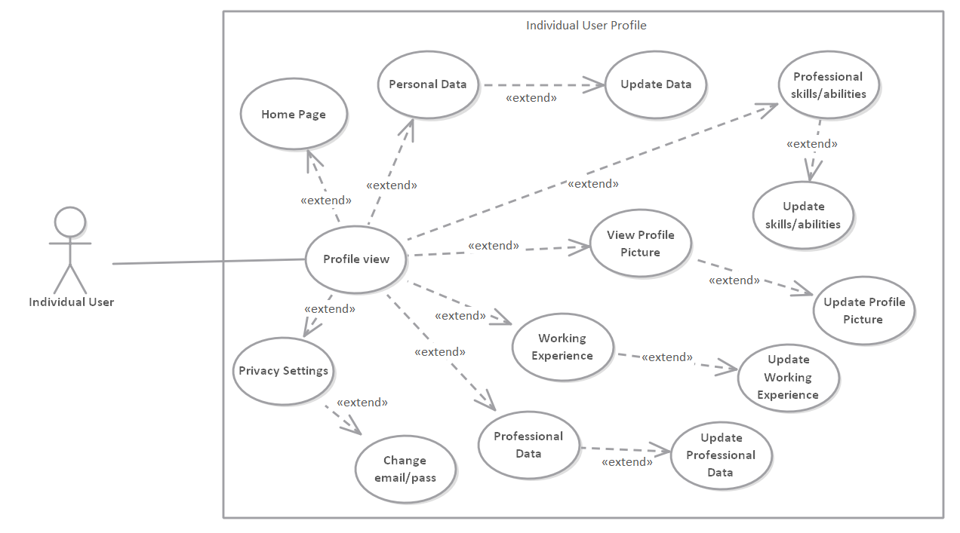

1.2. System admin dashboard

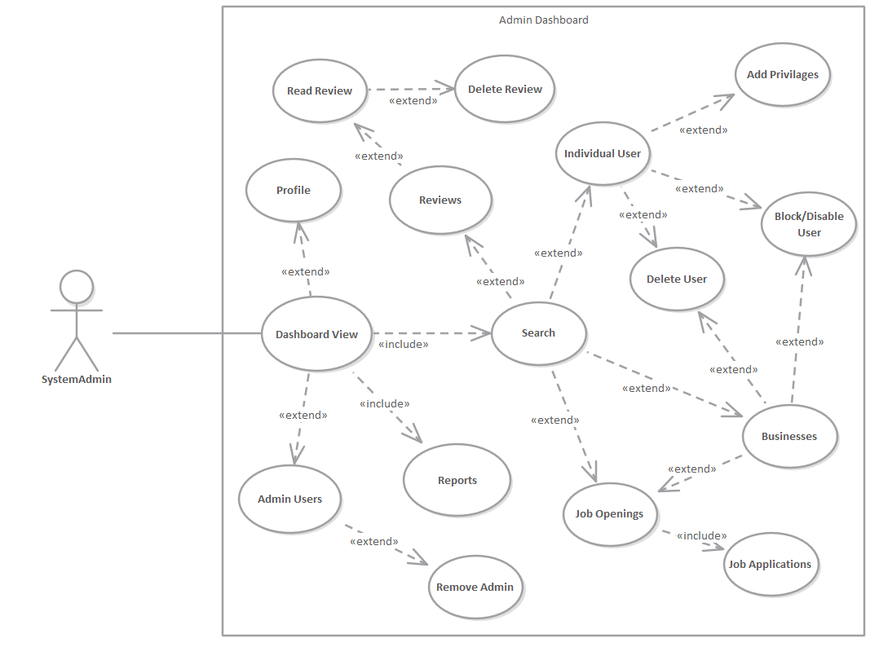

1.3. Individual user home page

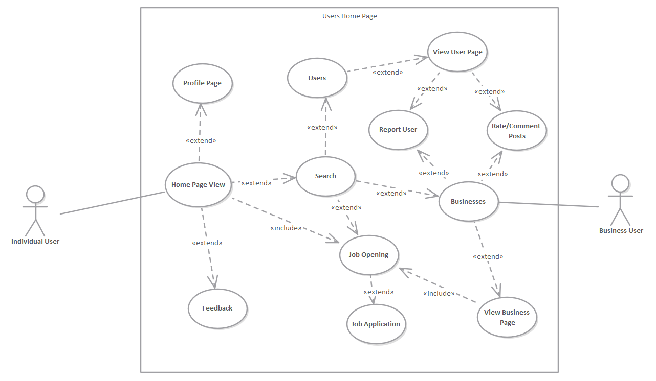

1.4. Business user profile

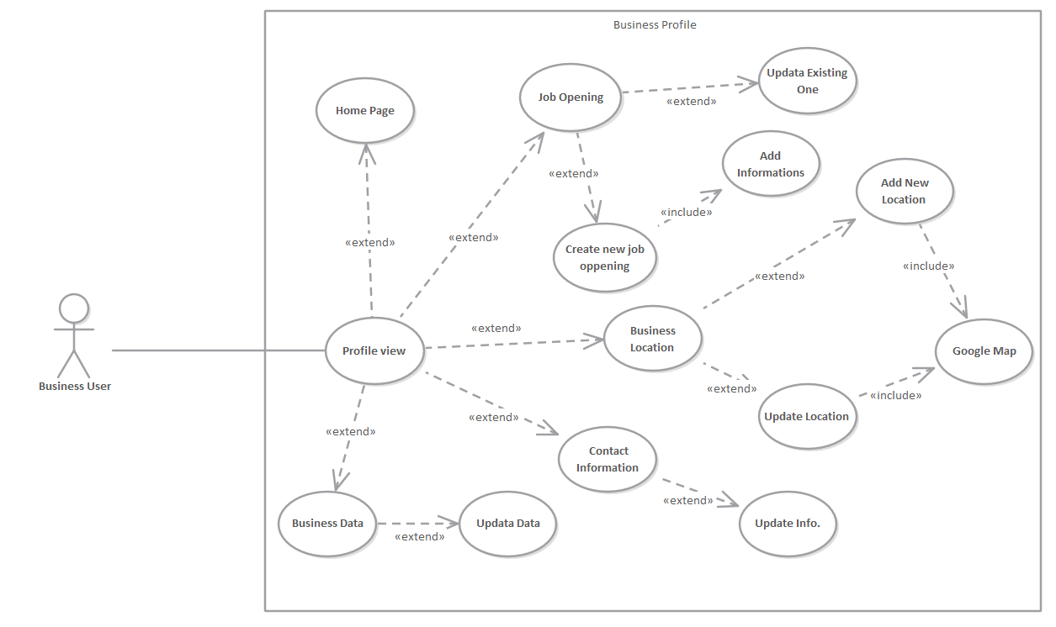

1.5. System authentication for users in general.

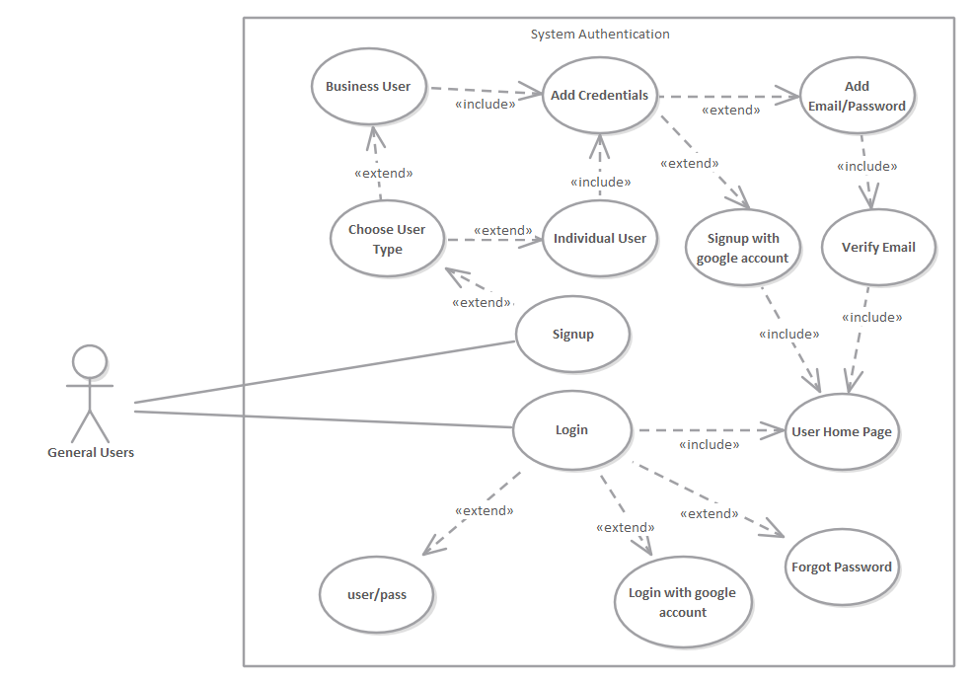

**System constraints**

1. Businesses cannot create job openings with the same title
2. System admins cannot make other businesses admins
3. System admins cannot make businesses as 'critics'
4. System admins cannot make businesses as 'field specialists'
5. Admin users cannot block or delete other admin users
6. Individuals that are 'critics' or 'field specialists' are not allowed to have any other badge
7. Individual users cannot rate and comment businesses that they did not work on
8. Visitor users cannot see other user profiles without creating an account
9. Individuals cannot comment on business images
10. Individuals/Businesses cannot browse the system features without being logged in
11. Users cannot delete rates and comments from their profile
12. Individuals/Businesses cannot visit the login/registration page when logged in
13. Users that don't have admin privileges cannot search blocked users
14. Users cannot create more than one account using the same email
15. Individuals cannot apply on a finished job opening
16. Business users cannot delete job openings that were opened 24 hours ago
17. Blocked users cannot delete their account until their account is unblocked
18. Critic and field specialist users cannot apply for job openings
19. Business users cannot rate and comment on users that didn't work on their company
20. Admins cannot give privileges to other admins

**Module Decomposition**

Module Decomposition describes functions that are included in every service. In the diagram below functions are elaborated by different colours, each color represents a different type of user or system.

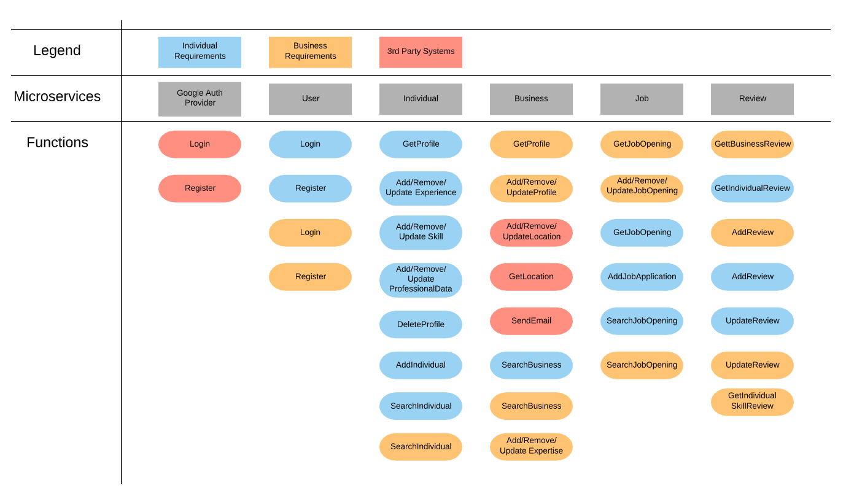

**Class Diagrams**

**Individual-Micro**

Entity package

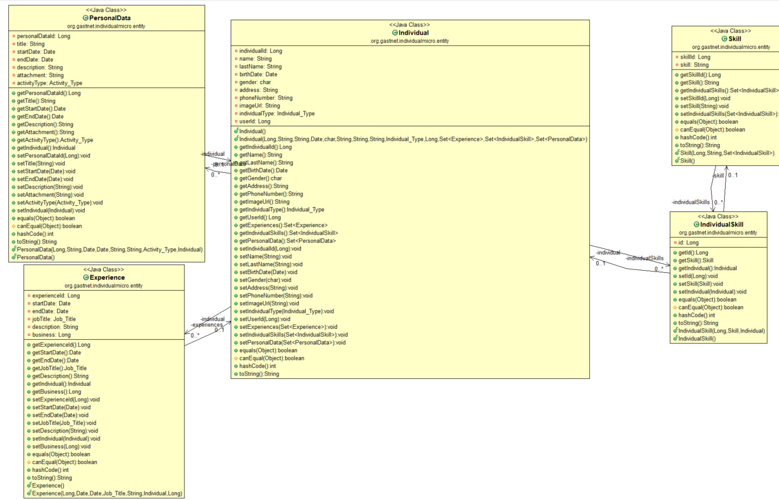

Controller package

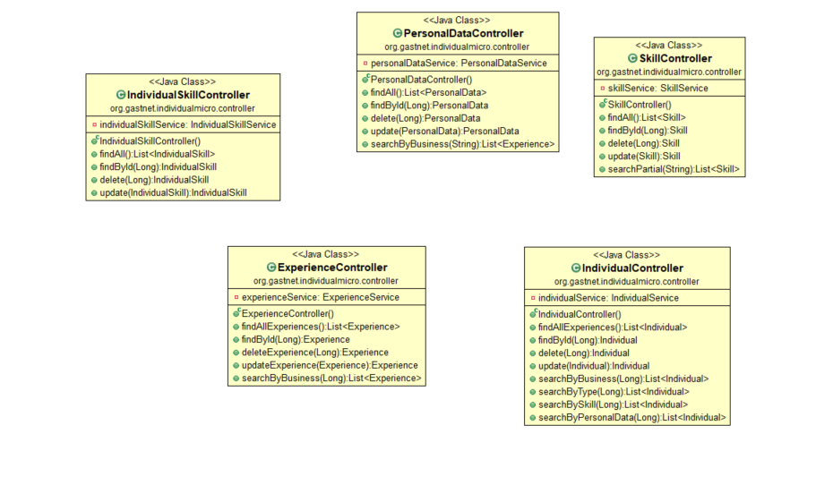

Repository package

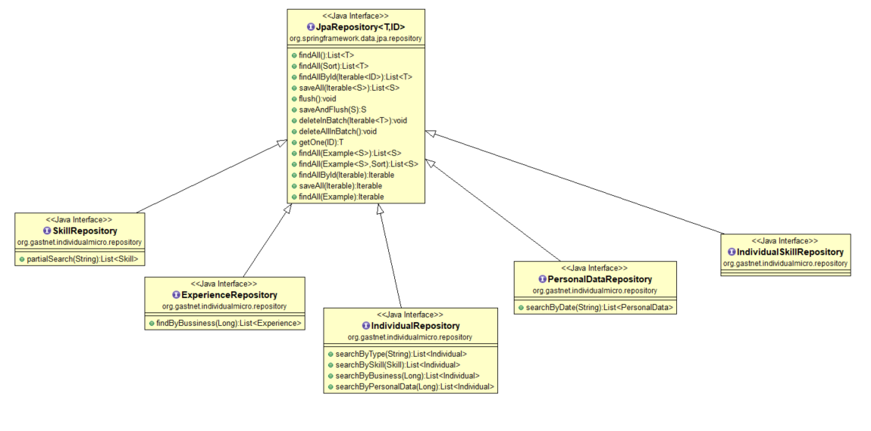

ServiceImpl package

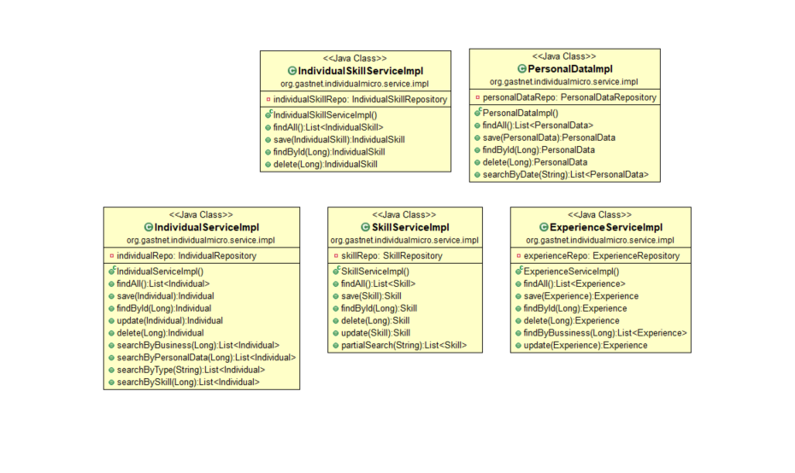

Service package

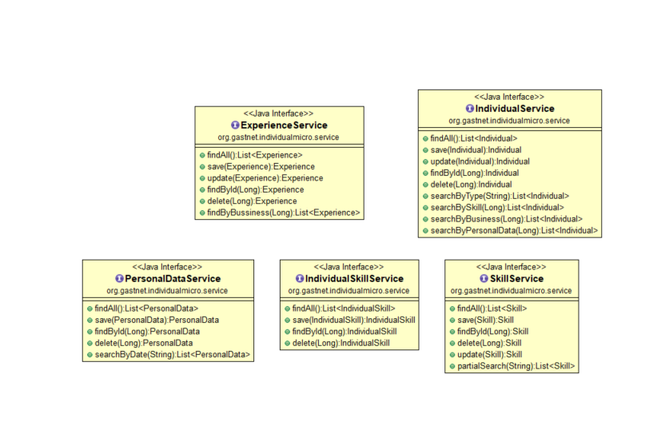

**User Micro**

Entity package

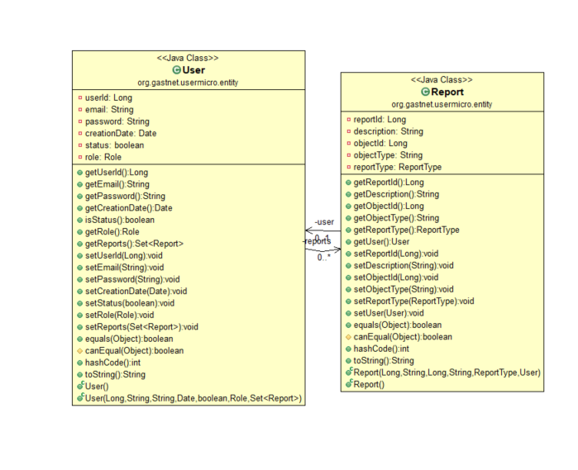

Controller package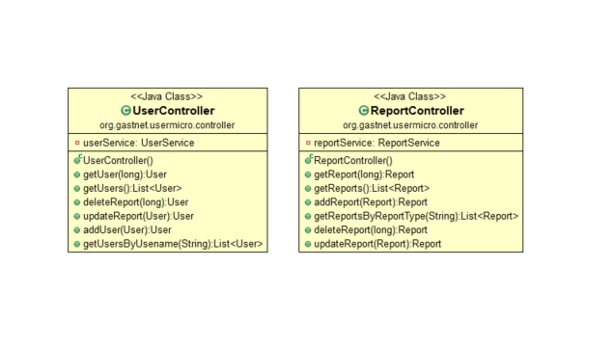

Repository package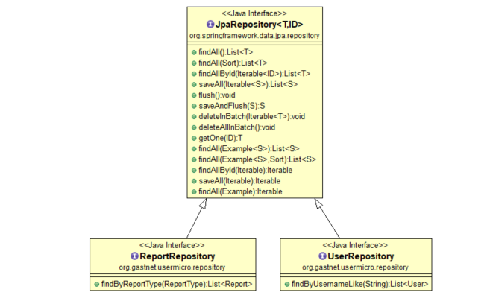

ServiceImpl package

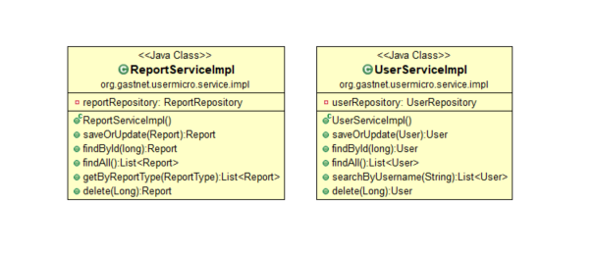

Service package

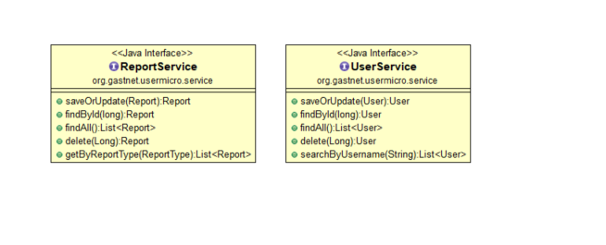

**Job Micro**

Entity package

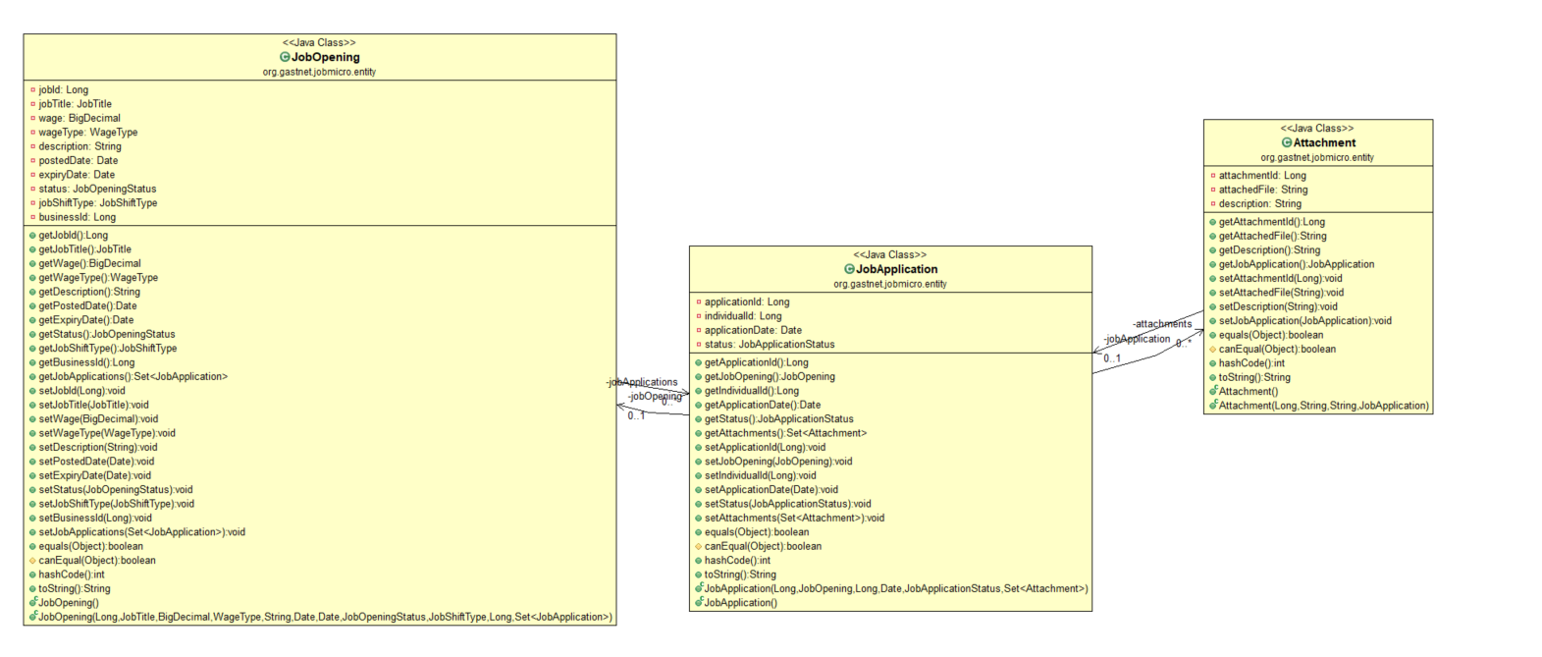

Controller package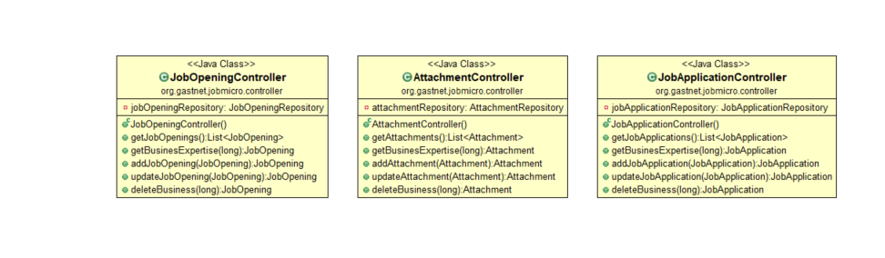

Repository package

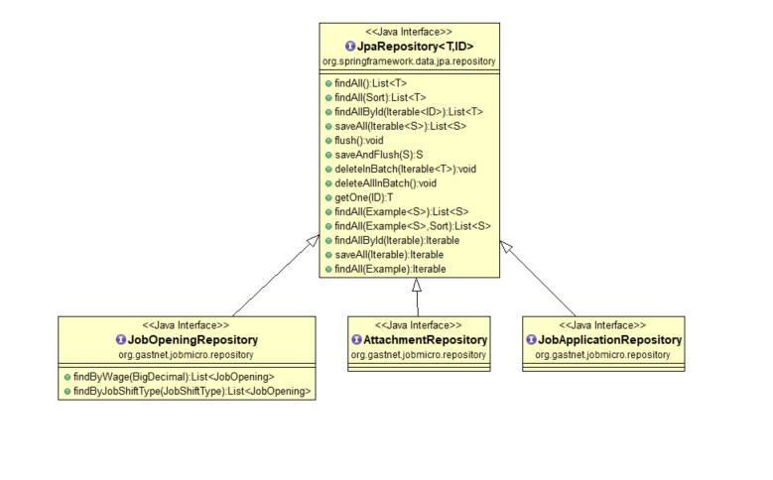

Service Impl Package

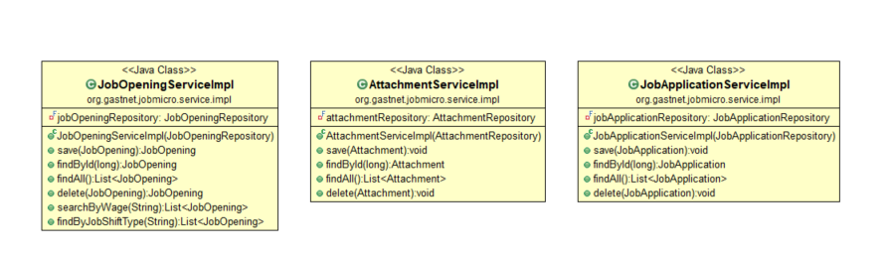

Service Package

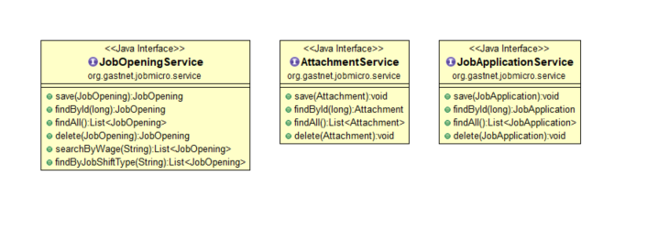

**Business Micro**

Entity package

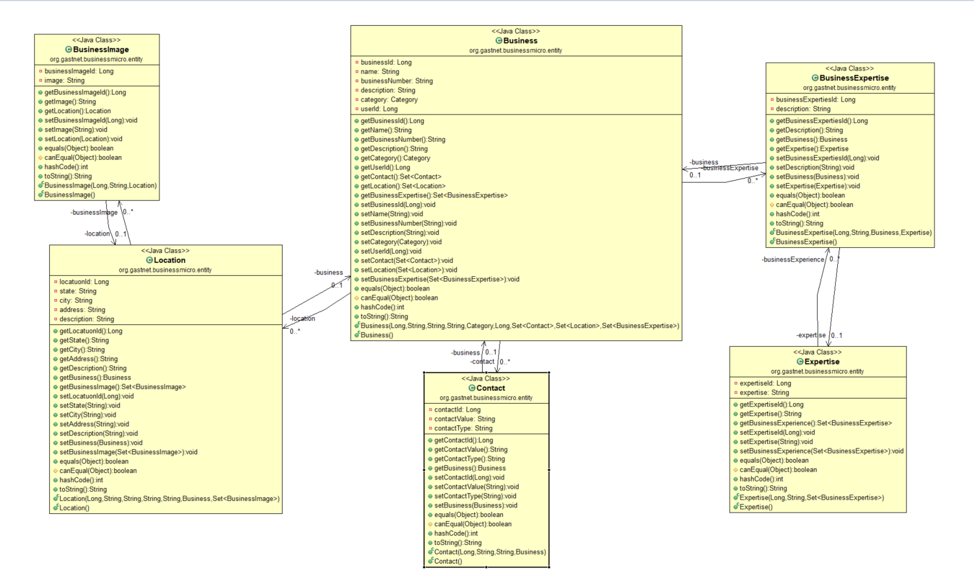

Controller package

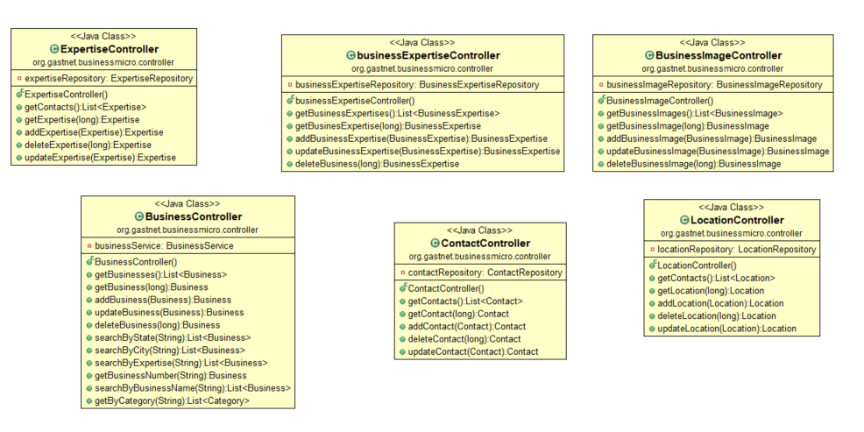

Service package

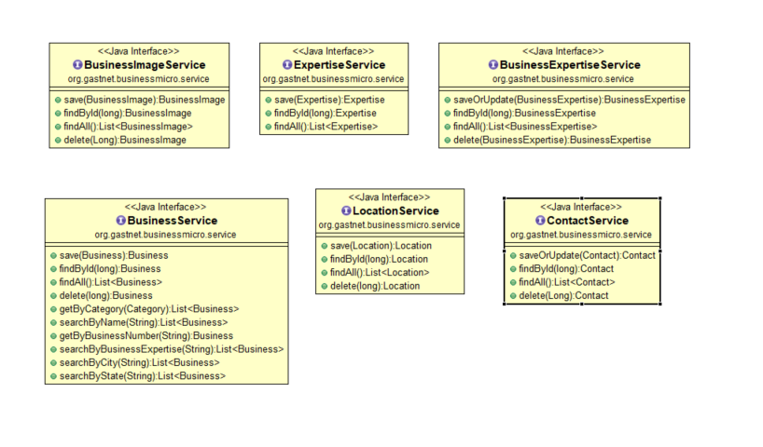

Service Impl package

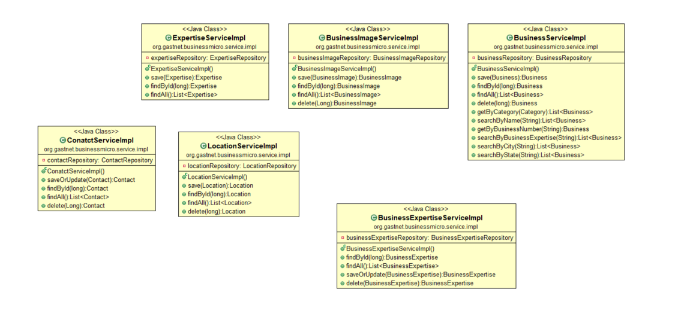

Repository package

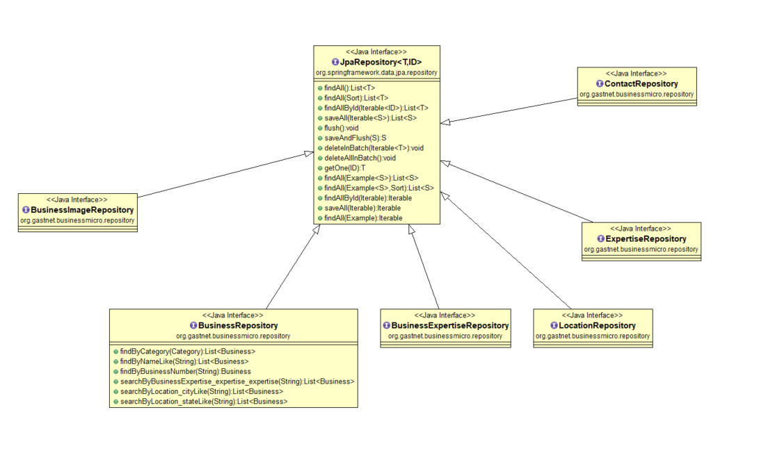

**Review Micro**

Entiry package

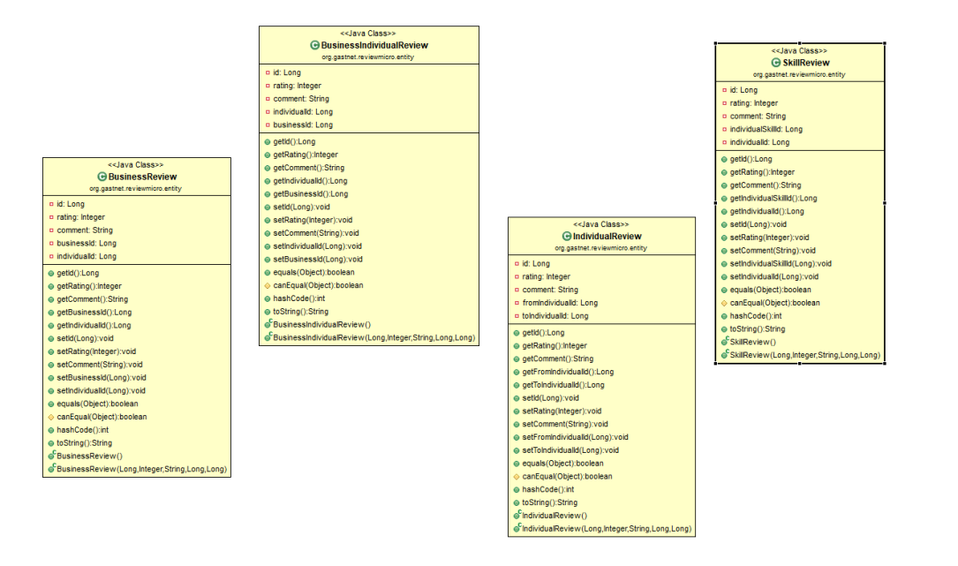

Controller package

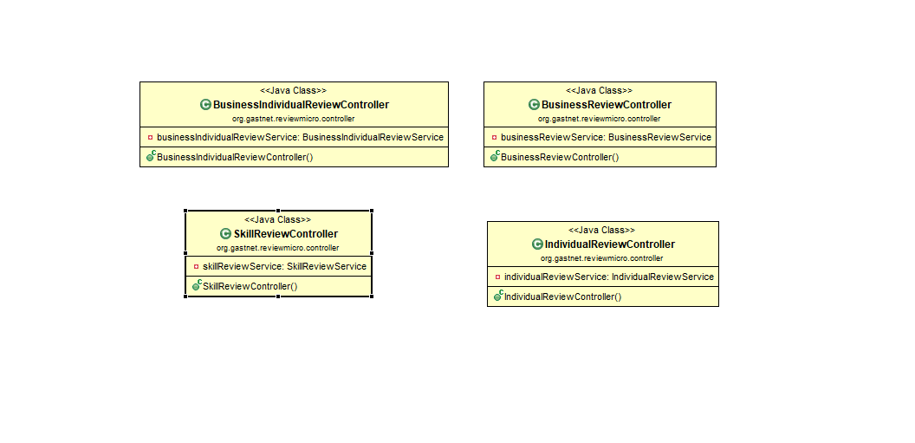

Service package

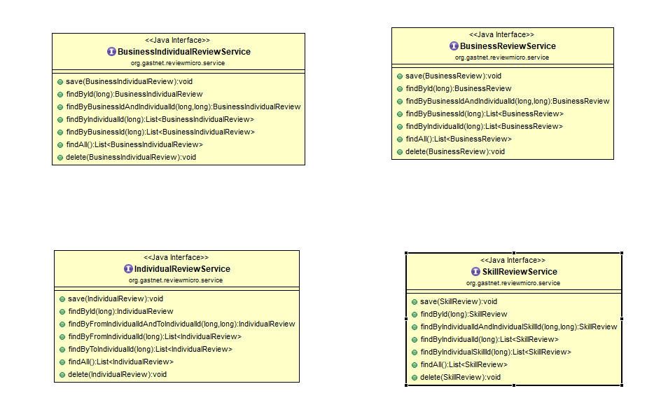

Service Impl package

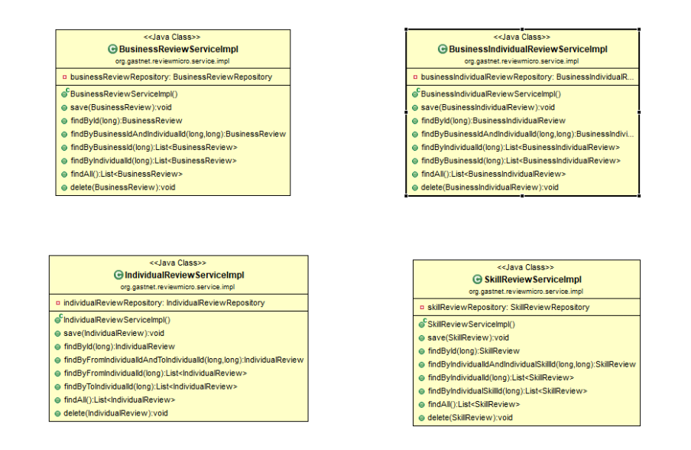

Repository package

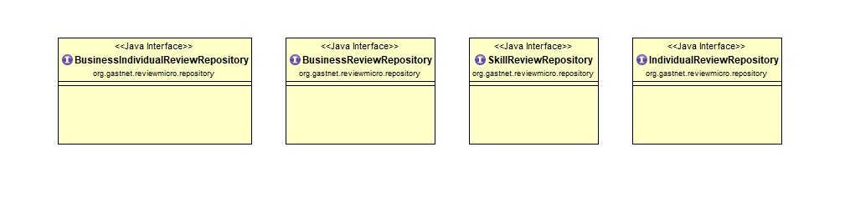

**ER-Diagrams**

1. User micro er-diagram

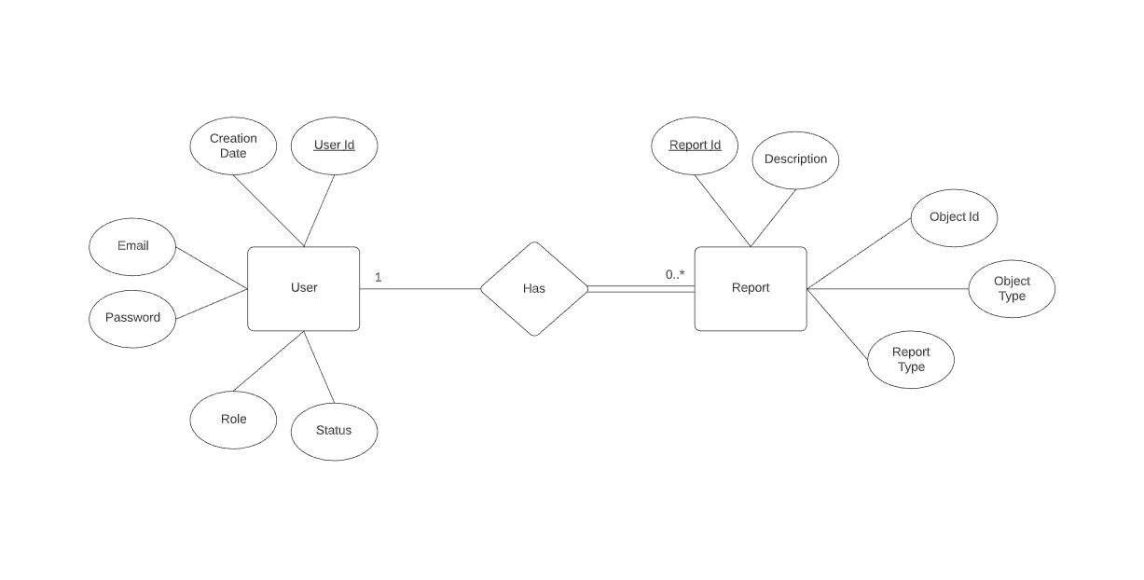

2. Individual micro er-diagram

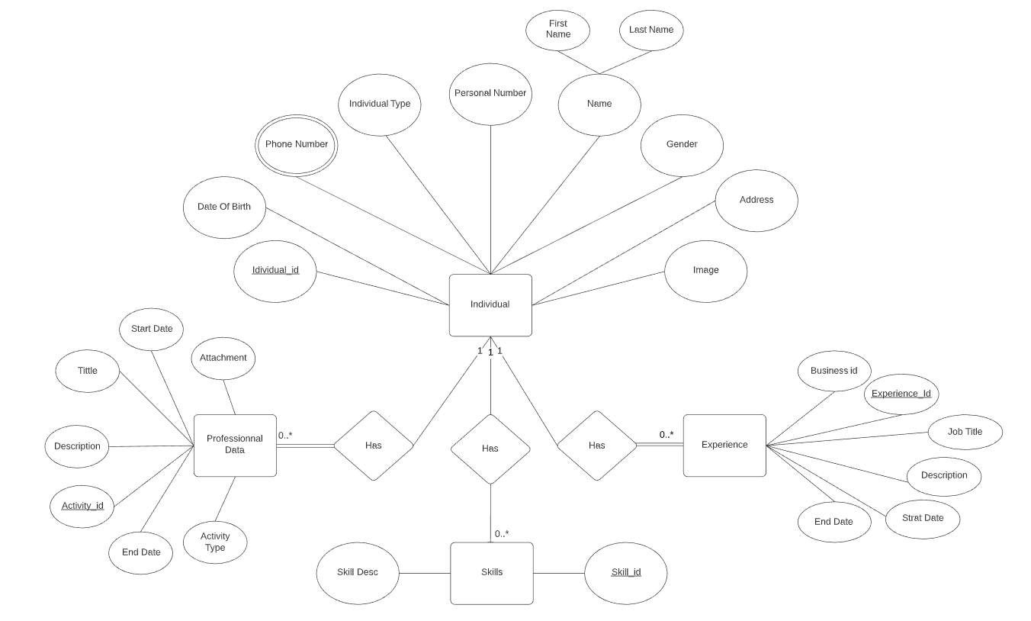

3. Business micro er-diagram

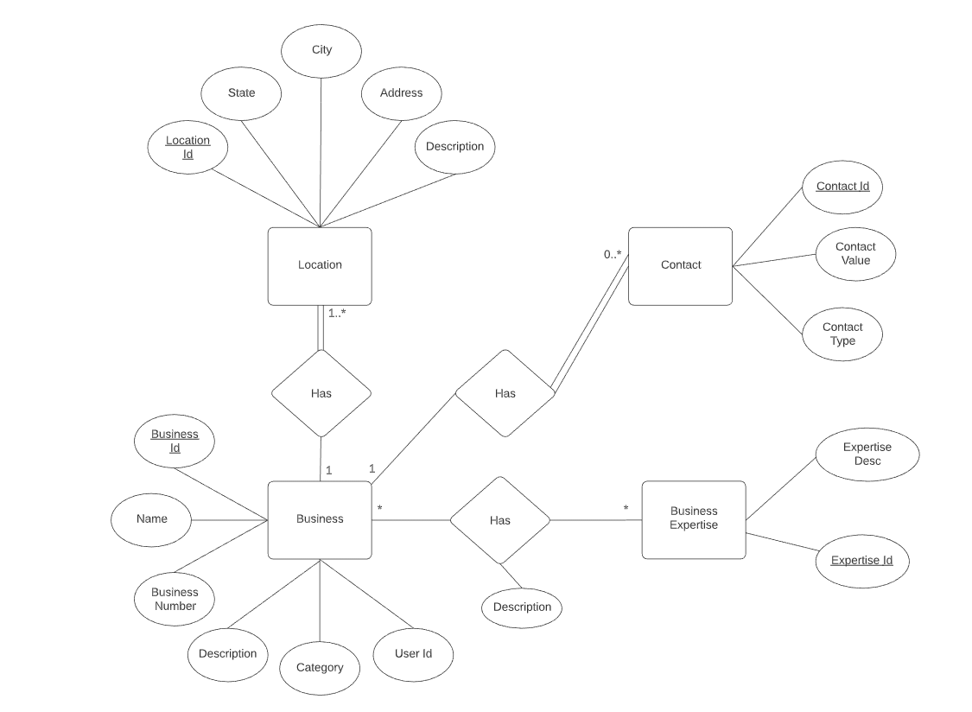

4. JobOpening micro er-diagram

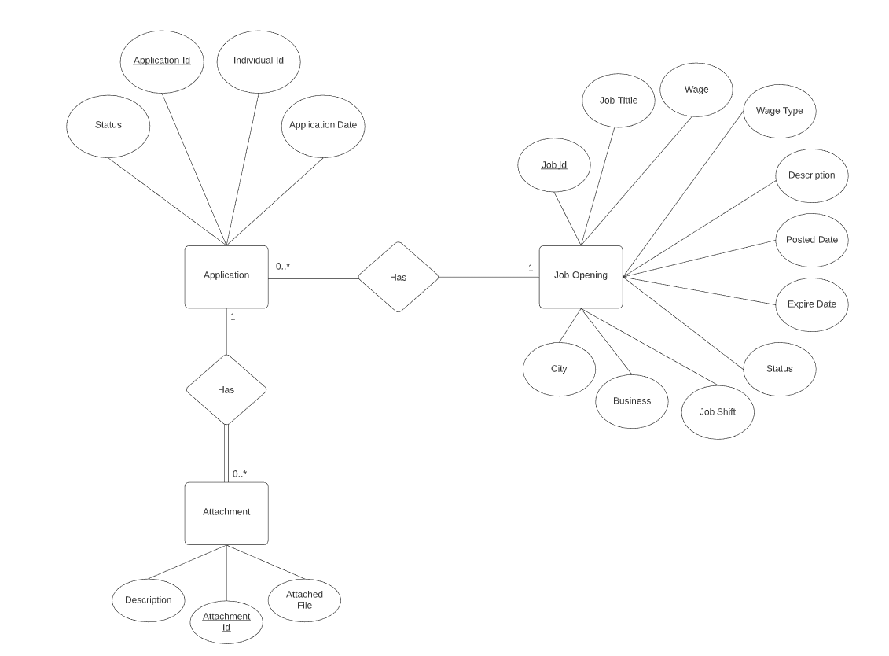

5. Review micro er-diagram

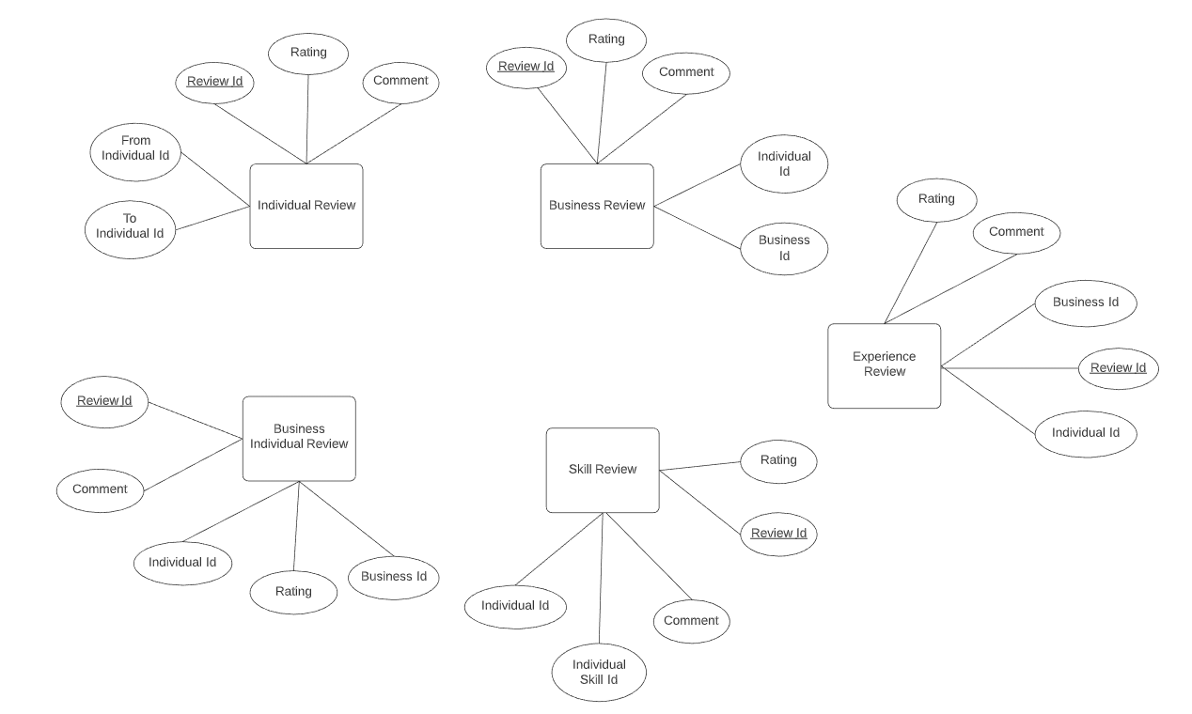

**GUI Design**

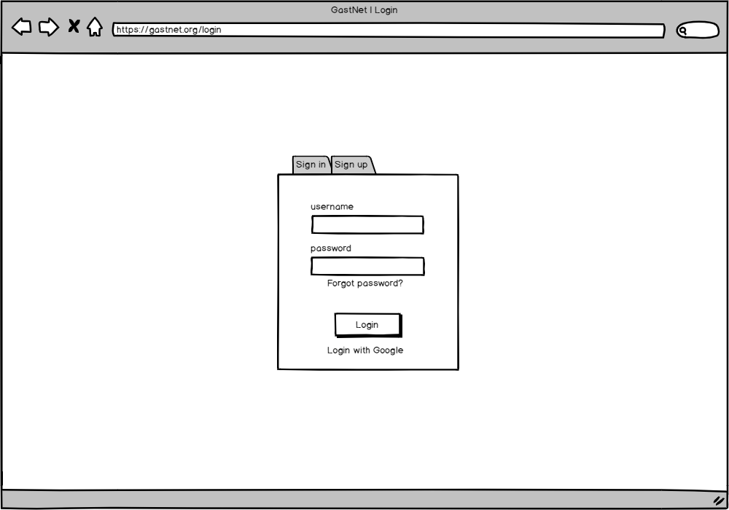

1. GastNet Login Page

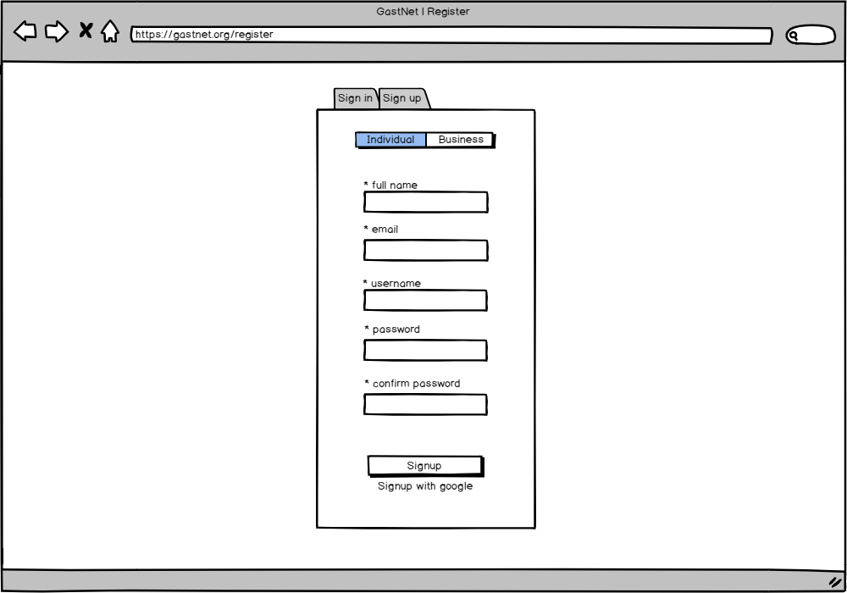

2. GastNet Signup Page

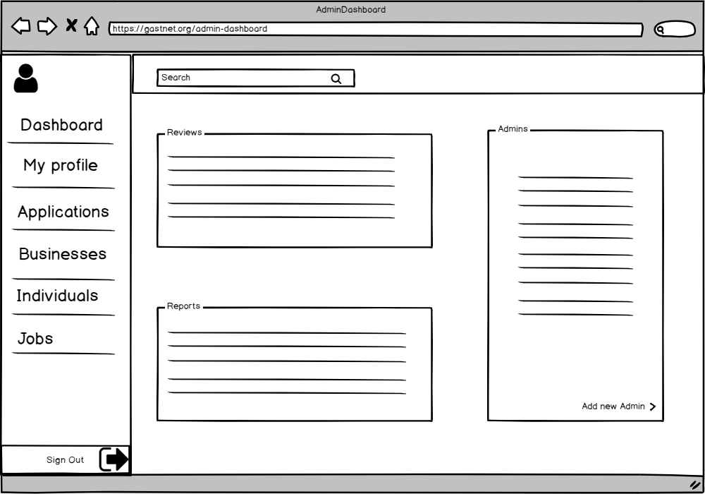

3. GastNet Admin Dashboard Page

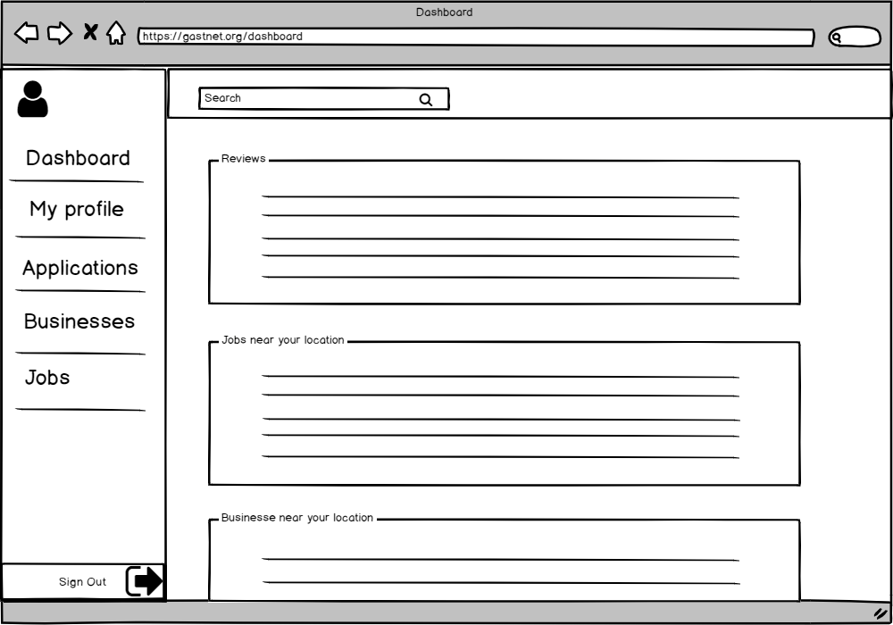

4. GastNet Dashboard Page

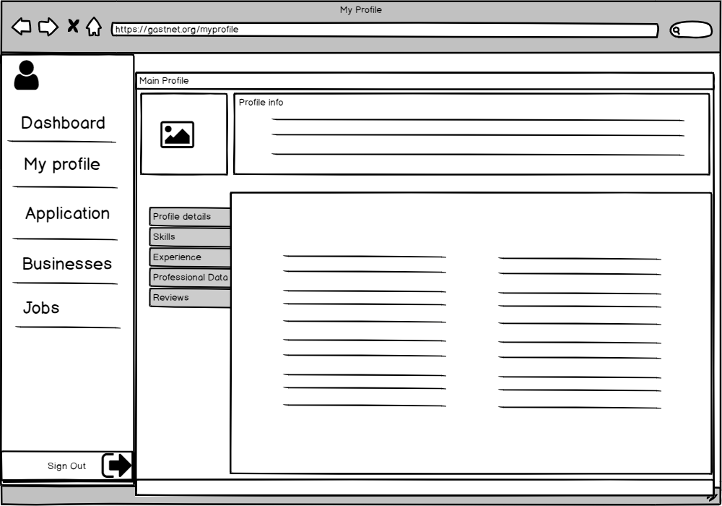

4. GastNet Individuals Profile Page

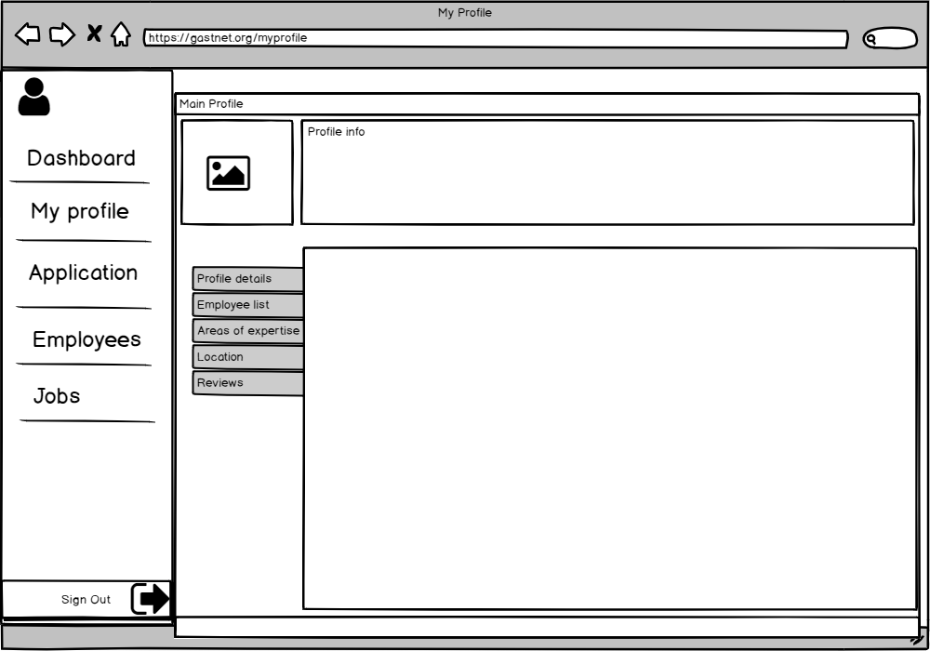

5. GastNet Business Profile Page

**Conceptual Architecture Design**

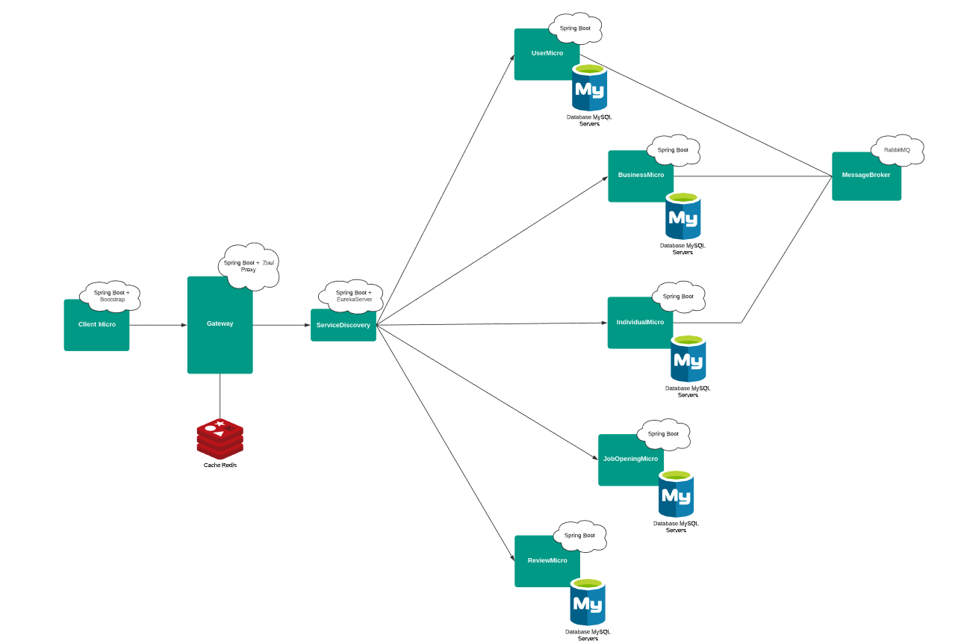

GastNet Conceptual Architecture Diagram

Module Association

Interface specification

|  |  |  |
| --- | --- | --- |
| **Interface** | **Syntax:** | List<Business> findByCategory(Category category); |
| **Pre:** | Input cannot be null  The Category object has to be created preliminarily |
| **Post:** | Returns a list of Businesses with a specific category  Returns null if there isn’t any of them |

|  |  |  |
| --- | --- | --- |
| **Interface** | **Syntax:** | List<Business> findByName(String name); |
| **Pre:** | Input cannot be null |
| **Post:** | Returns a list of businesses that correspond to that name  Returns null if there isn’t any of them |

|  |  |  |
| --- | --- | --- |
| **Interface** | **Syntax:** | Bisiness findByBusinessNumber(String businessNumber); |
| **Pre:** | Input cannot be null |
| **Post:** | Returns a businesses that correspond to that number  Returns null if the business doesn’t exists |

|  |  |  |
| --- | --- | --- |
| **Interface** | **Syntax:** | List<Business> searchByBusinessExpertise(Expertise expertise); |
| **Pre:** | Input cannot be null  The Expertise object has to be created preliminarily |
| **Post:** | Returns a list of businesses that correspond to that expertise  Returns null if there isn’t any of them |

|  |  |  |
| --- | --- | --- |
| **Interface** | **Syntax:** | List<Business> searchByLocation_cityLike(String city); |
| **Pre:** | Input cannot be null |
| **Post:** | Returns a list of businesses that correspond to that location  Returns null if there isn’t any of them |

|  |  |  |
| --- | --- | --- |
| **Interface** | **Syntax:** | List<Business> searchByLocation_stateLike(String state); |
| **Pre:** | Input cannot be null |
| **Post:** | Returns a list of businesses that correspond to that location  Returns null if there isn’t any of them |

|  |  |  |
| --- | --- | --- |
| **Interface** | **Syntax:** | BusinessExpertise findById(long businessExpertiseId); |
| **Pre:** | Input cannot be null  Input should be long |
| **Post:** | Returns a business expertise that correspond to that id  Returns null if business expertise doesn’t exists |

|  |  |  |
| --- | --- | --- |
| **Interface** | **Syntax:** | List<BusinessExpertise> findAll(); |
| **Pre:** | - |
| **Post:** | Returns a list of all business expertise from database  Returns null if there isn’t any of them |

|  |  |  |
| --- | --- | --- |
| **Interface** | **Syntax:** | BusinessExpertise delete(BusinessExpertise businessExpertise); |
| **Pre:** | Input cannot be null  The BusinessExpertise object has to be created preliminarily |
| **Post:** | Returns the business expertise that is already deleted  Returns null if business expertise doesn’t exists |

|  |  |  |
| --- | --- | --- |
| **Interface** | **Syntax:** | BusinessExpertise saveOrUpdate(BusinessExpertise businessExpertise); |
| **Pre:** | Input cannot be null |
| **Post:** | Returns the business expertise that is already created |

|  |  |  |
| --- | --- | --- |
| **Interface** | **Syntax:** | BusinessImage saveOrUpdate (BusinessImage businessImage); |
| **Pre:** | Input can be null |
| **Post:** | Returns the business image that is already saved/updated |

|  |  |  |
| --- | --- | --- |
| **Interface** | **Syntax:** | BusinessImage findById(Long businessImageId); |
| **Pre:** | Input cannot be null  Input should be long |
| **Post:** | Returns a business image that corresponds to that id  Returns null if there isn’t any business image with that id |

|  |  |  |
| --- | --- | --- |
| **Interface** | **Syntax:** | List<BusinessImage> findAll(); |
| **Pre:** | - |
| **Post:** | Returns a list of all business images from database  Returns null if there isn’t any of them |

|  |  |  |
| --- | --- | --- |
| **Interface** | **Syntax:** | BusinessImage delete(Long businessImageId); |
| **Pre:** | Input cannot be null  Input should be long  The BusinessImage object has to be created preliminarily |
| **Post:** | Returns the business image that is already deleted  Returns null if business image doesn’t exists |

|  |  |  |
| --- | --- | --- |
| **Interface** | **Syntax:** | Business saveOrUpdate(Business business); |
| **Pre:** | Input cannot be null  The Business object should be unique |
| **Post:** | Returns the business that is already saved |

|  |  |  |
| --- | --- | --- |
| **Interface** | **Syntax:** | Business findById(long businessId); |
| **Pre:** | Input cannot be null  Input should be long |
| **Post:** | Returns a business image that corresponds to that id  Returns null if there isn’t any business image with that id |

|  |  |  |
| --- | --- | --- |
| **Interface** | **Syntax:** | List<Business> findAll(); |
| **Pre:** | - |
| **Post:** | Returns a list of all business from database  Returns null if there isn’t any of them |

|  |  |  |
| --- | --- | --- |
| **Interface** | **Syntax:** | Business delete(long businessId); |
| **Pre:** | Input cannot be null  Input should be long  The Business object has to be created preliminarily |
| **Post:** | Returns the business that is already deleted  Returns null if business doesn’t exists |

|  |  |  |
| --- | --- | --- |
| **Interface** | **Syntax:** | List<Business> getBusinessByCategory(Category category); |
| **Pre:** | Input cannot be null  The Category object has to be created preliminarily |
| **Post:** | Returns a list of all business that correspond to that category  Returns null if there isn’t any of them |

|  |  |  |
| --- | --- | --- |
| **Interface** | **Syntax:** | List<Business> searchByName(String name); |
| **Pre:** | Input cannot be null |
| **Post:** | Returns a list of all business that correspond to that name  Returns null if there isn’t any of them |

|  |  |  |
| --- | --- | --- |
| **Interface** | **Syntax:** | Business getByBusinessNumeber(String businessNumber); |
| **Pre:** | Input cannot be null |
| **Post:** | Returns a businesses that correspond to that number  Returns null if the business doesn’t exists |

|  |  |  |
| --- | --- | --- |
| **Interface** | **Syntax:** | List<Business> searchByCity(String city); |
| **Pre:** | Input cannot be null |
| **Post:** | Returns a list of businesses that correspond to that location  Returns null if there isn’t any of them |

|  |  |  |
| --- | --- | --- |
| **Interface** | **Syntax:** | List<Business> searchByState(String state); |
| **Pre:** | Input cannot be null |
| **Post:** | Returns a list of businesses that correspond to that location  Returns null if there isn’t any of them |

|  |  |  |
| --- | --- | --- |
| **Interface** | **Syntax:** | Contact saveOrUpdate(Contact contact); |
| **Pre:** | Input cannot be null |
| **Post:** | Returns the contact that is already saved/updated |

|  |  |  |
| --- | --- | --- |
| **Interface** | **Syntax:** | Contact findById(long contactId); |
| **Pre:** | Input cannot be null  Input should be long |
| **Post:** | Returns a contact that corresponds to that id  Returns null if there isn’t any contact with that id |

|  |  |  |
| --- | --- | --- |
| **Interface** | **Syntax:** | List<Contact> findAll(); |
| **Pre:** | - |
| **Post:** | Returns a list of all contacts from database  Returns null if there isn’t any of them |

|  |  |  |
| --- | --- | --- |
| **Interface** | **Syntax:** | Contact delete(Long contactId) |
| **Pre:** | Input cannot be null  Input should be long  The Contact object has to be created preliminarily |
| **Post:** | Returns the contact that is already deleted  Returns null if contact doesn’t exists |

|  |  |  |
| --- | --- | --- |
| **Interface** | **Syntax:** | Expertise saveOrUpdate(Expertise expertise); |
| **Pre:** | Input cannot be null |
| **Post:** | Returns the expertise that is already saved/updated |

|  |  |  |
| --- | --- | --- |
| **Interface** | **Syntax:** | Expertise findById(long expertiseId); |
| **Pre:** | Input cannot be null  Input should be long |
| **Post:** | Returns a expertise that corresponds to that id  Returns null if there isn’t any expertise with that id |

|  |  |  |
| --- | --- | --- |
| **Interface** | **Syntax:** | List<Expertise> findAll(); |
| **Pre:** | - |
| **Post:** | Returns a list of all expertise from database  Returns null if there isn’t any of them |

|  |  |  |
| --- | --- | --- |
| **Interface** | **Syntax:** | Expertise delete(long expertiseId); |
| **Pre:** | Input cannot be null  Input should be long  The Expertise object has to be created preliminarily |
| **Post:** | Returns the expertise that is already deleted  Returns null if contact doesn’t exists |

|  |  |  |
| --- | --- | --- |
| **Interface** | **Syntax:** | Location saveOrUpdate(Location location); |
| **Pre:** | Input cannot be null |
| **Post:** | Returns the location that is already saved/updated |

|  |  |  |
| --- | --- | --- |
| **Interface** | **Syntax:** | Location findById(long locationId); |
| **Pre:** | Input cannot be null  Input should be long |
| **Post:** | Returns a location that corresponds to that id  Returns null if there isn’t any location with that id |

|  |  |  |
| --- | --- | --- |
| **Interface** | **Syntax:** | List<Location> findAll(); |
| **Pre:** | - |
| **Post:** | Returns a list of all location from database  Returns null if there isn’t any of them |

|  |  |  |
| --- | --- | --- |
| **Interface** | **Syntax:** | Location delete(long locationId); |
| **Pre:** | Input cannot be null  Input should be long  The Location object has to be created preliminarily |
| **Post:** | Returns the location that is already deleted  Returns null if contact doesn’t exists |

|  |  |  |
| --- | --- | --- |
| **Interface** | **Syntax:** | public JobOpening get(@PathVariable Long id) |
| **Pre:** | Id must not be null, and must be greater than 0 |
| **Post:** | returns the JobOpening with the particular id  returns empty response if JobOpening doesn’t exist  returns empty response if precondition is violated |

|  |  |  |
| --- | --- | --- |
| **Interface** | **Syntax:** | public Response* create(@RequestBody jobOpening) |
| **Pre:** | job opening json format must be valid |
| **Post:** | returns success message if job opening was saved successfully  return failure message if job opening could not be saved or precondition was violated |

|  |  |  |
| --- | --- | --- |
| **Interface** | **Syntax:** | public Response* update(@RequestBody jobOpening) |
| **Pre:** | job opening format must be valid and job opening must exist |
| **Post:** | returns success message if job opening was saved successfully  return failure message if job opening could not be updated or precondition was violated |

|  |  |  |
| --- | --- | --- |
| **Interface** | **Syntax:** | public List<JobOpening> getList(  @RequestParam(required=false) String title, @RequestParam(required=false) WageType wageType, @RequestParam(required=false) BigDecimal minWage, @RequestParam(required=false) BigDecimal maxWage,  @RequestParam(required=false) Date postedDate,  @RequestParam(required=false) Date expiryDate,  @RequestParam(required=false) JobOpeningStatus status,  @RequestParam(required=false) JobShiftType shiftType,  @RequestParam(required=false) Long businessId,  @RequestParam(required=true) Long page) |
| **Pre:** | page parameter must be present |
| **Post:** | returns the lastest 200 job openings if no parameters were sent  returns 200 filtered job openings based on the sent parameters  returns empty list of job openings if no job openings exist |

|  |  |  |
| --- | --- | --- |
| **Interface** | **Syntax:** | public Response* delete(@PathVariable Long id) |
| **Pre:** | Id must not be null, and must be greater than 0 |
| **Post:** | returns success message if job opening was deleted successfully  return failure message if job opening could not be deleted or precondition was violated |

|  |  |  |
| --- | --- | --- |
| **Interface** | **Syntax:** | public Response* changeStatus(@PathVariable Long id,  @RequestParam JobOpeningStatus status) |
| **Pre:** | Id must not be null, and must be greater than 0  status must be one of the acceptable statuses |
| **Post:** | returns success message if job opening status was changed successfully  return failure message if job opening status could not be changed or precondition was violated |

|  |  |  |
| --- | --- | --- |
| **Interface** | **Syntax:** | public JobApplication get(@PathVariable Long jobApplicationId) |
| **Pre:** | jobApplicationId must not be null, and must be greater than 0 |
| **Post:** | returns one job application if it exists  post: returns empty response if job application does not exist |

|  |  |  |
| --- | --- | --- |
| **Interface** | **Syntax:** | public Response* create(@PathVariable Long jobOpeningId, @RequestBody JobApplication jobApplication) |
| **Pre:** | jobOpeningIdmust not be null, and must be greater than 0  jobApplication json format must be valid |
| **Post:** | returns success message if job opening was saved successfully  return failure message if job opening could not be saved or precondition was violated |

|  |  |  |
| --- | --- | --- |
| **Interface** | **Syntax:** | public Response* update(@PathVariable Long jobOpeningId, @RequestBody JobApplication jobApplication) |
| **Pre:** | JobOpeningId must not be null, and must be greater than 0  jobApplication json format must be valid and job application must exist |
| **Post:** | returns success message if job opening was updated successfully  return failure message if job opening could not be updated or precondition was violated |

|  |  |  |
| --- | --- | --- |
| **Interface** | **Syntax:** | public Response* delete(@PathVariable Long jobApplicationId) |
| **Pre:** | JobApplicationId must not be null, and must be greater than 0  job application must exist |
| **Post:** | returns success message if job opening was deleted successfully  return failure message if job opening could not be deleted or precondition was violated |

|  |  |  |
| --- | --- | --- |
| **Interface** | **Syntax:** | public List<JobApplication> getAll() |
| **Pre:** |  |
| **Post:** | returns all the job applications of the logged in user  return empty list if there are no job applications for the logged in user |

|  |  |  |
| --- | --- | --- |
| **Interface** | **Syntax:** | public List<JobApplication> getByJobOpening(@PathVariable Long jobOpeningId) |
| **Pre:** | JobApplicationId must not be null, and must be greater than 0 |
| **Post:** | returns all the job applications of the specified job opening  return empty list if there are no job applications for the specified job opening |

|  |  |  |
| --- | --- | --- |
| **Interface** | **Syntax:** | public User getUser(@PathVariable long id) |
| **Pre:** | Id cannot be null |
| **Post:** | Returns the User with that particular id  Returns null if the User doesn’t exist  Rost: returns null if precondition is violated |

|  |  |  |
| --- | --- | --- |
| **Interface** | **Syntax:** | public List<User> getUsers() |
| **Pre:** | none |
| **Post:** | returns all the users on the database  returns null if there are no users on the database |

|  |  |  |
| --- | --- | --- |
| **Interface** | **Syntax:** | public User deleteUser(@PathVariable long id) |
| **Pre:** | Id must be greater or equal to zero |
| **Post:** | Deletes and returns the User with that particular id  Returns null if the User doesn’t exist  Returns null if precondition is violated |

|  |  |  |
| --- | --- | --- |
| **Interface** | **Syntax:** | public User addUser(@RequestBody User user) |
| **Pre:** | User cannot be null |
| **Post:** | Adds and returns the User that it accepts  Returns null if precondition is violated |

|  |  |  |
| --- | --- | --- |
| **Interface** | **Syntax:** | public List<User> getUsersByUsename(@PathVariable String username)) |
| **Pre:** | username cannot be null |
| **Post:** | Returns the users that start with the username parameter  Returns null if there are no users that start with that username  Returns null if precondition is violated |

|  |  |  |
| --- | --- | --- |
| **Interface** | **Syntax:** | public List<Report> getReportsByReportType(@PathVariable String reportType) |
| **Pre:** | reportType cannot be null |
| **Post:** | Returns all the reports that are of that particular type  Returns null if there are no reports with that particular type  Returns null if precondition is violated |

|  |  |  |
| --- | --- | --- |
| **Interface** | **Syntax:** | public Report addReport(@RequestBody Report report) |
| **Pre:** | report cannot be null |
| **Post:** | Adds and returns the Report that it accepts  Returns null if precondition is violated |

|  |  |  |
| --- | --- | --- |
| **Interface** | **Syntax:** | public Report deleteReport(@PathVariable long id) |
| **Pre:** | Id should be greater or equals to zero |
| **Post:** | Deletes and returns the Report with that particular id  Returns null if the Report doesn’t exist  Returns null if precondition is violated |

|  |  |  |
| --- | --- | --- |
| **Interface** | **Syntax:** | public List<Report> getReports() |
| **Pre:** | none |
| **Post:** | Returns all the Reports that are on the database  Returns null if there are no Reports on the database |

|  |  |  |
| --- | --- | --- |
| **Interface** | **Syntax:** | public Report getReport(@PathVariable long id) |
| **Pre:** | Id should be greater or equals to zero |
| **Post:** | Returns the Report with that particular id  Returns null if the Report doesn’t exist  Returns null if precondition is violated |

|  |  |  |
| --- | --- | --- |
| **Interface** | **Syntax:** | public List<Experience> searchByBusiness(@PathVariable long id) |
| **Pre:** | Id must be greater or equal to zero |
| **Post:** | Returns the Experience data that corresponds to that particular id  Returns null if the Business with that id doesn't exist  Returns null if precondition is violated |

|  |  |  |
| --- | --- | --- |
| **Interface** | **Syntax:** | public Experience add(@PathVariable Experience experience ) |
| **Pre:** | experience cannot be null |
| **Post:** | Returns the Experience after it is saved and evaluated from save() method in ExperienceServiceImpl  Returns null if precondition is violated |

|  |  |  |
| --- | --- | --- |
| **Interface** | **Syntax:** | public Experience findById(@PathVariable long id) |
| **Pre:** | Id must be greater or equal to zero |
| **Post:** | Returns the Experience data with that id  Returns null if the data doesn't exist  Returns null if precondition is violated |

|  |  |  |
| --- | --- | --- |
| **Interface** | **Syntax:** | public List<Individual> getAllIndividuals() |
| **Pre:** | none |
| **Post:** | Returns list with all the individuals in db  Returns null if there is no records of individuals in db |

|  |  |  |
| --- | --- | --- |
| **Interface** | **Syntax:** | public List<Individual> searchByBusiness(@PathVariable long id) |
| **Pre:** | Id must be greater or equal to zero |
| **Post:** | Returns the individuals that have that business id  Returns null if the Business with that id does not exist  Returns null if precondition is violated |

|  |  |  |
| --- | --- | --- |
| **Interface** | **Syntax:** | public Individuals getIndividual(@PathVariable long individualId) |
| **Pre:** | individualId must be greater or equal to zero |
| **Post:** | Retrims the individual with that id  Returns null if the Individual doesn’t exist  Returns null if precondition is violated |

|  |  |  |
| --- | --- | --- |
| **Interface** | **Syntax:** | public PersonalData update(@RequestBody PersonalData personalData) |
| **Pre:** | personalData cannot be null |
| **Post:** | Updates and returns the personalData it accepts  Returns null if personalData is null |

|  |  |  |
| --- | --- | --- |
| **Interface** | **Syntax:** | public List<PersonalData> findAll() |
| **Pre:** | none |
| **Post:** | Returns list with all the PersonalData in the  database  Returns null if there is no records of PersonalData in the database |

|  |  |  |
| --- | --- | --- |
| **Interface** | **Syntax:** | public PersonalData findById(@PathVariable long id) |
| **Pre:** | individualId must be greater or equal to zero |
| **Post:** | Returns PersonalData object that corresponds to that id  Returns null if the data doesn’t exist  Returns null if precondition is violated |

|  |  |  |
| --- | --- | --- |
| **Interface** | **Syntax:** | public List<Skill> searchPartial(@PathVariable String search) |
| **Pre:** | search parameter cannot be null |
| **Post:** | Returns the skill data that contains partially that string  Returns null if the records don’t exist  Returns null if precondition is violated |

**Method specification**

|  |  |
| --- | --- |
| **Signature** | public List<Business> getAllBusinesses(); |
| **Class** | BusinessController |
| **Description** | Returns all business stored in the database |
| **Behavior** | pre: -  post: list with all the business in db  post: null if there is no business in db |

|  |  |
| --- | --- |
| **Signature** | public Business getBusiness(@PathVariable long businessId); |
| **Class** | BusinessController |
| **Description** | Returns the Business that corresponds to that id |
| **Behavior** | pre: (id >= 1)  post: returns the business with that id  post: returns null if the business doesn’t exist  post: returns null if precondition is violated |

|  |  |
| --- | --- |
| **Signature** | public Business saveUpdateBusiness(@RequestParam Business business); |
| **Class** | BusinessController |
| **Description** | Returns the response from method save() from BusinessServiceImpl class and accepts as input a user after it is formatted from json format |
| **Behavior** | pre: (business != null)  post: returns the business after it is saved and evaluated from save() method in BusinessServiceImpl  post: returns null if precondition is violated |

|  |  |
| --- | --- |
| **Signature** | public Business deleteBusiness(@PathVariable long businessId); |
| **Class** | BusinessController |
| **Description** | Deletes the business which id corresponds to and returns it |
| **Behavior** | pre: (id >= 0)  post: returns the EvidenceData with that particular id  post: returns null if the EvidenceData doesn’t exist  post: returns null if precondition is violated |

|  |  |
| --- | --- |
| **Signature** | public List<Business> serachByState(@Path Variable String state) |
| **Class** | BusinessController |
| **Description** | Returns a list of businesses which location corresponds with given parameter |
| **Behavior** | pre: (state != null)  post: returns a list of Business that are near to specific location  post: returns null if there is no Business near to that location  post: returns null if precondition is violated |

|  |  |
| --- | --- |
| **Signature** | public List<Business> searchByCity(@PathVariable String city); |
| **Class** | BusinessController |
| **Description** | Returns a list of businesses which location corresponds with given parameter |
| **Behavior** | pre: (city != null)  post: returns a list of Business that are near to specific location  post: returns null if there is no Business near to that location  post: returns null if precondition is violated |

|  |  |
| --- | --- |
| **Signature** | public List<Business> searchByExpertise(@PathVariable String expertise); |
| **Class** | BusinessController |
| **Description** | Returns a list of businesses which expertise corresponds with given parameter |
| **Behavior** | pre: (expertise != null)  post: returns a list of Businesses that correspond with given parameters  post: returns null if there is no Business that correspond to given parameters  post: returns null if precondition is violated |

|  |  |
| --- | --- |
| **Signature** | public Business getBusinessNumber(@PathVAriable String businessNumber) |
| **Class** | BusinessController |
| **Description** | Returns the business which number corresponds with given parameter |
| **Behavior** | pre: (businessNumber != null)  post: returns the Business that correspond with given parameters  post: returns null if there is no Business that corresponds to given parameters  post: returns null if precondition is violated |

|  |  |
| --- | --- |
| **Signature** | public List<Business> searchByBusinessName(@PathVariable String name); |
| **Class** | BusinessController |
| **Description** | Returns a list of businesses which name corresponds with given parameter |
| **Behavior** | pre: (name != null)  post: returns a list of Businesses that correspond with given parameters  post: returns null if there is no Business that corresponds to given parameters  post: returns null if precondition is violated |

|  |  |
| --- | --- |
| **Signature** | public List<Business> getByCategory(@Path Varable String category); |
| **Class** | BusinessController |
| **Description** | Returns a list of businesses which categories corresponds with given parameter |
| **Behavior** | pre: (category != null)  post: returns a list of Businesses that correspond with given parameters  post: returns null if there is no Business that corresponds to given parameters  post: returns null if precondition is violated |

|  |  |
| --- | --- |
| **Signature** | public List<BusinessImage> getBusinessImage(); |
| **Class** | BusinessImageController |
| **Description** | Returns a list of all business images that exists in database |
| **Behavior** | pre: -  post: returns a list of Business images  post: returns null if the is no Business images |

|  |  |
| --- | --- |
| **Signature** | public BusinessImage getBusinessImageById(@PathVariable long businessImageId); |
| **Class** | BusinessImageController |
| **Description** | Returns a specific business image from database |
| **Behavior** | pre: (businessImageId != null)  post: returns a business image which id correspond with given parameters  post: returns null if there is no Business image id that corresponds to given parameters  post: returns null if precondition is violated |

|  |  |
| --- | --- |
| **Signature** | public BusinessImage addUpdateBusinessImage(@RequestParam BusinessImage businessImage); |
| **Class** | BusinessImageController |
| **Description** | Returns a specific business image that is already added or updated |
| **Behavior** | pre: (businessImage != null)  post: returns a business image  post: returns null if precondition is violated |

|  |  |
| --- | --- |
| **Signature** | public BusinessExpertise updateBusinessExpertise(@RequestParam BusinessExpertise businessExpertise) |
| **Class** | BusinessExpertiseController |
| **Description** | Updates a specific business expertise |
| **Behavior** | pre: (businessExpertise != null)  post: returns the businessExpertise that is already updated  post: returns null if precondition is violated |

|  |  |
| --- | --- |
| **Signature** | public BusinessImage deleteBusinessImgae(@PathVariable long businessImageId); |
| **Class** | BusinessImageController |
| **Description** | Deletes specific business image |
| **Behavior** | pre: (businessImageId != null)  post: returns the business image that is already deleted  post: returns null if precondition is violated |

|  |  |
| --- | --- |
| **Signature** | public List<Contact> getContact(); |
| **Class** | ContactController |
| **Description** | Returns all contact from database |
| **Behavior** | pre: -  post: returns a list of all contacts  post: returns null if there is no contact in database  post: returns null if precondition is violated |

|  |  |
| --- | --- |
| **Signature** | public Contact getContact(@Path Variable long contactId); |
| **Class** | ContactController |
| **Description** | Returns a specific contact from database |
| **Behavior** | pre: (contactId > 0)  post: returns a specific contact which id corresponds to given parameter  post: returns null if there is no contact with that id in database  post: returns null if precondition is violated |

|  |  |
| --- | --- |
| **Signature** | public Contact addContact(@RequestParam Contact contact); |
| **Class** | ContactController |
| **Description** | Return a contact that is already added |
| **Behavior** | pre: (contact != null)  post: returns a specific contact which is already added in the database  post: returns null if precondition is violated |

|  |  |
| --- | --- |
| **Signature** | public Contact deleteContact(@PathVariable long contactId); |
| **Class** | ContactController |
| **Description** | Deletes a specific contact |
| **Behavior** | pre: (contactId > 0)  pre: Contact should exists preliminarily  post: returns a specific contact which is deleted from database  post: returns null if precondition is violated |

|  |  |
| --- | --- |
| **Signature** | public Contact updateContact(@RequestParam Contact contact); |
| **Class** | ContactController |
| **Description** | Updates a specific contact |
| **Behavior** | pre: (contact != null)  pre: Contact should exists preliminarily  post: returns a specific contact which is already updated  post: returns null if precondition is violated |

|  |  |
| --- | --- |
| **Signature** | public List<Expertise> getExpertise(); |
| **Class** | ExpertiseController |
| **Description** | Returns all expertise from database |
| **Behavior** | pre: -  post: returns a list of expertise that exists in database  post: returns null if there is no expertise |

|  |  |
| --- | --- |
| **Signature** | public Expertise getExpertise(@PathVariable long epertiseId); |
| **Class** | ExpertiseController |
| **Description** | Returns a specific espertise |
| **Behavior** | pre: (epertiseId > 0)  post: returns a specific expertise which id corresponds to given parameter  post: returns null if there is no expertise with that id  post: returns null if precondition is violated |

|  |  |
| --- | --- |
| **Signature** | public Expertise addExpertise(@RequestParam Expertise expertise); |
| **Class** | ExpertiseController |
| **Description** | Adds a new expertise in to database |
| **Behavior** | pre: (expertise != null)  post: returns the expertise that is already added in to database  post: returns null if precondition is violated |

|  |  |
| --- | --- |
| **Signature** | public Expertise deleteExpertise(@PathVariable long expertiseId); |
| **Class** | ExpertiseController |
| **Description** | Deletes a specific expertise |
| **Behavior** | pre: (expertiseId > 0)  pre: Expertise should exists in database  post: returns the expertise that is already deleted from database  post: returns null if precondition is violated |

|  |  |
| --- | --- |
| **Signature** | public Expertise updateExpertise(@RequestParam Expertise expertise); |
| **Class** | ExpertiseController |
| **Description** | Updates a specific expertise |
| **Behavior** | pre: (expertise != null)  pre: Expertise should exists in database  post: returns the expertise that is already updated  post: returns null if precondition is violated |

|  |  |
| --- | --- |
| **Signature** | public List<Location> getLocation(); |
| **Class** | LocationControlerr |
| **Description** | Returns business location |
| **Behavior** | pre: -  post: returns a list of business locations |

|  |  |
| --- | --- |
| **Signature** | public Location getLocation(@PathVariable long locationId); |
| **Class** | LocationControlerr |
| **Description** | Returns a specific location |
| **Behavior** | pre: (locationId > 0)  post: returns the a specific business location  post: returns null if precondition is violated |

|  |  |
| --- | --- |
| **Signature** | public Location addLocation(@RequestParam Location location); |
| **Class** | LocationControlerr |
| **Description** | Adds a new business location |
| **Behavior** | pre: (location!= null)  pre: Location should not exists in database  post: returns the location that is already added  post: returns null if precondition is violated |

|  |  |
| --- | --- |
| **Signature** | public Location deleteLocation(@PathVariable long locationId); |
| **Class** | LocationControlerr |
| **Description** | Deletes a specific location |
| **Behavior** | pre: (locationId > 0)  pre: Location should exists in database  post: returns the location that is already deleted  post: returns null if precondition is violated |

|  |  |
| --- | --- |
| **Signature** | public Location updateLocation(@RequestParam Location location); |
| **Class** | LocationControlerr |
| **Description** | Updates a specific location |
| **Behavior** | pre: (location != null)  pre: Location should exists in database  post: returns the location that is already updated  post: returns null if precondition is violated |

|  |  |
| --- | --- |
| **Signature** | Public List<BusinessExpertise> getBusinessExpertise(); |
| **Class** | BusinessExpertiseController |
| **Description** | Returns a list of husinessExpertise |
| **Behavior** | pre: -  post: returns a list of business expertise that exits in database  post: returns null if there is no business expertise in database |

|  |  |
| --- | --- |
| **Signature** | public BusinessExpertise getBusinessExpertise(@PathVarable long businessExpertiseId); |
| **Class** | BusinessExpertiseController |
| **Description** | Returns a specific business expertise |
| **Behavior** | pre: (businessExpertiseId > 0)  post: returns a business expertise which id corresponds to give parameter  post: returns null if there is no business expertise with that in database  post: returns null if precondition is violated |

|  |  |
| --- | --- |
| **Signature** | public BusinessExpertise addBusinessExpertise(@RequestParam BusinessExpertise businessExpertise); |
| **Class** | BusinessExpertiseController |
| **Description** | Adds a specific business expertise |
| **Behavior** | pre: (businessExpertise != null)  post: returns a business expertise which is already added in database  post: returns null if precondition is violated |

|  |  |
| --- | --- |
| **Signature** | public BusinessExpertise updateBusinessExpertise(@RequestParam BusinessExpertise businessExpertise); |
| **Class** | BusinessExpertiseController |
| **Description** | Updates a specific business expertise |
| **Behavior** | pre: (businessExpertise != null)  pre: businessExpertise should exists in database  post: returns a business expertise which is already updated in database  post: returns null if precondition is violated |

|  |  |
| --- | --- |
| **Signature** | public BusinessExpertise deleteBusinessExpertise(@PatVarabale long businessExpertiseId); |
| **Class** | BusinessExpertiseController |
| **Description** | Deletes a specific business expertise |
| **Behavior** | pre: (businessExpertiseId >0)  pre: businessExpertise should exists in database  post: returns a business expertise which is already deleted in database  post: returns a null if there is no business expertise with that id  post: returns null if precondition is violated |

|  |  |
| --- | --- |
| **Signature** | public BusinessExpertise save(BusinessExpertsie businessExpertise); |
| **Class** | BusinessExpertiseServiceImpl |
| **Description** | Saves a specific business expertise |
| **Behavior** | pre: (businessExpertise != null)  post: returns a business expertise which is already added in database  post: returns null if precondition is violated |

|  |  |
| --- | --- |
| **Signature** | public BusinessExpertise findById(long businessExpertiseId); |
| **Class** | BusinessExpertiseServiceImpl |
| **Description** | Returns a specific business expertise |
| **Behavior** | pre: (businessExpertiseId >0 )  post: returns a business expertise which id corresponds with given parameter  post: returns null if there is no business expertise with that id  post: returns null if precondition is violated |

|  |  |
| --- | --- |
| **Signature** | public List<BusinessExpertise> findAll(); |
| **Class** | BusinessExpertiseServiceImpl |
| **Description** | Returns a list of business expertise |
| **Behavior** | pre: -  post: returns a list of business expertise’s that exists in database  post: returns null if there is no business expertise |

|  |  |
| --- | --- |
| **Signature** | public BusinessExpertise saveOrUpdate(BusinessExpertise businessExpertise); |
| **Class** | BusinessExpertiseServiceImpl |
| **Description** | Saves a specific business expertise |
| **Behavior** | pre: (businessExpertise != null)  post: returns a specific business which is already added in database  post: returns null if precondition is violated |

|  |  |
| --- | --- |
| **Signature** | public BusinessExpertise deleteBusinessExpertise (BusinessExpertise businessExpertise); |
| **Class** | BusinessExpertiseServiceImpl |
| **Description** | Deletes a specific business expertise |
| **Behavior** | pre: (businessExpertise != null)  post: returns a specific business which is already deleted from database  post: returns a null if there is no business in database  post: returns null if precondition is violated |

|  |  |
| --- | --- |
| **Signature** | public BusinessImage save(BusinessImage businessImage); |
| **Class** | BusinessImageServiceImpl |
| **Description** | Saves a specifi business image |
| **Behavior** | pre: (businessImage != null)  post: returns a specific business which is already added in database  post: returns null if precondition is violated |

|  |  |
| --- | --- |
| **Signature** | public BusinessImage findById(long businessImageId); |
| **Class** | BusinessImageServiceImpl |
| **Description** | Returns a specific business image |
| **Behavior** | pre: (businessImageId > 0)  post: returns a specific business which id corresponds with given parametrs  post: returns a null if there is no business images in database  post: returns null if precondition is violated |

|  |  |
| --- | --- |
| **Signature** | public List<BusinessImage> findAll(); |
| **Class** | BusinessImageServiceImpl |
| **Description** | Returns a list of business images |
| **Behavior** | pre: -  post: returns a list of business images that exists in database  post: returns a null if there is no business images in database |

|  |  |
| --- | --- |
| **Signature** | public BusinessImage delete(Long businessImagesId); |
| **Class** | BusinessImageServiceImpl |
| **Description** | Deletes a specific business images |
| **Behavior** | pre: (businessImageId > 0)  post: returns a specific business which is already deleted from database  post: returns a null if there is no business images in database  post: returns null if precondition is violated |

|  |  |
| --- | --- |
| **Signature** | public BusinessImage delete(Long businessImagesId); |
| **Class** | BusinessImageServiceImpl |
| **Description** | Deletes a specific business images |
| **Behavior** | pre: (businessImageId > 0)  post: returns a specific business which is already deleted from database  post: returns a null if there is no business images in database  post: returns null if precondition is violated |

|  |  |
| --- | --- |
| **Signature** | public List<Individual> getAllIndividuals(); |
| **Class** | IndividualController |
| **Description** | Returns all individuals stored in the database |
| **Behavior** | pre: none  post: list with all the individuals in db  post: null if there is no records of individuals in db |

|  |  |
| --- | --- |
| **Signature** | public Individual getIndividual(@PathVariable long id); |
| **Class** | IndividualController |
| **Description** | Returns the Individual that corresponds to that id |
| **Behavior** | pre: (id >= 1)  post: returns the user with that id  post: returns null if the user doesn’t exist  post: returns null if precondition is violated |

|  |  |
| --- | --- |
| **Signature** | public Individual addIndividual(@RequestParam Individual individual); |
| **Class** | IndividualController |
| **Description** | Returns the response from method save() from IndividualServiceImpl class and accepts as input a user after it is formatted from json format |
| **Behavior** | pre: (individual != null)  post: returns the user after it is saved and evaluated from save() method in IndividualServiceImpl  post: returns null if precondition user is null |

|  |  |
| --- | --- |
| **Signature** | public Individual update(@RequestParam Individual individual) |
| **Class** | IndividualController |
| **Description** | Returns the Individual corresponding to the id of the individual in the parameter |
| **Behavior** | pre: (individual !=null )  post: returns the Individual with that method input  post: returns null if the Individual doesn’t exist  post: returns null if precondition is violated |

|  |  |
| --- | --- |
| **Signature** | public Individual delete(@PathVariable Long id) |
| **Class** | IndividualController |
| **Description** | Returns the individual data that corresponds to that id |
| **Behavior** | pre: (id >= 1)  post: returns the Individual with that particular id  post: returns null if the Individual doesn’t exist  post: returns null if precondition is violated |

|  |  |
| --- | --- |
| **Signature** | public List<Individual> searchByBusiness(@PathVariable Long id) |
| **Class** | IndividualController |
| **Description** | Returns the Individuals mapped to the data corresponding to the id in the parameters |
| **Behavior** | pre: (id >= 1)  post: returns the Individuals that have that id as  post: returns null if the Business with that id doesn’t exist  post: returns null if precondition is violated |

|  |  |
| --- | --- |
| **Signature** | public List<Individual> searchByType(@PathVariable String type) |
| **Class** | IndividualController |
| **Description** | Returns the Individuals where type corresponds to the String data coming in as input |
| **Behavior** | pre: (type != null)  post: returns the Individuals with that particular type  post: returns null if the Individuals with the type dont exist  post: returns null if precondition is violated |

|  |  |
| --- | --- |
| **Signature** | public List<Individual> searchBySkill(@PathVariable Long id) |
| **Class** | IndividualController |
| **Description** | Returns the Individual data that corresponds to that skillid |
| **Behavior** | pre: (id >= 1)  post: returns the Individuals with that particular skillid  post: returns null if the Individual/s dont exist  post: returns null if precondition is violated |

|  |  |
| --- | --- |
| **Signature** | public List<Individual> searchByPersonalData(@PathVariable Long personalDataId) |
| **Class** | IndividualController |
| **Description** | Returns the Individual/s that correspond to that personalDataId |
| **Behavior** | pre: (personalDataId >= 1)  post: returns the Individual/s with that particular personalDataId  post: returns null if the Individual/s doesn’t exist  post: returns null if precondition is violated |

|  |  |
| --- | --- |
| **Signature** | public List<Individual> findAll() |
| **Class** | IndividualServiceImpl |
| **Description** | Returns all Individual records coming from the invokation of method findAll() of the IndividualRepository |
| **Behavior** | pre: none  post: list with all the individuals in db  post: null if there is no records of individuals in db |

|  |  |
| --- | --- |
| **Signature** | public Individual save(Individual individual) |
| **Class** | IndividualServiceImpl |
| **Description** | Returns Individual coming from the invocation of method save() of the IndividualRepository |
| **Behavior** | pre: (individual !=null)  post: An Individual record from db  post: null if there is no records of this individual in db |

|  |  |
| --- | --- |
| **Signature** | public Individual findById(Long id) |
| **Class** | IndividualServiceImpl |
| **Description** | Returns Individual coming from the invocation of method findById() of the IndividualRepository |
| **Behavior** | pre: (id >= 1)  post: An Individual corresponding with that id  post: null if theres no Individual with that id  post: null if precondition is violated |

|  |  |
| --- | --- |
| **Signature** | public Individual update(Individual individual) |
| **Class** | IndividualServiceImpl |
| **Description** | Returns Individual coming from the invocation of method update() of the IndividualRepository |
| **Behavior** | pre: (individual != null)  post: An Individual corresponding with the method input  post: null if the Individual doesn't exist  post: null if precondition is violated |

|  |  |
| --- | --- |
| **Signature** | public Individual delete(Long id) |
| **Class** | IndividualServiceImpl |
| **Description** | Returns Individual coming from the invocation of method delete() of the IndividualRepository |
| **Behavior** | pre: (id >= 1)  post: An Individual corresponding with that id  post: null if theres no Individual with that id  post: null if precondition is violated |

|  |  |
| --- | --- |
| **Signature** | public List<Individual> searchByPersonalData(Long data) |
| **Class** | IndividualServiceImpl |
| **Description** | Returns Individuals coming from the invocation of method searchByPersonalData(Long id)of the IndividualRepository s |
| **Behavior** | pre: (data >= 1)  post: returns the Individual/s with that particular personalDataId  post: returns null if the Individual/s doesn’t exist  post: returns null if precondition is violated |

|  |  |
| --- | --- |
| **Signature** | public List<Individual> searchByBusiness(Long id) |
| **Class** | IndividualServiceImpl |
| **Description** | Returns Individuals coming from the invocation of method searchByBusiness(Long id)of the IndividualRepository s |
| **Behavior** | pre: (id >= 0)  post: returns the Individuals that have that id  post: returns null if the Business with that id doesn’t exist  post: returns null if precondition is violated |

|  |  |
| --- | --- |
| **Signature** | public List<Individual> searchByBusiness(Long id) |
| **Class** | IndividualServiceImpl |
| **Description** | Returns Individuals coming from the invocation of method searchByBusiness(Long id)of the IndividualRepository |
| **Behavior** | pre: (id >= 1)  post: returns the Individuals that have that id  post: returns null if the Business with that id doesn’t exist  post: returns null if precondition is violated |

|  |  |
| --- | --- |
| **Signature** | public List<Individual> searchBySkill(Long id) |
| **Class** | IndividualServiceImpl |
| **Description** | Returns Individuals coming from the invocation of method searchBySkill(Long id)of the IndividualRepository |
| **Behavior** | pre: (id >= 1)  post: returns the Individuals with that particular skillid  post: returns null if the Individual/s dont exist  post: returns null if precondition is violated |

|  |  |
| --- | --- |
| **Signature** | public List<Experience> findAllExperiences() |
| **Class** | ExperienceController |
| **Description** | Returns all Experience data stored in the database |
| **Behavior** | pre: none  post: list with all the Experience records in db  post: null if there is no records of Experience in db |

|  |  |
| --- | --- |
| **Signature** | public Experience findById(@PathVariable Long id) |
| **Class** | ExperienceController |
| **Description** | Returns the Experience data that corresponds to that id |
| **Behavior** | pre: (id >= 1)  post: returns the Experience data with that id  post: returns null if the data doesn’t exist  post: returns null if precondition is violated |

|  |  |
| --- | --- |
| **Signature** | public Experience add(@RequestParam Experience experience); |
| **Class** | ExperienceController |
| **Description** | Returns the response from method save() from ExperienceServiceImpl class and accepts as input a Experience object after it is formatted from json format |
| **Behavior** | pre: (experience != null)  post: returns the Experience after it is saved and evaluated from save() method in ExperienceServiceImpl  post: returns null if precondition user is null |

|  |  |
| --- | --- |
| **Signature** | public Experience updateExperience(@RequestBody Experience experience) |
| **Class** | ExperienceController |
| **Description** | Returns the Experience corresponding to the id of the Experience data in the parameter |
| **Behavior** | pre: (experience !=null)  post: returns the Experience with that method input  post: returns null if the data doesn’t exist  post: returns null if precondition is violated |

|  |  |
| --- | --- |
| **Signature** | public Experience deleteExperience(@PathVariable Long id) |
| **Class** | ExperienceController |
| **Description** | Returns the Experience data that corresponds to that id |
| **Behavior** | pre: (id >= 1)  post: returns the Experience with that particular id  post: returns null if the data doesn’t exist  post: returns null if precondition is violated |

|  |  |
| --- | --- |
| **Signature** | public List<Experience > searchByBusiness(@PathVariable Long id) |
| **Class** | ExperienceController |
| **Description** | Returns the Experience data mapped to the data corresponding to the id in the parameters |
| **Behavior** | pre: (id >= 1)  post: returns the Experience data that have that id  post: returns null if the Business with that id doesn’t exist  post: returns null if precondition is violated |

|  |  |
| --- | --- |
| **Signature** | public List<Experience> findAll() |
| **Class** | ExperienceServiceImpl |
| **Description** | Returns all Experience records coming from the invocation of method findAll() of the ExperienceRepository |
| **Behavior** | pre: none  post: list with all the Experience data in db  post: null if there is no records of individuals in db |

|  |  |
| --- | --- |
| **Signature** | public Experience save(Experience experience) |
| **Class** | Experience ServiceImpl |
| **Description** | Returns Experience data coming from the invocation of method save() of the ExperienceRepository |
| **Behavior** | pre: (experience !=null)  post: An Experience record from db  post: null if there is no records in db |

|  |  |
| --- | --- |
| **Signature** | public Experience findById(Long id) |
| **Class** | Experience ServiceImpl |
| **Description** | Returns Experience data coming from the invocation of method findById() of the ExperienceRepository |
| **Behavior** | pre: (id >= 1)  post: An Experience corresponding with that id  post: null if theres no Experience with that id  post: null if precondition is violated |

|  |  |
| --- | --- |
| **Signature** | public Experience update(Experience experience) |
| **Class** | Experience ServiceImpl |
| **Description** | Returns Experience coming from the invocation of method update() of the ExperienceRepository |
| **Behavior** | pre: (experience != null)  post: An Experience corresponding with the method input  post: null if the Experience doesn't exist  post: null if precondition is violated |

|  |  |
| --- | --- |
| **Signature** | public Experience delete(Long id) |
| **Class** | Experience ServiceImpl |
| **Description** | Returns Experience coming from the invocation of method delete() of the ExperienceRepository |
| **Behavior** | pre: (id >= 1)  post: An Experience data corresponding with that id  post: null if theres no Experience data with that id  post: null if precondition is violated |

|  |  |
| --- | --- |
| **Signature** | public List<Skill> findAll() |
| **Class** | SkillController |
| **Description** | Returns all Skill data stored in the database |
| **Behavior** | pre: none  post: list with all the Skill records in db  post: null if there is no records of Skill in db |

|  |  |
| --- | --- |
| **Signature** | public Skill findById(@PathVariable Long id) |
| **Class** | SkillController |
| **Description** | Returns the Skill data that corresponds to that id |
| **Behavior** | pre: (id >= 1)  post: returns the Skill data with that id  post: returns null if the data doesn’t exist  post: returns null if precondition is violated |

|  |  |
| --- | --- |
| **Signature** | public Skill add(@RequestParam Skill skill); |
| **Class** | Skill Controller |
| **Description** | Returns the response from method save() from ExperienceServiceImpl class and accepts as input a Experience object after it is formatted from json format |
| **Behavior** | pre: (skill != null)  post: returns the Skill after it is saved and evaluated from save() method in SkillServiceImpl  post: returns null if precondition user is null |

|  |  |
| --- | --- |
| **Signature** | public Skill update(@RequestBody Skill skill ) |
| **Class** | SkillController |
| **Description** | Returns the Skill corresponding to the id of the Skill data in the parameter |
| **Behavior** | pre: (id >= 0)  post: returns the Skill with that particular id  post: returns null if the data doesn’t exist  post: returns null if precondition is violated |

|  |  |
| --- | --- |
| **Signature** | public Skilldelete(@PathVariable Long id) |
| **Class** | SkillController |
| **Description** | Returns the Skill data that corresponds to that id |
| **Behavior** | pre: (id >= 1)  post: returns the Skillwith that particular id  post: returns null if the data doesn’t exist  post: returns null if precondition is violated |

|  |  |
| --- | --- |
| **Signature** | public List<Skill> searchPartial(@PathVariable String search) |
| **Class** | SkillController |
| **Description** | Returns the Skill records containing partialy that string input |
| **Behavior** | pre: (search !=null )  post: returns the Skill data that contains partialy that id  post: returns null if the records dont exists  post: returns null if precondition is violated |

|  |  |
| --- | --- |
| **Signature** | public List<Skill> findAll() |
| **Class** | SkillServiceImpl |
| **Description** | Returns Skill data coming from the invocation of method save() of the SkillRepository |
| **Behavior** | pre: none  post: All Skill records from db  post: null if there is no records in db |

|  |  |
| --- | --- |
| **Signature** | public Skill findById(Long id) |
| **Class** | SkillServiceImpl |
| **Description** | Returns Skilldata coming from the invocation of method findById() of the SkillRepository |
| **Behavior** | pre: (id >= 1)  post: A Skill corresponding with that id  post: null if theres no Skill with that id  post: null if precondition is violated |

|  |  |
| --- | --- |
| **Signature** | public Skill update(Skill skill) |
| **Class** | SkillServiceImpl |
| **Description** | Returns Experience coming from the invocation of method update() of the SkillRepository |
| **Behavior** | pre: (skill != null)  post: An Skill corresponding with the method input  post: null if the Skilldoesn't exist  post: null if precondition is violated |

|  |  |
| --- | --- |
| **Signature** | public Skill delete(Long id) |
| **Class** | SkillServiceImpl |
| **Description** | Returns Skill coming from the invocation of method delete() of the SkillRepository |
| **Behavior** | pre: (id >= 1)  post: An Skill data corresponding with that id  post: null if there's no Skill data with that id  post: null if precondition is violated |

|  |  |
| --- | --- |
| **Signature** | public List<PersonalData> findAll() |
| **Class** | PersonalDataController |
| **Description** | Returns all PersonalData stored in the database |
| **Behavior** | pre: none  post: list with all the PersonalDatarecords in db  post: null if there is no records of PersonalDatain db |

|  |  |
| --- | --- |
| **Signature** | public PersonalData findById(@PathVariable Long id) |
| **Class** | PersonalDataController |
| **Description** | Returns the PersonalData that corresponds to that id |
| **Behavior** | pre: (id >= 1)  post: returns the PersonalData with that id  post: returns null if the data doesn’t exist  post: returns null if precondition is violated |

|  |  |
| --- | --- |
| **Signature** | public PersonalData add(@RequestParam PersonalData personalData); |
| **Class** | PersonalData Controller |
| **Description** | Returns the response from method save() from PersonalData ServiceImpl class and accepts as input a PersonalData object after it is formatted from json format |
| **Behavior** | pre: (personalData != null)  post: returns the PersonalData after it is saved and evaluated from save() method in PersonalData ServiceImpl  post: returns null if precondition user is null |

|  |  |
| --- | --- |
| **Signature** | public PersonalData update(@RequestBody PersonalData personalData ) |
| **Class** | PersonalData Controller |
| **Description** | Returns the PersonalData corresponding to the id of the PersonalData data in the parameter |
| **Behavior** | pre: (personalData !=null )  post: returns the PersonalData corresponding to the method input  post: returns null if the data doesn’t exist  post: returns null if precondition is violated |

|  |  |
| --- | --- |
| **Signature** | public PersonalData delete(@PathVariable Long id) |
| **Class** | PersonalData Controller |
| **Description** | Returns the PersonalData data that corresponds to that id |
| **Behavior** | pre: (id >= 1)  post: returns the PersonalData with that particular id  post: returns null if the data doesn’t exist  post: returns null if precondition is violated |

|  |  |
| --- | --- |
| **Signature** | public List<PersonalData > searchPartial(@PathVariable String search) |
| **Class** | SkillController |
| **Description** | Returns the Skill records containing partialy that string input |
| **Behavior** | pre: (search !=null )  post: returns the Skill data that contains partialy that id  post: returns null if the records dont exists  post: returns null if precondition is violated |

|  |  |
| --- | --- |
| **Signature** | public List<PersonalData > findAll() |
| **Class** | PersonalDataServiceImpl |
| **Description** | Returns all PersonalData records coming from the invocation of method findAll() of the PersonalDataRepository |
| **Behavior** | pre: none  post: list with all the PersonalData records in db  post: null if there is no records of PersonalData in db |

|  |  |
| --- | --- |
| **Signature** | public PersonalDatafindById(Long id) |
| **Class** | PersonalDataServiceImpl |
| **Description** | Returns PersonalData coming from the invocation of method findById() of the PersonalDataRepository |
| **Behavior** | pre: (id >= 1)  post: A PersonalData corresponding with that id  post: null if theres no PersonalData with that id  post: null if precondition is violated |

|  |  |
| --- | --- |
| **Signature** | public PersonalData update(PersonalData personalData) |
| **Class** | PersonalDataServiceImpl |
| **Description** | Returns PersonalData coming from the invocation of method update() of the PersonalDataRepository |
| **Behavior** | pre: (personalData != null)  post: An PersonalData corresponding with the method input  post: null if the PersonalData doesn't exist  post: null if precondition is violated |

|  |  |
| --- | --- |
| **Signature** | public PersonalData delete(Long id) |
| **Class** | PersonalDataServiceImpl |
| **Description** | Returns PersonalData coming from the invocation of method delete() of the PersonalDataRepository |
| **Behavior** | pre: (id >= 1)  post: An PersonalData corresponding with that id  post: null if theres no PersonalData with that id  post: null if precondition is violated |

|  |  |
| --- | --- |
| **Signature** | public User getUser(@PathVariable long id) |
| **Class** | UserController |
| **Description** | Returns the User that corresponds to that id |
| **Behavior** | pre: (id >= 0)  post: returns the User with that particular id  post: returns null if the User doesn’t exist  post: returns null if precondition is violated |

|  |  |
| --- | --- |
| **Signature** | public List<User> getUsers() |
| **Class** | UserController |
| **Description** | Returns a list of users |
| **Behavior** | pre: none  post: returns all the users that are on the database  post: returns null if there are no users on the database |

|  |  |
| --- | --- |
| **Signature** | public User deleteUser(@PathVariable long id) |
| **Class** | UserController |
| **Description** | Deletes the user with the corresponding id and returns that particular user |
| **Behavior** | pre: (id >= 0)  post: deletes and returns the User with that particular id  post: returns null if the User doesn’t exist  post: returns null if precondition is violated |

|  |  |
| --- | --- |
| **Signature** | public User updateUser(@RequestBody User user) |
| **Class** | UserController |
| **Description** | Updates and returns the user that it accepts |
| **Behavior** | pre: (user != null)  post: updates and returns the User that it accepts  post: returns null if precondition is violated |

|  |  |
| --- | --- |
| **Signature** | public User addUser(@RequestBody User user) |
| **Class** | UserController |
| **Description** | Adds and returns the user it accepts |
| **Behavior** | pre: (user != null)  post: adds and returns the User that it accepts  post: returns null if precondition is violated |

|  |  |
| --- | --- |
| **Signature** | public List<User> getUsersByUsename(@PathVariable String username) |
| **Class** | UserController |
| **Description** | Returns all the users that start with the username that the method accepts |
| **Behavior** | pre: (username != null)  post: returns the users that start with the username parameter  post: returns null if there are no users that start with that username  post: returns null if precondition is violated |

|  |  |
| --- | --- |
| **Signature** | public List<User> searchByUsername(String username) |
| **Class** | UserServiceImpl |
| **Description** | Returns all the users that start with the username that the method accepts |
| **Behavior** | pre: (username != null)  post: returns null if username is not valid  post: returns the users that start with the username parameter  post: returns null if there are no users that start with that username  post: returns null if precondition is violated |

|  |  |
| --- | --- |
| **Signature** | public User saveOrUpdate(User user) |
| **Class** | UserServiceImpl |
| **Description** | Saves a User if it does not exist or updates a user if it exists and than returns the particular user |
| **Behavior** | pre: (user  != null)  post: returns the user that it saves/updates  post: returns null if user is not valid  post: returns null if precondition is violated |

|  |  |
| --- | --- |
| **Signature** | public User findById(long userId) |
| **Class** | UserServiceImpl |
| **Description** | Returns the user that corresponds to the particular id |
| **Behavior** | pre: (id >= 0)  post: returns the user that corresponds to the particular id  post: returns null if there are no users that that particular id  post: returns null if precondition is violated |

|  |  |
| --- | --- |
| **Signature** | public List<User> findAll() |
| **Class** | UserServiceImpl |
| **Description** | Returns a list of users |
| **Behavior** | pre: none  post: returns all the users that are on the database  post: returns null if there are no users on the database |

|  |  |
| --- | --- |
| **Signature** | public User delete(Long userId) |
| **Class** | UserServiceImpl |
| **Description** | Deletes the user with the corresponding id and returns that particular user |
| **Behavior** | pre: (id >= 0)  post: deletes and returns the User with that particular id  post: returns null if the User doesn’t exist  post: returns null if precondition is violated |

|  |  |
| --- | --- |
| **Signature** | List<User> findByUsernameLike(String username) |
| **Class** | UserRepository |
| **Description** | Finds and returns all the users that start with a particular username |
| **Behavior** | pre: (username != null)  post: returns the users that start with the username parameter  post: returns null if there are no users that start with that username  post: throws  IllegalArgumentException - if username is null. |

|  |  |
| --- | --- |
| **Signature** | public Report getReport(@PathVariable long id) |
| **Class** | ReportController |
| **Description** | Returns the Report that corresponds to that id |
| **Behavior** | pre: (id >= 0)  post: returns the Report with that particular id  post: returns null if the Report doesn’t exist  post: returns null if precondition is violated |

|  |  |
| --- | --- |
| **Signature** | public List<Report> getReports() |
| **Class** | ReportController |
| **Description** | Returns a list of Reports |
| **Behavior** | pre: none  post: returns all the Reports that are on the database  post: returns null if there are no Reports on the database |

|  |  |
| --- | --- |
| **Signature** | public Report deleteReport(@PathVariable long id) |
| **Class** | ReportController |
| **Description** | Deletes the Report with the corresponding id and returns that particular Report |
| **Behavior** | pre: (id >= 0)  post: deletes and returns the Report with that particular id  post: returns null if the Report doesn’t exist  post: returns null if precondition is violated |

|  |  |
| --- | --- |
| **Signature** | public Report updateReport(@RequestBody Report report) |
| **Class** | ReportController |
| **Description** | Updates and returns the Report that it accepts |
| **Behavior** | pre: (report != null)  post: updates and returns the Report that it accepts  post: returns null if precondition is violated |

|  |  |
| --- | --- |
| **Signature** | public Report addReport(@RequestBody Report report) |
| **Class** | ReportController |
| **Description** | Adds and returns the Report it accepts |
| **Behavior** | pre: (report != null)  post: adds and returns the Report that it accepts  post: returns null if precondition is violated |

|  |  |
| --- | --- |
| **Signature** | public List<Report> getReportsByReportType(@PathVariable String reportType) |
| **Class** | ReportController |
| **Description** | Returns all the Reports that are of the particular type |
| **Behavior** | pre: (reportType != null)  post: returns all the reports that are of that particular type  post: returns null if there are no reports with that particular type  post: returns null if precondition is violated |

|  |  |
| --- | --- |
| **Signature** | public List<Report> getByReportType(ReportType reportType) |
| **Class** | ReportServiceImpl |
| **Description** | Returns all the Reports that are of the particular type |
| **Behavior** | pre: (reportType != null)  post: returns all the reports that are of that particular type  post: returns null if reportType is not valid  post: returns null if there are no reports with that particular type  post: returns null if precondition is violated |

|  |  |
| --- | --- |
| **Signature** | public Report saveOrUpdate(Report report) |
| **Class** | ReportServiceImpl |
| **Description** | Saves a Report if it does not exist or updates a Report if it exists and than returns the particular Report |
| **Behavior** | pre: (Report  != null)  post: returns the Report that it saves/updates  post: returns null if Report is not valid  post: returns null if precondition is violated |

|  |  |
| --- | --- |
| **Signature** | public Report findById(long reportId) |
| **Class** | ReportServiceImpl |
| **Description** | Returns the Report that corresponds to the particular reportId |
| **Behavior** | pre: (reportId >= 0)  post: returns the Report that corresponds to the particular reportId  post: returns null if there are no Reports that that particular reportId  post: returns null if precondition is violated |

|  |  |
| --- | --- |
| **Signature** | public List<Report> findAll() |
| **Class** | ReportServiceImpl |
| **Description** | Returns a list of Reports |
| **Behavior** | pre: none  post: returns all the Reports that are on the database  post: returns null if there are no Reports on the database |

|  |  |
| --- | --- |
| **Signature** | public Report delete(Long reportId) |
| **Class** | ReportServiceImpl |
| **Description** | Deletes the Report with the corresponding reportId and returns that particular Report |
| **Behavior** | pre: (id >= 0)  post: deletes and returns the Report with that particular reportId  post: returns null if the Report doesn’t exist  post: returns null if precondition is violated |

|  |  |
| --- | --- |
| **Signature** | List<Report> findByReportType(ReportType reportType); |
| **Class** | ReportRepository |
| **Description** | Finds and returns all the Reports that correspond to the reportType parameter |
| **Behavior** | pre: (reportType != null)  post: returns the Reports that correspond to the reportType parameter  post: returns null if there are no Reports that reportType  post: throws  IllegalArgumentException - if reportType is null. |

|  |  |
| --- | --- |
| **Signature** | List<T> findAll() |
| **Class** | JpaRepository |
| **Description** | Returns all instances of the type from db. |
| **Behavior** | post: returns all instances of the type  post: returns null if there are no instances |

|  |  |
| --- | --- |
| **Signature** | List<T> findAll(Sort sort) |
| **Class** | JpaRepository |
| **Description** | Returns all entities sorted by the given options from db. |
| **Behavior** | post: returns  all entities sorted by the given options.  post: returns null if there are no entities of that type |

|  |  |
| --- | --- |
| **Signature** | List<T> findAllById(Iterable<ID> ids) |
| **Class** | JpaRepository |
| **Description** | Returns all instances of the type T with the given IDs.  If some or all ids are not found, no entities are returned for these IDs. |
| **Behavior** | pre: (ids != null)  && ids cannot contain any null values.  post: returns the instances guaranteed to be not null. The size can be equal or less than the number of given ids  post: IllegalArgumentException - in case the given ids or one of its items is null |

|  |  |
| --- | --- |
| **Signature** | <S extends T> List<S> saveAll(Iterable<S> entities) |
| **Class** | JpaRepository |
| **Description** | Saves all given entities to db. |
| **Behavior** | pre: (entities != null)  && entities cannot contain any null values.  post: the saved entities; will never be null. The returned Iterable will have the same size as the Iterable passed as an argument.  post: IllegalArgumentException - in case the given entities or one of its items is null |

|  |  |
| --- | --- |
| **Signature** | void flush(); |
| **Class** | JpaRepository |
| **Description** | Flushes all pending changes to the database. |
| **Behavior** | pre: none  post: flushes all pending changes in db. |

|  |  |
| --- | --- |
| **Signature** | <S extends T> S saveAndFlush(S entity); |
| **Class** | JpaRepository |
| **Description** | Saves an entity and flushes changes instantly. |
| **Behavior** | pre:(entity != null)  post: returns the entity after it saves it to database  post: flushes all pending changes in db.  post: throws IllegalArgumentException - in case the given entity is null |

|  |  |
| --- | --- |
| **Signature** | void deleteInBatch(Iterable<T> entities); |
| **Class** | JpaRepository |
| **Description** | Deletes the given entities in a batch |
| **Behavior** | pre:(entities != null)  post: deletes the entities that it accepts in parameter  post: throws IllegalArgumentException - in case the given parameter is null |

|  |  |
| --- | --- |
| **Signature** | void deleteAllInBatch(); |
| **Class** | JpaRepository |
| **Description** | Deletes all entities in a batch call. |
| **Behavior** | pre:none  post:deletes all the entities in a batch call |

|  |  |
| --- | --- |
| **Signature** | T getOne(ID id); |
| **Class** | JpaRepository |
| **Description** | Returns a reference to the entity with the given identifier |
| **Behavior** | pre:(id != null)  post: returns a reference to the entity with the given identifier  post: returns null if the entity does not exist  post: throws IllegalArgumentException - in case the given parameter is null |

|  |  |
| --- | --- |
| **Signature** | <S extends T> List<S> findAll(Example<S> example); |
| **Class** | JpaRepository |
| **Description** | Returns all entities matching the given Example. |
| **Behavior** | pre:(example != null)  post: returns all the entities matching the given example  post: In case no match could be found an empty Iterable is returned  post: throws IllegalArgumentException - in case the given parameter is null |

|  |  |
| --- | --- |
| **Signature** | <S extends T> List<S> findAll(Example<S> example, Sort sort); |
| **Class** | JpaRepository |
| **Description** | Returns all entities matching the given Example applying the given Sort |
| **Behavior** | pre:(example != null) && (sort != null)  post: returns all the entities matching the given example applying the given sort  post: In case no match could be found an empty Iterable is returned  post: throws IllegalArgumentException - in case one of the given parameters are null |

|  |  |
| --- | --- |
| **Signature** | public JobOpening get(@PathVariable Long id) |
| **Class** | JobOpeningController |
| **Description** | Returns one job opening |
| **Behavior** | pre: id >= 0  post: returns the JobOpening with the particular id  post: returns empty response if JobOpening doesn’t exist  post: returns empty response if precondition is violated |

|  |  |
| --- | --- |
| **Signature** | public Response* create(@RequestBody jobOpening) |
| **Class** | JobOpeningController |
| **Description** | Creates one job opening |
| **Behavior** | pre: job opening json format must be valid  post: returns success message if job opening was saved successfully  post: return failure message if job opening could not be saved or precondition was violated |

|  |  |
| --- | --- |
| **Signature** | public Response* update(@RequestBody jobOpening) |
| **Class** | JobOpeningController |
| **Description** | Updates one job opening |
| **Behavior** | pre: job opening format must be valid and job opening must exist  post: returns success message if job opening was saved successfully  post: return failure message if job opening could not be updated or precondition was violated |

|  |  |
| --- | --- |
| **Signature** | public List<JobOpening> getList(  @RequestParam(required=false) String title, @RequestParam(required=false) WageType wageType, @RequestParam(required=false) BigDecimal minWage, @RequestParam(required=false) BigDecimal maxWage,  @RequestParam(required=false) Date postedDate,  @RequestParam(required=false) Date expiryDate,  @RequestParam(required=false) JobOpeningStatus status,  @RequestParam(required=false) JobShiftType shiftType,  @RequestParam(required=false) Long businessId,  @RequestParam(required=true) Long page) |
| **Class** | JobOpeningController |
| **Description** | Returns jobs openings |
| **Behavior** | pre: page parameter must be present  post: returns the lastest 200 job openings if no parameters were sent  post: returns 200 filtered job openings based on the sent parameters  post: returns empty list of job openings if no job openings exist |

|  |  |
| --- | --- |
| **Signature** | public Response* delete(@PathVariable Long id) |
| **Class** | JobOpeningController |
| **Description** | Deletes one job opening |
| **Behavior** | pre: id >= 0  post: returns success message if job opening was deleted successfully  post: return failure message if job opening could not be deleted or precondition was violated |

|  |  |
| --- | --- |
| **Signature** | public Response* changeStatus(@PathVariable Long id,  @RequestParam JobOpeningStatus status) |
| **Class** | JobOpeningController |
| **Description** | Changes the status of a job opening |
| **Behavior** | pre: id >= 0  pre: status must be one of the acceptable statuses  post: returns success message if job opening status was changed successfully  post: return failure message if job opening status could not be changed or precondition was violated |

|  |  |
| --- | --- |
| **Signature** | public JobOpening findById(Long id) |
| **Class** | JopOpeningService |
| **Description** | Returns one job opening |
| **Behavior** | pre: id >= 0  post: returns the JobOpening with the particular id  post: returns empty response if JobOpening doesn’t exist  post: returns empty response if precondition is violated |

|  |  |
| --- | --- |
| **Signature** | public void save(JobOpening jobOpening) |
| **Class** | JopOpeningService |
| **Description** | Saves or updates one job opening |
| **Behavior** | pre: job must be valid  pre: job opening argument must have id if its going to be inserted into database  pre: job opening argument must be associated with the logged in user if its going to be updated |

|  |  |
| --- | --- |
| **Signature** | public void delete(Long id) |
| **Class** | JopOpeningService |
| **Description** | Deletes one job opening |
| **Behavior** | pre: id >= 0  pre: job opening must exist and must be associated with the logged in user |

|  |  |
| --- | --- |
| **Signature** | public List<JobOpening> findAll() |
| **Class** | JopOpeningService |
| **Description** | Returns all jobs openings |
| **Behavior** | post: returns all the job openings  post: returns empty list if no job openings exist |

|  |  |
| --- | --- |
| **Signature** | public List<JobOpening> findByFilters(JobOpeningFilterDto filterDto) |
| **Class** | JopOpeningService |
| **Description** | Returns job openings that match the filters in the filter dto |
| **Behavior** | pre: filter dto must not be null  post: returns the latest 200 job openings if all filters are empty  post: returns 200 filetered job openings based on the filtered of the filter dto |

|  |  |
| --- | --- |
| **Signature** | public void changeStatus(Long id, JobOpeningStatus status) |
| **Class** | JopOpeningService |
| **Description** | Changes the status of a job opening |
| **Behavior** | pre: id >= 0  pre: status must be one of the acceptable statuses  pre: job opening must exist  pre: job opening must be associated with the logged in user |

|  |  |
| --- | --- |
| **Signature** | public JobApplication get(@PathVariable Long jobApplicationId) |
| **Class** | JobApplicationController |
| **Description** | Returns one job application |
| **Behavior** | pre: jobApplicationId >= 0  post: returns one job application if it exists  post: returns empty response if job application does not exist |

|  |  |
| --- | --- |
| **Signature** | public Response* create(@PathVariable Long jobOpeningId, @RequestBody JobApplication jobApplication) |
| **Class** | JobApplicationController |
| **Description** | Creates one job application |
| **Behavior** | pre: jobOpeningId >= 0  pre: jobApplication json format must be valid  post: returns success message if job opening was saved successfully  post: return failure message if job opening could not be saved or precondition was violated |

|  |  |
| --- | --- |
| **Signature** | public Response* update(@PathVariable Long jobOpeningId, @RequestBody JobApplication jobApplication) |
| **Class** | JobApplicationController |
| **Description** | Updates one job application |
| **Behavior** | pre: jobOpeningId >= 0  pre: jobApplication json format must be valid and job application must exist  post: returns success message if job opening was updated successfully  post: return failure message if job opening could not be updated or precondition was violated |

|  |  |
| --- | --- |
| **Signature** | public Response* delete(@PathVariable Long jobApplicationId) |
| **Class** | JobApplicationController |
| **Description** | Deletes one job application |
| **Behavior** | pre: jobApplicationId >= 0  pre: job application must exist  post: returns success message if job opening was deleted successfully  post: return failure message if job opening could not be deleted or precondition was violated |

|  |  |
| --- | --- |
| **Signature** | public List<JobApplication> getAll() |
| **Class** | JobApplicationController |
| **Description** | Returns all the job applications of a user |
| **Behavior** | post: returns all the job applications of the logged in user  post: return empty list if there are no job applications for the logged in user |

|  |  |
| --- | --- |
| **Signature** | public List<JobApplication> getByJobOpening(@PathVariable Long jobOpeningId) |
| **Class** | JobApplicationController |
| **Description** | Returns all the job applications associated with the business specified job opening |
| **Behavior** | pre: jobOpeningId >= 0  post: returns all the job applications of the specified job opening  post: return empty list if there are no job applications for the specified job opening |

|  |  |
| --- | --- |
| **Signature** | public Response* changeStatus(@PathVariable Long jobApplicationId, @PathVariable JobApplicationStatus status) |
| **Class** | JobApplicationController |
| **Description** | Changes the status of a job application |
| **Behavior** | pre: jobApplicationId >= 0  pre: status must be one of the valid job application statuses  post: returns success message if job application status was updated successfully  post: return failure message if job application could not be deleted or precondition was violated |

|  |  |
| --- | --- |
| **Signature** | public JobApplication findById(Long jobApplicationId) |
| **Class** | JobApplicationService |
| **Description** | Returns one job application |
| **Behavior** | pre: jobApplicationId >= 0  post: returns one job application if it exists  post: returns empty response if job application does not exist |

|  |  |
| --- | --- |
| **Signature** | public void save(Long jobOpeningId, JobApplication jobApplication) |
| **Class** | JobApplicationService |
| **Description** | Saves or updates one job opening |
| **Behavior** | pre: jobOpeningId >= 0  pre: jobApplication json must be valid  pre: if job application id is present, job application must exist  pre: if job application id is present, job application must be associated with the current logged in user |

|  |  |
| --- | --- |
| **Signature** | public void delete(Long jobApplicationId) |
| **Class** | JobApplicationService |
| **Description** | Deletes one job opening |
| **Behavior** | pre: jobApplicationId >= 0  pre: job application must exist  pre: job application must be associated with the current logged in user |

|  |  |
| --- | --- |
| **Signature** | public List< JobApplication> findAll() |
| **Class** | JobApplicationService |
| **Description** | Returns all the job applications of a user |
| **Behavior** | post: returns all the job applications of the logged in user  post: return empty list if there are no job applications for the logged in user |

|  |  |
| --- | --- |
| **Signature** | public List<JobApplication> findByJobOpeningId(Long jobOpeningId) |
| **Class** | JobApplicationService |
| **Description** | Returns all the job applications associated with the business specified job opening |
| **Behavior** | pre: job opening must exist  pre: job opening must be associated with the logged in user  post: returns all the job applications of the specified job opening  post: return empty list if there are no job applications for the specified job opening |

|  |  |
| --- | --- |
| **Signature** | public void changeStatus(Long jobApplicationId, JobApplicationStatus status) |
| **Class** | JobApplicationService |
| **Description** | Returns all the job applications of a user |
| **Behavior** | pre: jobApplicationId >= 0  pre: status must be one of the valid job application statuses  pre: job application must exist  pre: job application must be associated with the logged in user |

|  |  |
| --- | --- |
| **Signature** | public Attachment get(@PathVariable Long attachmentId) |
| **Class** | AttachmentController |
| **Description** | Returns one attachment |
| **Behavior** | pre: attachmentId >= 0  post: returns one attachment  post: returns empty response if attachment does not exist |

|  |  |
| --- | --- |
| **Signature** | public Response* create(@PathVariable Long jobApplicationId,  @RequestParam MultipartFile file) |
| **Class** | AttachmentController |
| **Description** | Creates new attachment |
| **Behavior** | pre: jobApplicationId >= 0  pre: file must not be null and must be a valid file  post: returns success message if attachment was created successfully  post: returns fail response if attachment could not be created |

|  |  |
| --- | --- |
| **Signature** | public Response* delete(@PathVariable Long attachmentId) |
| **Class** | AttachmentController |
| **Description** | Delete attachment |
| **Behavior** | pre: attachmentId >= 0  post: returns success message if attachment was deleted successfully  post: returns fail response if attachment could not be deleted |

|  |  |
| --- | --- |
| **Signature** | public List<Attachment> getAll(@PathVariable String jobApplicationId) |
| **Class** | AttachmentController |
| **Description** | Return all the attachments for one job application |
| **Behavior** | pre: jobApplicationId >= 0  post: returns list of attachments for the job application  post: returns empty list if no attachments exist for the job application |

|  |  |
| --- | --- |
| **Signature** | public void download(@PathVariable attachmentId, HttpServletResponse response) |
| **Class** | AttachmentController |
| **Description** | Returns the file of one attachment entity, available for download |
| **Behavior** | pre: attachmentId >= 0  post: returns list of attachments for the job application  post: returns empty list if no attachments exist for the job application |

|  |  |
| --- | --- |
| **Signature** | public Attachment findById(Long attachmentId) |
| **Class** | AttachmentService |
| **Description** | Returns one attachment |
| **Behavior** | pre: attachmentId >= 0  pre: attachment must exist  post: returns one attachment  post: returns empty response if attachment does not exist |

|  |  |
| --- | --- |
| **Signature** | public void save(Attachment attachment) |
| **Class** | AttachmentService |
| **Description** | Saves a new attachment |
| **Behavior** | pre: attachment must not be null and must be valid  pre: file url should be validated to check if the image was saved successfully  pre: job application (from attachment) must be associated with the logged in user |

|  |  |
| --- | --- |
| **Signature** | public void delete(Long attachmentId) |
| **Class** | AttachmentService |
| **Description** | Delete attachment |
| **Behavior** | pre: attachmentId >= 0  pre: attachment must exist  pre: attachment must be associated with the current user |

|  |  |
| --- | --- |
| **Signature** | public List<Attachment> findByJobApplicationId(Long jobApplicationId) |
| **Class** | AttachmentService |
| **Description** | Return all the attachments for one job application |
| **Behavior** | pre: jobApplicationId >= 0  pre: job application must be associated with the current user  post: returns list of attachments for the job application  post: returns empty list if no attachments exist for the job application |

**Implementation View**

Black-box diagram

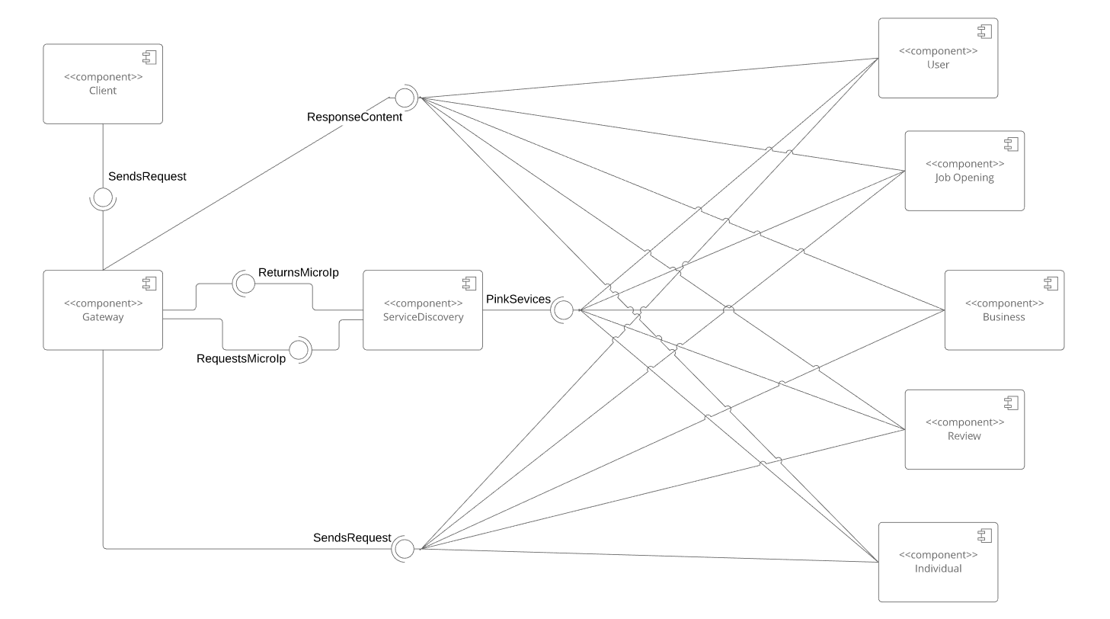

White-box diagram

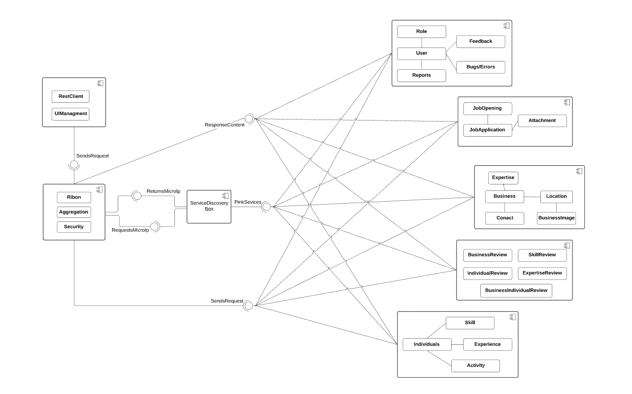

**Layer Architechture**

## Physical View

Deployment Diagram

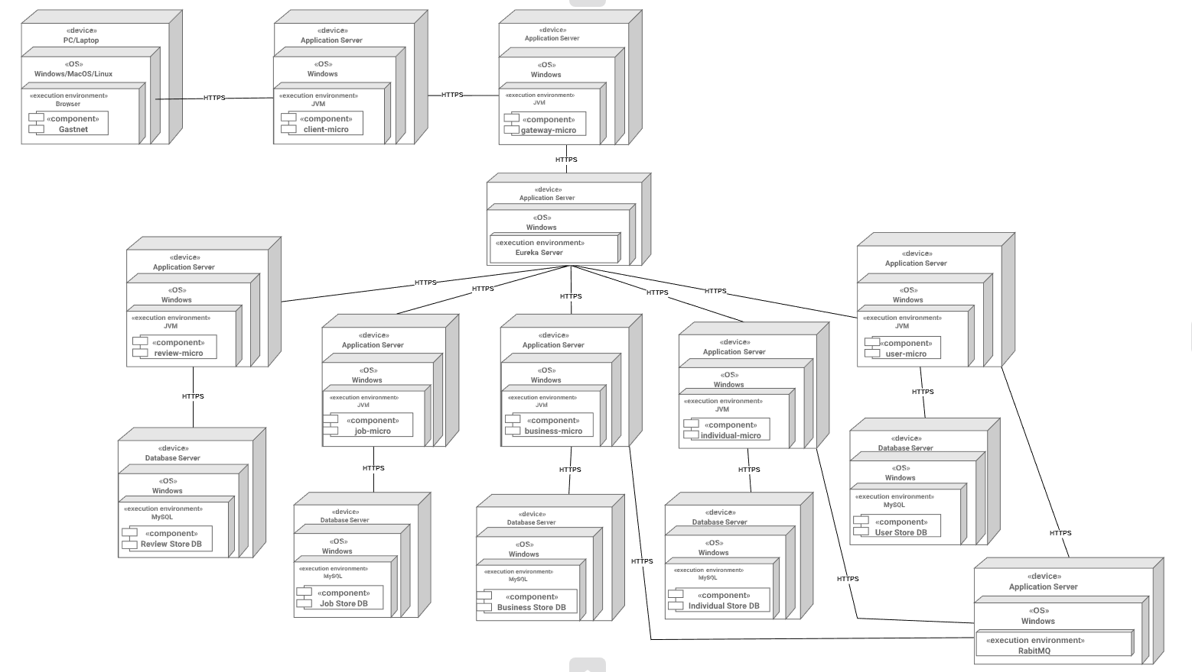

### 

### Deployment diagrams component description

All the services run on JVM and they communicate with each other using HTTPS as a protocol. The requests have the content type of JSON, all services accept JSON only and also will return JSON. Each of the services that contain business logic, have their own databases which run as MySQL databases.The responses from the client service, will be run on the most modern browsers without problem. For communication that includes more than 2 services RabbitMQ will be used so the request/responses are asynchronous. The services were made to be as loosely coupled as possible. Each of the services will be run on their own serves.

### 

### Layer Architecture design

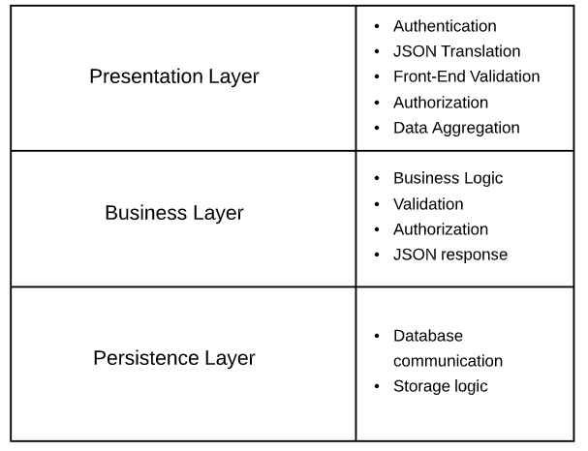

Presentation layer

The presentation layer will handle the authentication, front-end authorization and front-end validation and the translation of the data depending on the requested format. Data aggregation will also be handled on presentation layer, when a response contains data from multiple services. After accepting the request from the client, authentication and authorization will be performed on client request, if successfull a JSON request will be send to the business layer, which will return a response which is then shown in the view.

Business layer

This particular layer will handle all the validation, back-end authorization and specific business logic related with the data. This layer will accept and respond using only JSON

which then it’s handled by the presentation layer. When accepting JSON requests from presentation layer authorization will be performed first. After authorization , the validation will be performed, if the validation is successfull, based on the request the business logic will be performed, and sent in the persistence layer. As a response, an appropriate message will be returned based on the result from the business layer logic.

Persistence layer

The persistence layer will be responsible for handling database communication. Through persistence layer the system will retrieve data from the database which will be mapped and returned as objects using Hibernate ORM library.

**References**

<https://spring.io/projects>

<https://www.mysql.com/>

<https://www.rabbitmq.com/>

<https://docs.spring.io/spring-boot/docs/current/reference/htmlsingle/>

<https://redis.io/>

<https://www.datamation.com/storage/8-major-advantages-of-using-mysql.html>

<https://martinfowler.com/microservices/>

<https://dzone.com/microservices-news-tutorials-tools>

<https://github.com/Netflix/eureka>

<https://github.com/Netflix/ribbon>

<https://netflixtechblog.com/netflix-oss-and-spring-boot-coming-full-circle-4855947713a0>

<https://www.mscharhag.com/spring/api-gateway-with-spring-cloud-zuul>

<https://www.guru99.com/component-diagram-uml-example.html>